SUBCOURSE EDITION
MP 1016 A

TESTIMONIAL EVIDENCE

TESTIMONIAL EVIDENCE

Subcourse Number MP 1016

EDITION A

United States Army Military Police School
Fort McClellan, Alabama 36205-5030

10 Credit Hours

Edition Date: September 1991

SUBCOURSE OVERVIEW

We designed this subcourse to teach you how to interrogate suspects and subjects, interview witnesses and victims, conduct rights warning procedures, obtain sworn statements, coordinate polygraph requests, and utilize observations and descriptions.

There are no prerequisites for this subcourse.

This subcourse reflects the doctrine that was current at the time it was prepared. In your own work situation, always refer to the latest official publications.

Unless otherwise stated, the masculine gender of singular pronouns is used to refer to both men and women.

TERMINAL LEARNING OBJECTIVE

ACTION: You will identify procedures and legal considerations for gathering testimonial evidence for use in criminal proceedings.

CONDITION: You will have this subcourse, pencil, and paper.

STANDARD: To demonstrate competency, you must achieve a minimum of 75% on the subcourse examination.

i MP1016

TABLE OF CONTENTS

SUBCOURSE OVERVIEW i

LESSON 1 - Planning Interviews & Interrogations 1-1

Practice Exercise 1-14

Answer Key and Feedback 1-22

LESSON 2 - Conducting Interviews and Interrogations 2-1

Part A: Techniques 2-2

Part B: The Interrogation 2-6

Part C: Interpreters 2-7

Part D: The Polygraph 2-10

Practice Exercise 2-11

Answer Key and Feedback 2-17

LESSON 3 - Obtaining Written Statement 3-1

Practice Exercise 3-18

Answer Key and Feedback 3-25

LESSON 4 - Coordinate Polygraph Requests 4-1

Practice Exercise 4-22

Answer Key and Feedback 4-28

LESSON 5 - Observation and Description 5-1

Practice Exercise 5-32

Answer Key and Feedback 5-41

EXAMINATION E-1

MP1016 ii

* * * IMPORTANT NOTICE * * *

THE PASSING SCORE FOR ALL ACCP MATERIAL IS NOW 70%.

PLEASE DISREGARD ALL REFERENCES TO THE 75% REQUIREMENT.

September 1991

iii MP1016
LESSON 1

PLANNING INTERVIEWS AND INTERROGATIONS

Critical Tasks: 191-390-132
191-390-131
191-390-129

OVERVIEW

LESSON DESCRIPTION:

At the end of this lesson, you will be able to:

1. Discuss preliminary considerations before preparing for interviews and interrogations.

2. Warn the suspect of his legal rights and obtain a waiver using DA Form 3881.

3. Prepare for interviews and interrogations.

TERMINAL LEARNING OBJECTIVE:

ACTION: Plan interviews and interrogations.

CONDITION: You will have this subcourse, pencil, and paper.

STANDARD: You must complete all exercises for each lesson, take the final subcourse examination, and obtain a score of at least 75 percent correct answers.

REFERENCE: FM 19-20.

INTRODUCTION

1. INTRODUCTION:

a. Collection and evaluation of physical evidence is an important part of your job as a criminal investigator. However, without person to person communication, these items will have little or no practical value. It is only through communication with those connected with the incident that you can learn the meaning of physical evidence.

1-1 MP1016

b. To be an effective special agent (SA), you must be able to use good questioning techniques, be able to communicate well with people, and be an accurate, impartial listener.

c. Before you can hope to develop interviewing and interrogating skills, and before supervisors can help you with these skills, you must know the principles involved. You must have the basic understandings and attitudes before you can develop your skills.

2. Definitions. The following definitions will apply for Lessons 1 and 2.

a. An interview is the questioning of a person who is ready, willing, and able to talk freely. This person will often give his account of the facts in his own words and in his own way.

b. An interrogation is the questioning of a person who may be or is reluctant, unwilling, or for some reason, unable to freely disclose information.

c. An admission is a self-incriminating statement that falls short of an acknowledgement of guilt.

d. A confession is an acknowledgement of guilt.

e. A statement is a written or oral account of facts obtained from anyone during an investigation.

3. Uses of Interviews and Interrogations.

a. The questioning of criminal suspects, witnesses, victims, and informants will be a major part of your investigative efforts. In some cases, physical evidence will not exist. The only approach to a solution of the crime will be your interviews or interrogations. It is a fact that most of our serious crimes would remain unsolved if it were not for the leads developed (and the proof of guilt established) through interviews and interrogations. A recent study of New York County courts revealed that of 91 pending cases of homicide, 25 defendants would not have been indicted had it not been for their confessions.

b. The purpose of interviews and interrogations is to gather the facts of the crime. You must realize, however, that all this information is not fact. The art of interview and interrogation is to verify the facts of the crime. This will involve checking statements as you link the evidence to what occurred and link it with the suspect or perpetrator. You must pursue all information available to YOU. You must seek out and identify accomplices and additional witnesses to secure more evidence. This, in turn, will help to eliminate suspects as well as recover the fruits and the tools of the crime.

MP1016 1-2

4. Preliminary Preparation.

a. The Interview and Interrogation Room. The Field Office/Resident Agency commander must provide a suitable room. Make sure that the room is properly prepared prior to the interview or interrogation. When it is not feasible to use this room, you must be sure that the location selected and the surroundings are the best available. When you select a location, you must be aware of psychological factors for a successful interview or interrogation. Privacy is important. Most people with problems often find it easier to confide in one person rather than two or more. Equally as important, is to have a comfortably furnished room, free of distractions. This room should be plain, windowless, or have covered windows. It should have soft lighting and be free of telephones, display of firearms, night sticks, as well as plaques or slogans. The seating should be arranged so that you can reach out and touch the suspect. Tables, desks, or other pieces of furniture should not be between you and the subject. This would offer him a psychological barrier to hide behind. An example of good seating is shown in Figure 1-1. It is important co have an observation room adjoining this room. This would be partitioned with a two-way mirror and contain a concealed microphone. This would then be set up for stenographic service as well as other needed observations or recording of what occurs in the room.

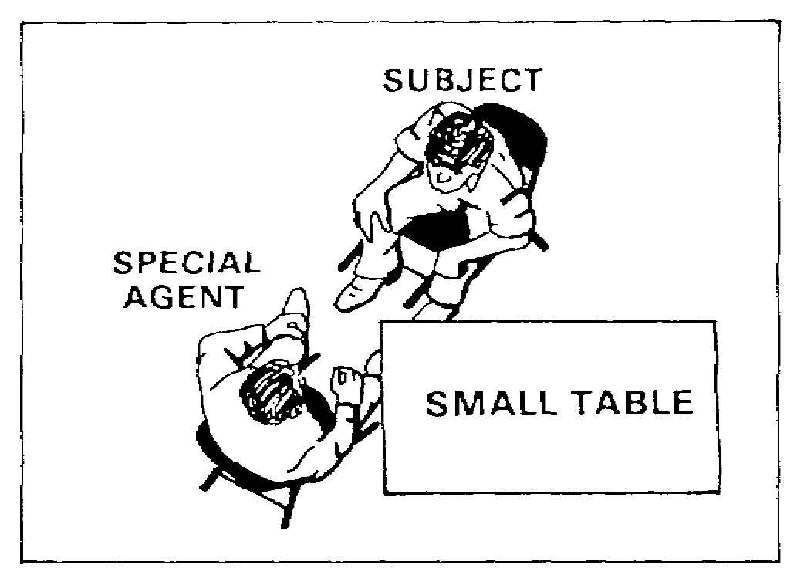
Figure 1-1. Interrogation Room.

1-3 MP1016

b. Special Agent Preparation. Prior to any meeting or contact with the subject, you must prepare yourself. You must become familiar with all the known facts of the incident under investigation. You should interview the desk sergeant, military policeman (MP), or anyone else who may have some knowledge of the initial complaint. Any oral, written, or recorded statements made by the subject, victim, witness, or complainant must be read and considered. Visit the scene of the alleged incident. Become familiar with the surroundings, even if there will be no crime scene processing. Learn what has been discussed in front of the suspect. Become familiar with the backgrounds of the persons involved, especially the suspect. Personal background information should include:

(1) Age, date of birth, place of birth, race, and nationality.

(2) Military rank or civilian status; and social security number.

(3) Present and former occupations.

(4) Educational level attained.

(5) Habits, hobbies, and associates.

(6) Relationship toward family, church, country, and job.

(7) Record of trials or police arrests.

(8) Criminal investigation depository check.

Be familiar with the case, the relationship of the subject with the case, and background information of the persons involved. You can create a definite advantage in your favor. You should determine questions and techniques for engaging the person in conversation. This will not be easy. You must maintain control and ask probing questions. Lying by the suspect must be detected. Cover all aspects to make sure you do not "run out of gas."

Decide on the information you seek to develop during the questioning. If possible, you should prepare a list of specific questions to be asked; avoid questions certain to get "yes" or "no" answers. Prepare questions like: "What did you see?" rather than "Did you see the accident?" Questioning must be conducted on the basis of accurate information. Lack of information will not impress the subject, but will make him more confident in his lying. A suspect who is told that his fingerprints were found at the scene of a crime, when at the time he was wearing gloves, will keep his resolve to lie.

c. Legal Preparation. Knowing the laws that apply to the offense is necessary for a successful interview or interrogation. Knowledge of these laws will help you to recognize an incriminating statement, and to assist in evaluating any statement made. You must be acquainted with those portions of the Manual
for Courts-Martial that set requirements and tests for the admissibility
of evidence. You must know the specific acts which constitute the elements
of proof of the alleged crime. You should know and avoid the actions
and conditions of improper questioning. Seek to protect the rights of

MP1016 1-4

persons involved in a case; to protect yourself from charges that might arise from your own misconduct; and make sure that the information you develop is complete and will be admissible as evidence. In any case of doubt, you must seek advice from the Staff Judge Advocate (SJA).

5. Rights of a Person Being Questioned.

a. As an SA, about to question a person suspected or accused of a crime, you must be sure that his rights are protected, per Article 31, UCMJ, and/or the Fifth Amendment to the U.S. Constitution. He is also entitled to counsel, as provided by the Sixth Amendment to the Constitution.

b. Before a statement can be used against an accused in court, it must be shown that his rights were protected, that the statement was freely and voluntarily given, that he was warned of his rights, that he understood the warning, and that he waived those rights. See Figures 1-2 and 1-3 for completed DA Form 3881, front and back.

(1) If the accused or suspect indicates that he wishes to consult with a lawyer, he must not be questioned until a lawyer is present. Likewise, if he indicates he does not wish to be questioned and he has no lawyer present, he must not be questioned.

(2) It is not advisable to read all of Article 31 and the Fifth Amendment to the suspect or the accused before questioning. The warning is a simple restatement of the rights which he must be told before being asked to waive his rights.

c. The rights warning must be given ONLY to persons suspected or accused of an offense. There is no obligation to advise complainants, victims, or witnesses of their rights unless you believe that they may have committed an offense. It is a poor policy to advise persons other than suspects of their rights as it may tend to restrict the free flow of information. However, if during their interview, they become a suspect in ANY criminal offense, you must stop the questioning and give the rights warning.

d. Only those persons subject to the UCMJ will be warned of their rights under Article 31. All other persons will be warned of their rights as provided by the Fifth and Sixth Amendments to the Constitution.

6. Persons Commonly Interviewed and Interrogated. As an SA, you may question many types of persons, including victims, witnesses, sources, complainants, and accusers.

a. Victims. A victim is normally interviewed first to develop the facts of an incident. This may take place in a hospital, at the home of the victim, or under conditions not of your choosing. A victim is not always reliable, cooperative, or available. This is sometimes due to a fear of some form of retaliation, a state of mental or physical shock, the possible involvement of relatives or friends, or a fear of publicity. He may be interviewed several times before all the facts are correctly disclosed to you.

1-5 MP1016

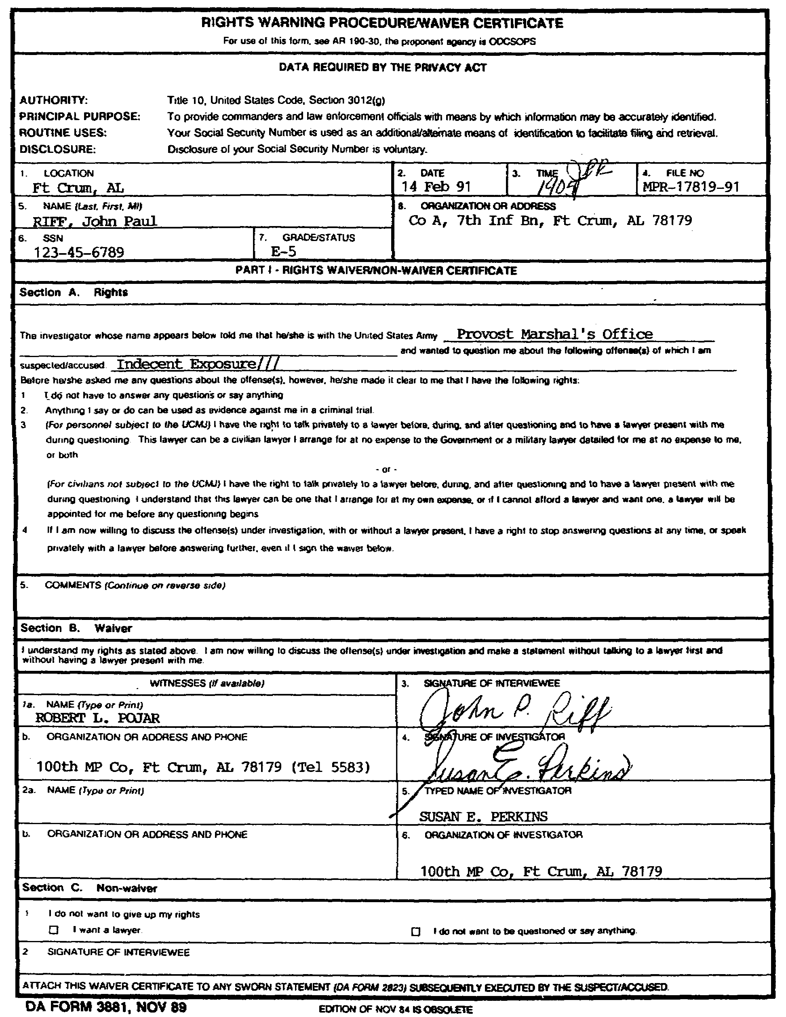
Figure 1-2. DA Form 3881 (front).

MP1016 1-6

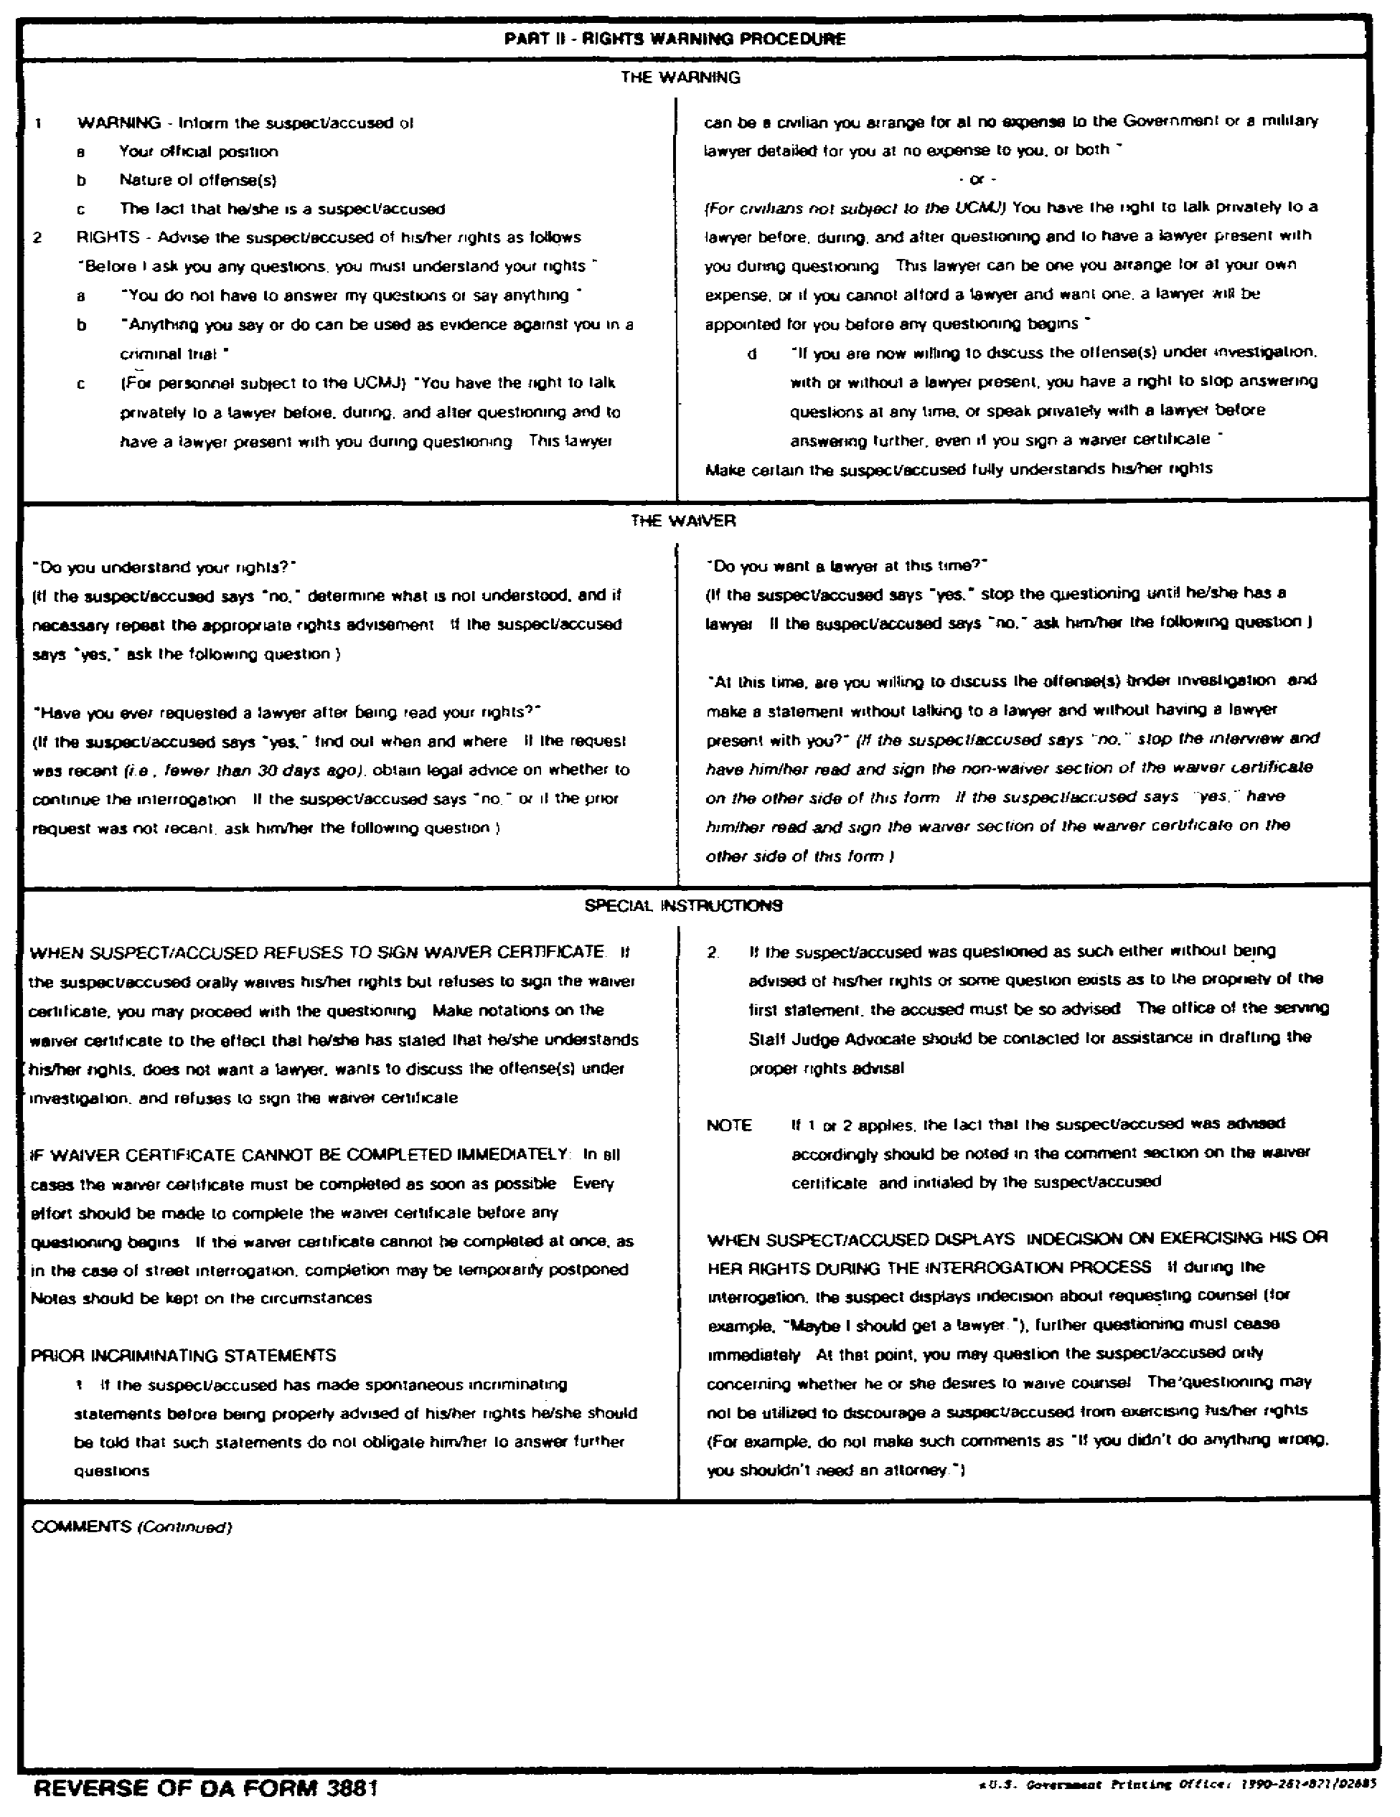
Figure 1-3. DA Form 3881 (back).

1-7 MP1016

b. Witnesses. A witness is a person, other than a suspect, who gives information concerning an incident. He may also be the victim, complainant, or accuser who first notified the MP of the incident. A witness must be sought when he does not come forward to present his knowledge of the crime. He may be a person who saw the crime, who can testify as to the actions and whereabouts of the accused at the time of the crime, who knows facts or heard the accused say certain things, a scientific specialist who can give expert testimony in court, or a person who, by his knowledge of certain facts can contribute to the case. He is usually interviewed, but may be interrogated when he is suspected of lying, or of withholding information.

c. Sources. The success and efficiency of an investigation may depend, to some extent, on a person who furnishes information about a criminal and his activities. This source is protected by you, who often, if suitable, interviews the source under conditions of his own choosing. A written statement is generally not taken from the source because of his reluctance to commit himself on paper to appear in court.

d. Complainants and Accusers. During a criminal investigation, a person may report or accuse another. He is usually interviewed. In some cases, it may be desirable to interrogate an accuser or complainant who is suspected of lying, or of concealing the fact that he provoked the accused, or is trying to divert suspicion from himself. When he is suspected of any offense, he must be advised of his rights, as set forth in paragraph 5.

e. Others. Information is often needed that will give a clearer understanding of the motives and actions of persons involved in offense. Interview persons who know the victim, suspect, witness, or source. This is normally conducted in the office, home, or place of business of such a person. Rarely does this interview turn into an interrogation.

7. Distracting Persons. You must meet persons who have no connection with a crime nor knowledge of it, who still present you with "information." They may claim to be witnesses or victims, or even perpetrators. Despite the lack of any real basis for their statements, these persons should not be dismissed lightly. Listen to their stories, evaluate what they say, and take the necessary action. These people can be classified as to the following.

a. Sensation or Publicity Seekers. Persons in this class are not often encountered during investigations. Some mentally warped or highly imaginative persons, however, may present themselves as witnesses, as additional victims, or as accomplices of suspects who have received a lot of publicity. Make every effort to handle them in such a manner that neither the investigation nor the reputation of the Armed Forces suffers.

b. Grudge Bearing and Lying Witnesses. Because of previous troubles with
an accused or suspect, or in order to settle an old score, a person with no knowledge of an incident may volunteer information about, or profess to be a witness to an offense. If you know the facts and details of the incident, it
will often enable you to detect lies in the story of such a person. The
testimony may be similar to the accounts of the incident that have been
released. Where the real motives of such a witness are obscure to you, all

MP1016 1-8

possible background information should be developed to disclose the lies and motivations.

c. False Accusers. An accuser may make a charge that will later prove false. Sometimes such a charge will persist until a trial is conducted. A false charge is, at times, an exaggerated version of an actual crime of a lesser nature, or is sometimes made when no offense has been committed. False charges are prevalent in theft cases, and are common in sex crimes and other crimes in which men and women are involved. A false charge may represent the sincere, though erroneous thinking of the victim. It may rest on the victim's reaction to previous ill will, suspicion, or jealousy. All of your skill is required in the initial interview with an accuser to separate truth from false hoods.

8. Reliability of Information. Certain human factors will affect your success in getting people to talk. It also influences the accuracy of their information. You must evaluate each person and his evidence; understand the person's motivations, fears, and mental makeup; use this understanding of the person to gain useful information. You must consider the following factors and how they affect the accuracy of the information given by a person.

a. Perception. The truth of the information from an interview or an interrogation is influenced by the subject's ability to perceive correctly what happened in his presence, and to transmit it correctly to you. A weakness in his ability to see, hear, smell, taste, or touch should be understood as well as his location in relation to the incident. Rarely do two people give the same account of the same incident.

b. Memory. A lapse of time since the incident, or the person's having had no reason for attaching much importance to it at the time both influence his memory or recall. The account given at a later time is often affected by what he has heard or seen about it since. Furthermore, a person may fill in the gaps in his knowledge by rationalizing what he did see or hear and may repeat the entire mixed up story to you as the truth. To prevent this, a person should be talked to as soon as possible after the incident. Even then all of your skill will be required to discover what the person actually did observe.

9. Witnesses to Interviews and Interrogations.

a. When too many persons are present, a person is usually reluctant to tell all that he knows about the incident. The presence of too many persons has been held by the courts to be duress. On the other hand, someone should be present to witness the questioning, any statements made, and to protect you against a possible charge of coercion or duress. Not more than two agents should be present in the room. When more than two persons have an official interest, the other persons may witness the questioning from behind an observation mirror where they will be out of sight, but where they can still see and hear everything.

1-9 MP1016

b. Female Subjects. You should never jeopardize an interview or interrogation by ignoring the fact that a woman may not want to talk in the presence of other persons about intimate topics. There is no legal requirement to have a witness for the questioning of females. A female subject may desire a female witness but she does not have the right or entitlement. However, for your own safeguard, you WILL make sure that a female witness is present at least within hearing distance.

10. Records. An index file should be maintained by name to record facts about each interview and interrogation. The file should be cross-referenced to each instance of questioning, to the case for which questioning was accomplished, and to the Report of Investigation that contain the REPORTED information. You may be able to consult the name-index file and the case reports to gain information about a person. This will prevent duplication of effort, and provide summary knowledge until complete background information can be developed.

11. Interview.

a. Only a few people near a crime can give information that will be of value. Locate these and separate them from those who do not. This is best solved through the interview.

b. An interview is the questioning of any person who is ready, willing, and able to tell what he knows. The person usually gives his account of the incident in his own words.

12. Planning the Interview.

a. Time of Interview. A person should be interviewed as soon as possible after the incident, but only after you have the information necessary to conduct that interview. This will preclude or reduce his forgetting or being influenced not to talk. Question witnesses, victims, and complainants at their convenience. Allow enough time to conduct a thorough interview; improper scheduling can result in a rushed interview. Important details may be overlooked.

b. Place of Interview. Conduct the interview in a place where the psychological advantage is in your favor. The location should be carefully selected, and based on the facts of each case. Decide on where your chances are best for encouraging the person to talk. At times, this may be in surroundings familiar to the person, such as in his home or office; at other times it is best to hold it in a place where he is deprived of the comfort or ease of his familiar environment. When interviewing a source or witness whose identity has not been publicized, it is best to choose a place that will not attract attention to him. These sessions may become interrogations, during which you should be able to exercise control over him and the surroundings.

MP1016 1-10

13. Introduction.

a. As an SA, you should introduce yourself courteously to the person. Make certain that he is aware of your identity; show your credentials if he has a doubt as to your authority.

b. A hasty introduction or an appearance of haste at the beginning may be embarrassing. It may make the person think that his presence is of little importance and that the information he has is of little value. A few minutes spent in a proper introduction are not wasted; this gives you time in which to evaluate the person and the approach; the person is given an opportunity to calm down, and is in a better frame of mind to answer questions.

14. The Opening Statement.

a. Make a general statement about the case. Do not disclose any of the facts that have been developed. The statement should be so worded as to create an understanding between you. This is a good point on which to begin the discussion and it gives you time in which to "size up" the interviewee.

b. If he is a suspect or an accused, then after making the general statement, you must make sure that he fully understands his rights as set forth in the preceding paragraphs. Remember, that merely warning him of his rights is not enough; you must make sure that he UNDERSTANDS his rights. You must also ensure that the suspect has not been advised of his rights in the past 30 days and requested legal counsel.

15. Conducting the Interview. Your attitude and actions will usually determine the success or failure of the interview. Be friendly and businesslike. You should get the person into a talkative mood. Guide the conversation toward his knowledge of the case. He should be permitted to tell his complete story without unnecessary interruptions. Questions should be phrased so as to keep a free flow of talk. Mentally note any inconsistencies. Obtain clarification after he has completed his story.

16. Approaches. The indirect approach is generally used in the interview. The interviewee is usually aware of the reason for the interview. He is permitted to discuss the facts rather than answer probing questions. He is encouraged to talk about the incident and to give a true and complete account of his knowledge of it. The more direct type of questioning is normally reserved for the interrogation. However, it may be used when the person shows a fear, dislike, or distrust of police officers, or does not want to talk.

a. Complainant. The complainant should be interviewed as to whether the crime occurred as alleged. Be receptive and sympathetic. Let him know that you recognize the importance of the complaint and intend to take proper action. Be tactful and open-minded toward the person and his complaint. Attempt to establish the motive for the complaint. Be alert for any grudge or jealousy on his part, and determine any relationship to the person accused and the facts developed.

1-11 MP1016

b. Witnesses. You must often guide the witness in order to help him recall and relate the facts of an incident as they were observed. Help him realize that he has important and necessary information. Questioning should be designed to develop a detailed account. Be aware of the human factors that affect a witness's ability to observe and describe things related to the crime.

c. Victims. When interviewing the victim of a crime, especially a crime of violence, consider his emotional and physical state. A state of shock or hysteria may cause him to give a hazy, erroneous, or garbled account of the crime. Wild opinions or conclusions are often included in his account of the crime. Keep an open mind. Evaluate each element of the story in relation to the physical evidence and the testimony of witnesses. The interview procedure used for a victim can usually give reliable information about the events leading to the crime, but his account of the details of, and the events following, the crime may be faulty because of excitement and tension.

17. Recording the Facts. The recording of the facts disclosed in the interview is necessary to the proper conduct of the investigation and to the report.

a. Most people who are interviewed have no objection to the SA discreetly taking notes. Notes, however, should not be taken until he has had a chance to tell his story completely and to correct any honest mistakes made in the first telling.

b. Some display annoyance when the SA diverts his attention from them to the taking of notes, while others are reluctant to talk when they know that what they say is being recorded. When this happens, do not make notes until just before closing the interview, or just afterwards, while the details are still fresh in your mind.

c. A recording device (tape or wire) is a good means of preserving the interview. The recordings should be kept in their entirety, together with any transcripts made from them. A complete chain of custody is maintained for all such items as they may later prove valuable in legal proceedings, provided they can be properly identified.

18. Closing the Interview.

a. The closing should be just as careful as any other part of the interview. Make certain that you note all information received: a brief summary prior to the departure of the person will disclose any mistake, either in his account or in your understanding. Show your appreciation for his cooperation and emphasize the importance of the information. You may reassure him that the information will be handled in a confidential manner, and that the right action will be taken.

b. Bringing the interview to a close may uncover more information.
A reluctant person may tend to drop his guard after the questioning has
ceased and you have put your notebook away. The person who has suppressed facts

MP1016 1-12

during the interview may mention such facts after the interview. By being alert, you may secure the very facts that had eluded you during the interview.

c. If the person has traveled far to be interviewed, help him to arrange and schedule his travel home, or to get reimbursed when authorized. Such action promotes future cooperation.

19. Evaluating the Interview. During and right after closing the interview, strive to evaluate the interviewee, and the information, as well as your own performance.

a. The Interviewee. The mannerisms and emotional state of the person may indicate the reliability of his information. Evasiveness, hesitation, or unwillingness may signify that he is not cooperating to the fullest. Nervousness, such as a continuous wetting of the lips, may show an attempt at deception. Flushing or perspiration on the face may show the seriousness which he attaches to the points being discussed. These may also indicate that he is not giving complete information. Some persons, however, are able to lie without any noticeable outward signs. Moreover, innocent persons sometimes display signs of extreme nervousness. There are these reasons, and many others that may cause you to misjudge such signs. The information furnished during the interview cannot be evaluated conclusively. Seek persons who have known the interviewee for some time in order to weigh inferences gained from the signs of emotional disturbance displayed.

b. The Information. This has no real value until it is evaluated and, if possible, checked for accuracy as follows:

(1) Compare it in detail with the known facts of the crime.

(2) Conflicting statements about the same c se should be compared. These should be compared with the known facts against the background information developed. The human factors that affect the powers of perception and memory may be the cause of the differences; they should be considered but should not be relied upon too greatly to explain different accounts of the same event. Sometimes, the cause of the differences may be found only in the motivation or prejudices of the person who lied in his account of the incident.

(3) Review the entire case as it has been developing. Give close attention to the gaps in your knowledge of the case. Strive to obtain a clearer picture of the case than you had before the interview.

c. Your Own Performance. You should try to improve your ability to interview persons successfully. Evaluate your own performance during and after each interview, both your approach and manner. This is more necessary when you have been unsuccessful in extracting from the interviewee all the information that you believed he had.

1-13 MP1016

LESSON 1

PRACTICE EXERCISE

REQUIREMENT. The following questions are multiple choice. There are four choices to each. You are to select the one that is correct. Indicate your choice by CIRCLING the letter beside the correct choice directly on the page. This is a self-graded lesson exercise. Do not look up the correct answer from the lesson solution sheet until you have finished. To do so will endanger your ability to learn this material. Also, your final examination score will tend to be lower than if you had not followed this recommendation.

GENERAL SITUATION. You are the operations officer, Fort Blank Field Office, Third Region, USACIDC, Fort Blank.

SPECIAL SITUATION: You are explaining the rights of a person being interviewed, and the procedures to be followed in conducting a successful interview to the field office special agents.

1. Who is the person responsible for ensuring that the place designated for an interview is properly arranged, clean, and ready for the interview?

A. Provost marshal.

B. Special agent.

C. Operations officer.

D. Resident agency commander.

2. What is the correct definition of an interview?

A. The initial questioning of a victim, accused, or complainant.

B. The questioning technique used when a person is believed to be withholding information.

C. An attempt to obtain information from someone who has it.

D. The questioning of a person who is ready, willing, and able to talk freely.

MP1016 1-14

3. You are interviewing the complainant of a larceny of government property. What should you do if you believe the complainant is actually the suspect to the larceny?

A. Stop all questioning, and advise the complainant of his rights.

B. Change from interviewing the complainant to interrogating him.

C. Phrase your questions so that the complainant will incriminate himself.

D. Switch to a more direct type interview approach where you can ask probing questions to determine the complainant's involvement in the crime.

4. Reference the Fifth and Sixth Amendments of the United States Constitution and Article 31 of the UCMJ, what is your most important consideration after reading the suspect the proper warning of his rights?

A. The suspect signs a waiver of his rights.

B. There is a witness present from this point on.

C. The suspect understands his rights.

D. A lawyer must be present from this point on.

5. Where is the source normally interviewed?

A. In the special agent's office.

B. The interview and interrogation room.

C. Any place the source chooses.

D. The place chosen by the source, if suitable.

6. What is the best way to conduct an interview?

A. Flatter the person and build up the value of the information he has.

B. Have the person tell the story in his own way.

C. Outline the case to the person, and ask him which points are correct.

D. Question the person step-by-step until you learn what he knows about the incident.

1-15 MP1016

7. Last night a soldier was assaulted in the Aces Bar, a local city hot spot. What must you do before you interview the bartender about the assault?

A. Warn him of his rights as provided by Article 31, UCMJ.

B. Advise him of his right to counsel as provided by the Sixth Amendment.

C. Advise him of his rights per the Fifth and Sixth Amendments to the United States Constitution.

D. Introduce yourself and state the purpose of the interview.

8. Which one of the following furniture arrangements would you use for an interrogation? (see page 1-17.)

MP1016 1-16

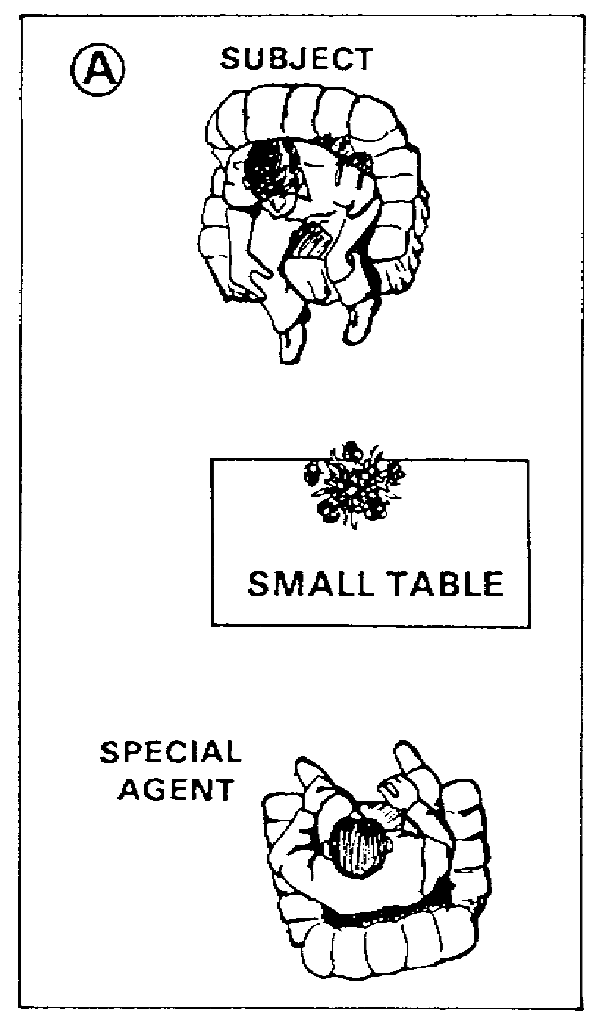 | 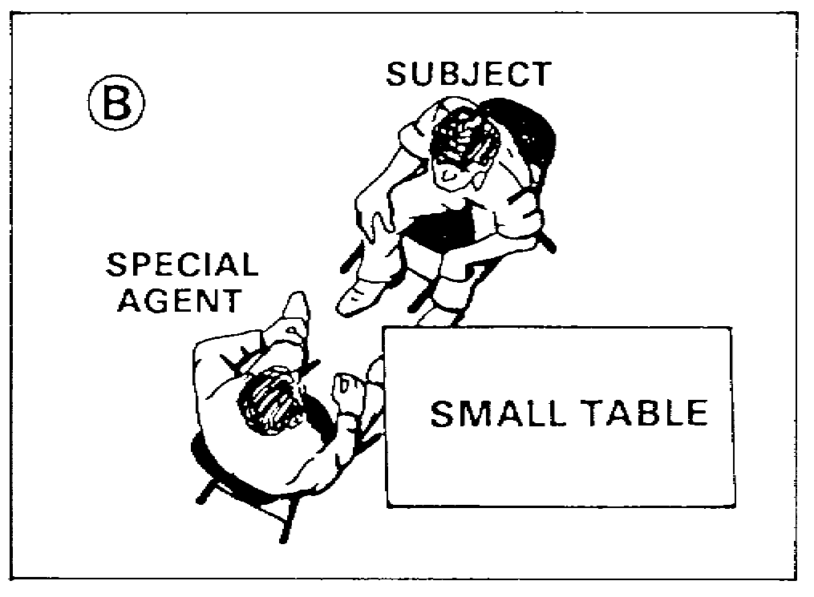

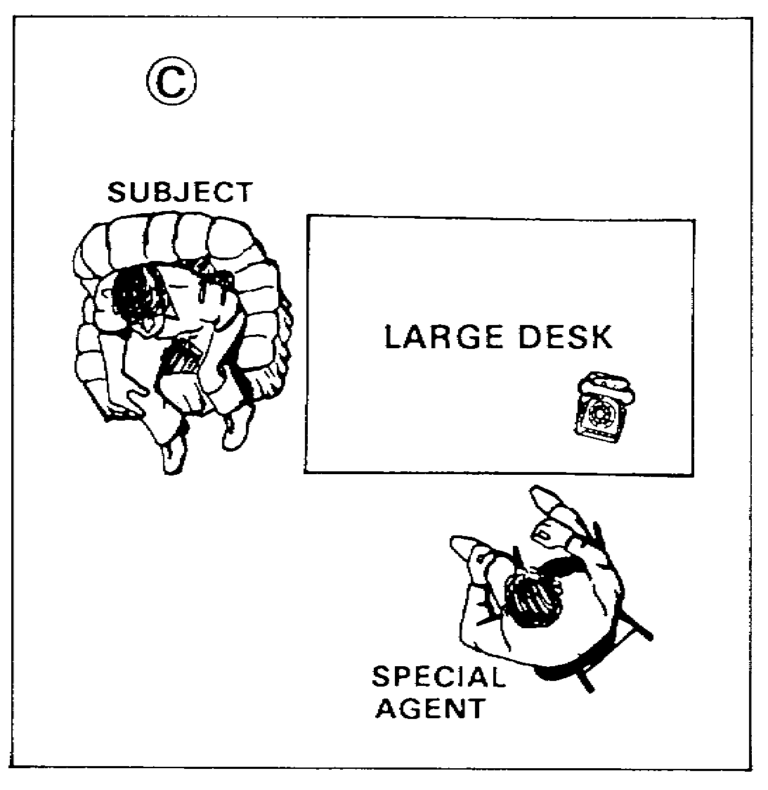 | 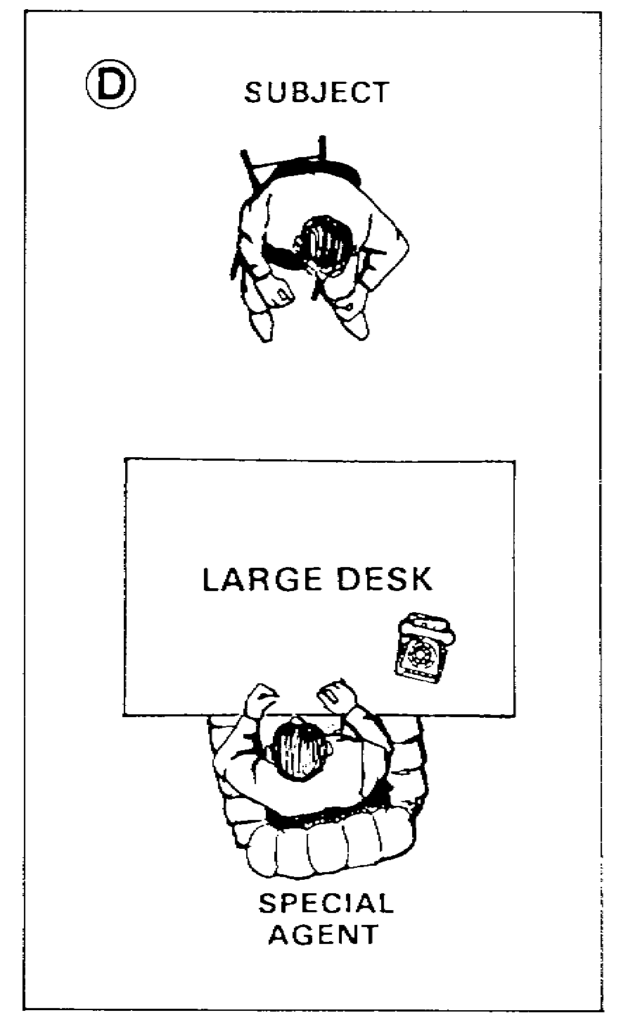

1-17 MP1016

9. What is the best way to take notes to record an interview?

A. Be obvious so that the interviewee knows his statement is being recorded.

B. Discreetly take necessary notes during the entire course of the interview.

C. Take notes only on inconsistencies during the interview.

D. Wait until the interviewee has finished his story before making any notes.

10. During the course of an interrogation a suspect conceded that he was in the vicinity of the crime. What is this statement called?

A. A confession.

B. An acknowledgement.

C. An admission.

D. A location.

11. Which one of the following would provide the special agent with the best psychological advantage when conducting an interview?

A. An observation room.

B. Privacy.

C. Display of firearms.

D. A nondistracting room.

12. You have prepared a list of questions to ask a witness. Which one of the following should you avoid?

A. Would you describe the condition of the suspect's clothes.

B. Did you see the suspect leave the scene?

C. Would you portray the suspect's actions?

D. What were the actions of the other witnesses to the crime?

MP1016 1-18

13. What, if any, is a female subject entitled to as a witness during an interview or interrogation?

A. A female noncommissioned officer, commissioned officer, or warrant officer.

B. Either a male or female witness.

C. A female witness.

D. There is no legal requirement to have a witness.

14. You have finished warning a suspect of his rights, asked him if he wants a lawyer, and if he will make a statement. The subject does not want a lawyer, and will make a statement. About halfway through the interrogation, the subject states that he wants a lawyer. What should you do?

A. Remind the subject of his original rejection of a lawyer and continue the interrogation.

B. Stop all questioning.

C. Make arrangements to obtain a lawyer, and then continue taking the statement from the subject.

D. Obtain a lawyer for the subject at the completion of the interrogation.

15. During the course of a robbery investigation, which one of the following persons should be interviewed first?

A. LT Alfa, victim.

B. SPC Bravo, subject.

C. 1SG Charlie, complainant.

D. MAJ Delta, witness.

16. A rape victim is to be interviewed regarding the circumstances surrounding the incident. Which one of the following should represent her best account of the incident?

A. Reliable regarding the events prior to, during, and after the incident.

B. Unreliable because of her emotional state.

C. Reliable as to the events leading up to the rape.

D. Believable regarding the events prior to, and following the rape.

1-19 MP1016

17. Other agencies and individuals were interested in the suspect's possible confession. Therefore, you interrogated him in front of 7 or 8 people. What might the court hold as to the method that this confession was obtained?

A. Under duress.

B. In a proper manner.

C. Through unlawful influence.

D. Through coercion.

18. During the interview of a complainant, you suspect him of lying and concealing the facts, and of actually being the subject of the crime. Which one or more of the following procedures would you take?

I. Continue to interview.

II. Switch to an interrogation.

III. Warn him of his rights.

A. I.

B. I, II.

C. II.

D. III.

19. A newly assigned special agent explains to you that he is having difficulty interviewing and obtaining the desired information. Which one or more of the following would you consider best for guiding him to success?

I. Understand the basic principles governing the interview.

II You can only learn by doing.

III. Watch other successful interviewers and their techniques.

IV. A good interviewer is born, not made.

A. I, II.

B. II, IV.

C. II, III.

D. I, IV.

MP1016 1-20

This page left blank intentionally

1-21 MP1016

Lesson 1
Practice Exercise
Answer Key and Feedback

Item Correct Answer and Feedback

1. B. Special Agent.
Make sure that the room... (page 1-3, para 4a).

2. D. The questioning of a person who is ready, willing, and able to talk freely.
An interview is... (page 1-2, para 2a).

3. A. Stop all questioning, and advise the complainant of his rights.
However, if during the interview... (page 1-5, para 5c).

4. C. The suspect understands his rights.
Before a statement can be used... (page 1-5, para 5b).

5. D. The place chosen by the source, if suitable.
This source is protected by you... (page 1-5, para 6c).

6. B. Have the person tell the story in his own way.
The person usually gives... (page 1-10, para llb).

7. D. Introduce yourself and state the purpose of the interview.
As a SA, you should ... (page 1-11, para 13a).

8. B. Figure 1-1 Interrogation room.
The seating should be arranged... (page 1-3, para 4a).

9. D. Wait until the interviewee has finished his story before making any notes.
Most people who are... (page 1-12, para 17a).

10. C. Admission.
An admission is a self-incriminating... (page 1-2, para 2c).

11. B. Privacy.
When you select a location... (page 1-3, para 4a).

12. B. Did you see the suspect leave the scene?
Decide on the information you seek... (page 1-4, para 4b).

13. D. There is no legal requirement to have a witness.
You should never jeopardize... (page 1-10, para 9b).

14. B. Stop all questioning.
Before a statement can be used... (page 1-5, para 5a).

MP1016 1-22

15. A. Lt. Alfa, victim.
A victim is normally interviewed first... (page 1-5, para 6a).

16. C. Reliable as to the events leading up to the rape.
The interview procedure used... (page 1-12, para 16c).

17. A. Under duress.
When too many persons are present... (page 1-9, para 9a).

18. D. III warn him of his rights.
When he is suspected of any offense... (page 1-8, para 6d).

19. A. I and II understand the basic principles governing the interview. You can only learn by doing.
Before you can hope to... (page 1-2, para 1c).

1-23 MP1016

LESSON 2

CONDUCTING INTERVIEWS AND INTERROGATIONS

Critical Tasks: 191-390-0132
191-390-0129

OVERVIEW

LESSON DESCRIPTION:

At the end of this lesson, you will be able to:

1. Conduct an interrogation utilizing the direct and indirect approaches.

2. Chose and control an interpreter when a suspect with a language difference must be interrogated.

3. Identify scientific aids available for interrogations, discuss their capabilities and limitations.

TERMINAL LEARNING OBJECTIVE:

ACTION: Conduct interviews and interrogations.

CONDITION: You will have this subcourse, pencil, and paper.

STANDARD: You must complete all exercises for each lesson, take the final examination and obtain a score of at least 75 percent correct answers.

2-1 MP1016

INTRODUCTION

1. An interrogation is the questioning of a person who is believed to be guilty of a crime, to be an accomplice to a crime, or to be withholding information directly pertaining to a crime; without it, very little evidence is developed for use in court. Interrogation serves to answer the basic questions of any investigation: the who, what, where, when, and why.

2. The purposes of an interrogation are to:

a. Ascertain the facts of a crime.

b. Develop information that will enable you as a special agent (SA) to gain independent testimony and physical evidence to prove the truth of an admission or a confession.

c. Get the truth from a lying, evasive, or reluctant witness, false accuser, or other uncooperative person whose information could lead to the solution of a crime.

d. Learn the identity of an accomplice to the crime and/or the details of any criminal plan or scheme.

e. Get a confession or admission to a certain crime.

f. Get information about other crimes, but investigate separately - stick to the subject.

g. Recover the fruits of a crime.

PART A: TECHNIQUES

1. Whom to Interrogate. Interrogate a person who is believed to have information pertaining to a crime. Avoid interrogating any person who can be successfully interviewed.

2. Preparing for the Interrogation. Base your plan on the facts of the case and the known background information. Statements of the victim and witnesses, in addition to physical evidence, will help you to reconstruct the crime mentally. This will help you to anticipate some of the facts which you may obtain during the interrogation.

Based on the known information, prepare a formal outline of the case. List the main points with all supporting statements or evidence; the outline should also contain the questions that you intend to ask.

3. Psychological Factors. You can enhance your advantage by consideration of the following:

a. Time of Interrogation. A person suspected of a crime should be interrogated as soon as possible after the report of the incident, but only

MP1016 2-2

after you are prepared and are thoroughly ready. Every minute that elapses between the crime and the apprehension and interrogation of the suspect affords him a chance to compose himself, to fabricate alibis, and to communicate with accomplices.

Because the interrogation is normally time consuming, and cannot be rushed, there should be no time limit. Do not schedule any other activities that may interrupt it or cut it short. The interrogation, however, should never be continued for a length of time that would constitute duress.

b. Place of Interrogation. A suspect, surprised and apprehended in the act of committing a crime, is sometimes interrogated on the spot while he is under considerable emotional strain. Properly handled, this may often produce an admission or confession that will help to establish the guilt of the suspect and his accomplices. Normally, however, it is conducted at your office. This will provide recording facilities and secretarial assistance. Witnesses are also available to guard against possible charges of abuse, duress, or coercion, and to witness statements, admissions, and confessions. At your office or an interrogation facility, you can arrange for privacy, control the environment, and make fairly certain that it will not be interrupted.

4. Classification of Suspects.

a. The classification of suspects into two general groups will help you in the approach most likely to succeed. Your efforts to classify a suspect will depend upon your own ability and experience, and also upon the information developed about the suspect or the case. A wrong classification may result in a poor interrogation. This would happen if the approach, based on the original classification, is not skillfully and quickly changed before the suspect becomes aware of your error. Suspects are divided into the following groups.

(1) Suspects whose guilt is reasonably certain. This category may be further divided into:

(a) Those influenced by sympathy or understanding (first offenders or "heat of passion" offenders).

(b) Those influenced by logic (habitual criminals or those who feel no concern for their offense).

(2) Those whose guilt is doubtful or uncertain.

b. Your success will depend upon a quick and accurate appraisal of the subject, and the technique appropriate for the occasion. Should you appeal to his logic? Should you be sympathetic? Should you appeal to the person's pride, or shift the blame to someone else? Should you be tough? What terminology should you use? These are but a few of the questions you will have to ask yourself while sizing up the subject and deciding on the technique to use. (See Chapter 5, FM 19-20 for additional information on the interrogation.)

2-3 MP1016

5. Commencing the Interrogation. As the SA, you should identify yourself prior to beginning. Present your credentials or badge so that no doubt will exist in the subject's mind as to your authority. After the introduction, tell the subject the nature of the accusation. Inform him that an investigation is being conducted. Take care in making this statement so that none of the specific details of the crime are prematurely disclosed. Make sure that the subject fully understands his legal rights in the manner set forth in paragraph 5, Lesson 1. Ensure that prior preparations are made in case a language problem exists (See Chapter 5, FM 19-20).

6. Conducting the Interrogation: Your approach is influenced by the subject's background and available facts and evidence. After considering these factors and making preparations and plans, you are ready to proceed. Decide on the approach you think would be best. There are only two types of approaches: direct and indirect. After you have selected the best approach, you will then have to consider which different interrogation techniques you want to use during the course of the interrogation. First, we will discuss the two types of approaches and then we will discuss different types of interrogation techniques.

a. Direct Approach. The direct approach is used with the suspect whose guilt seems definite or reasonably certain. Be direct and positive. Let the suspect know you know who committed the crime, but are willing to hear his side of the story.

b. Indirect Approach. The indirect approach is used when interrogating suspects whose guilt is uncertain or doubtful. This approach is exploratory in nature.

Once you have selected the type of approach you wish to use towards the suspect you are then ready to decide what type of interrogation techniques you might want to use during the course of that interrogation. We will discuss the thirteen most common interrogation techniques used by investigators in the field today. These techniques have been proven over the years to be some of the best available to investigators conducting interrogations.

(1) Sympathetic: Use with persons who appear to have a caring nature. Tell the person that he did the act because he was in need, because of concern, or because he cared. This is not limited to but often used with suspects of burglary, robbery, or larceny.

(2) Logic and Reasoning: This technique is to be used with persons who have an analytical mind; those who want to know what is in it for themselves. You tell him he knows and he knows you know, and that all the facts will come out. Explain to him his cooperation will be beneficial to him.

(3) Psychological: Use this technique on persons who are family or people oriented. Ask what his loved ones or a special person he respects would think of him for doing this or what they would want to do.

MP1016 2-4

(4) Hypothetical: Make up a story about another person who committed a similar offense but through his cooperation has put this behind him with minimal effects and results. Emphasize the other person's cooperation.

(5) Cold shoulder: During the interrogation if you know or feel the person has lied when answering a question; stop, don't talk to him, don't look at him, or just turn away. Freeze him out and often he will make additional remarks to qualify his initial answer. Continue until he sees the futility in this effort and finally reverses or alters his statement to the truth.

(6) Using one suspect against another: It is important to keep the two people out of sight and hearing of each other. Interview one and then continue to imply to the second that the first told the truth and is blaming him. It may be necessary to bring the first man in and repeat the process with him.

(7) Providing suspect with excuses: Offer the person excuses, allowing him to save face by letting him shift the blame for the reason he committed the offense. Often times he will accept a reason that is less morally offensive.

(8) Condemning society, the law, or the victim: Attempt to obtain a confession by placing the blame on a situation or entity. Indicate that he had no alternative but to respond as he did.

(9) False statement: This ploy is used to apply psychological pressures on the person. Show the suspect a statement in a manner that he cannot read it and imply that it is testimonial evidence.

(10) Flattery: Use as an ego inflator, but be realistic, don't over stroke him. Safe topics; i.e., good appearance, nice personality, intelligence, ability, loyalty, concern, etc.

(11) Claim the victim exaggerated: Increase the amount damaged or stolen, or exaggerate the degree of physical damage. Often the suspect will be willing to confess to a smaller amount of money or damage.

(12) Get minor admissions: Get the suspect to admit being in the area or with the person on some other pretext. After obtaining this admission, slowly walk him into deeper involvement until you get to a complete confession and the real person. This technique is better used in combination with other techniques, i.e., sympathetic, blaming victim, logic, and reasoning.

(13) Ask "why" the offense was committed: Offer suspect an opportunity to give you a reason for the crime. He may give you his reason and, if so, he has furnished you an avenue of pursuit to guide your questioning.

2-5 MP1016

Any other technique you can create; you are limited only by your own imagination. You must be cautious to stay within the bounds of legality and not violate the suspect's rights.

7. Recording the Facts. Take notes of person's name and address during the questioning. You must train yourself to remember correctly all the facts and discrepancies during the interrogation. Do not take written notes until after the suspect has confessed and is willing to fully cooperate. Then explain to the suspect that you wish to take notes only to ensure that you get his story down straight.

8. Evaluating the Information. You have opportunity during the interrogation to observe and to evaluate the mannerisms and the emotional state of the subject. Be alert for any signs of emotional disturbance or nervous tension that may indicate deception or guilt. Evaluate the information given in respect to known facts, the testimony of the victim and witnesses, and the physical evidence available. Verify every pertinent statement made by the suspect.

9. Summary. Interviews and interrogations are the principle activities of CID investigators engaged in the search for truth. Without them, special agents cannot expect to learn about events that happened while they were not present. Interviews should be conducted where the person interviewed is at ease, while interrogations should be conducted where the CID investigator enjoys the psychological advantage. Interviews serve to develop leads, verify facts, obtain information, identify persons, develop background information, and locate the fruits of the crime. Interrogations are conducted to get facts from persons who will not respond to questions set in an interview framework. Frequently, interrogations are questioning sessions with suspects and are designed to get admissions or confessions of guilt; however, interrogation approaches and techniques may be useful in getting the truth from any person, including victims, who are involved in CID investigations.

PART B: THE INTERROGATOR

1. Conduct and Attitude. As an SA, the conduct and attitude toward the subject may be the key to success or failure. Your attitude should be that of one seeking the truth, rather than a confession or a conviction; you should be seeking to clarify a misunderstanding, or to help the subject straighten himself out rather than seek punishment. A sympathetic, understanding attitude, on your part, will be far more effective than one that belittles or degrades the subject. The approach used will vary with each case, but the following tips will be useful, regardless of the approach.

a. Command. Be in command of any interrogation. You must establish your command, not through your authority, but by your personality and air of confidence. Do this by being firm and sympathetic, without being harsh or soft. Present a calm, dignified, self-assured manner, confident of your own ability to get the facts from any subject.

MP1016 2-6

b. Patience and Perseverance. Be patient. Give the impression that you have "all the time necessary to obtain the true facts of the case." Avoid rapid-fire questions. Go back over important points that were discussed earlier. Be persistent enough to continue after you have decided that it is fruitless to go on. By continuing for only 15 minutes more, you may be able to overcome the subject's resistance and obtain the desired information.

c. Integrity. If the subject has any doubt about your honesty, it will be impossible for you to instill confidence and trust in him. You must not make promises you cannot keep, or promise anything you cannot deliver.

d. Mannerisms. During the interrogation, remain seated, and refrain from pacing the room. Do not smoke, doodle, fumble with a pen or pencil, or display other such distracting mannerisms. These would give the suspect the appearance of lack of concern on your part. Any actions that could give the impression of impatience should be avoided. This would give the subject strength in his resolve to lie. He would feel that if he could hold out a little longer that you would give up.

e. Dress. Dress in civilian clothes. Wear a conservative suit or jacket. Avoid the use of a loud tie or other flashy articles. You should wear your suit throughout the interrogation. After the introduction, the badge, credentials, and any other police-identifying items should be removed from the subject's view. You should not carry a gun or club into the room.

f. Language. Adapt your language to that of the subject. Avoid the use of slang unless he does not understand more acceptable terminology. Profanity and vulgarity should be avoided. Speak so that the subject can understand each question. When speaking to experts, know something of their field and terminology, and speak on their level.

On the other hand, do not use big words to a person who can hardly read a comic book.

g. Respect. Do not give the impression that he is stupid, ignorant, or inferior to you. When dealing with persons of low social standings, such as prostitutes or pimps, it may be helpful to call them Miss or Mr. rather than by their first name, or by slang. Persons of high social standard are used to being referred to as Mr. or Mrs. and calling them by their first name may throw them off balance, and "knockdown" some of their self-confidence. Regardless of the nature of the crime a tactical approach may "turn him on" but a disrespectful approach will "turn him off." The subject should always be treated as a human being, worthy of decency and respect.

PART C: INTERPRETERS

1. The Language Problem. Interpreters, especially overseas, may be needed
to question persons because of language differences. He should be a member
of the Armed Forces or a U.S. citizen, but if you cannot find such a person,
a qualified local inhabitant should be employed. This should not discourage
you from learning the new language. If you expect an overseas assignment you

2-7 MP1016

should develop foreign language skills. The knowledge of the language may be the best solution to your problem. It may be a means of checking the accuracy, loyalty, and obedience of an interpreter. Do not attempt an interrogation alone, unless you are skilled in the language. Whenever you have doubt as to your own ability, use a qualified interpreter.

2. Choosing the Interpreter. The person should have the following qualifications:

a. He must be intelligent and must be capable of learning rapidly your habits, methods, and procedures.

b. He must be well-educated in both foreign and English languages. He must be able to express himself clearly and intelligibly to all persons whom you are likely to question.

c. He must be honest and free from criminal tendencies. If he is a native, he should have a good reputation among the local inhabitants.

d. His standing in the community should be such that he will not be intimidated by persons of higher rank and standing. A person's social and educational level is often indicated by his speech habits or peculiarities.

e. He must be willing to accept a supporting role in the questioning of persons; i.e., he must permit you to both ask the questions and to receive and evaluate the answers.

3. Controlling the Interpreter. Make sure that he performs his duties correctly, and that he does not take your place. You are responsible for the investigation and for any interview or interrogation. You must remain in complete control throughout the questioning. You must ask the questions, receive and evaluate the answers. Use him only as a means to overcome the language barrier. Areas to be avoided include the following:

a. He must never ask questions of his own. He must never give his version of your questions or the subject's answer.

b. He must never intimidate or berate the subject or engage in any behavior that will lower your prestige, or affect the investigation.

c. He must never hold back information given by the subject because it may adversely affect him or someone known to him.

d. You, in turn, must never bully, criticize, or admonish him in the presence of the subject. Criticism is made in private to avoid lowering his prestige.

4. Procedure for Questioning Through the Interpreter. This includes the following:

MP1016 2-8

a. Prepare, in advance, the questions that you intend to ask. The questions should be clear, brief, and of the type that will get brief, factual answers.

b. The interpreter should stand or sit to the side and slightly ahead you so that he can converse with both you and the subject by merely turning head. He should not be permitted to move about or do anything that will distract the subject's attention.

c. As the SA, you should address the subject directly. Look him in the eye in order to hold his attention. The questions should be asked slowly and clearly in concise, simple English. Avoid slang and other expressions that confuse the interpreter. If the subject and interpreter begin an extensive conversation or argument, you should put an immediate stop to it.

d. The interpreter translates your questions into the language of the subject. He should do this promptly in a clear, well-modulated voice.

e. The subject should answer your answers in his native language.

f. The interpreter should repeat the subject's answer in English, word for word, without the use of such expressions as "he says" or "I believe he is lying." If you want an explanation of an answer that concerns the use of or meaning of a word, you should request it from the interpreter at a later time. If you need to clear up a fact, you may do so by asking more questions.

g. Never tell the interpreter to ask the subject a question. By the same token, you should insist that he translate the answers directly and literally. In other words, you should never say, "Ask him if he knows John Doe," or permit the interpreter to reply, "He says he does." instead, the question should be put directly to the subject in English, "Do you know John Doe?" and you receive the answer through the interpreter, as though it were answered in English by the subject, "Yes, I know him."

h. In some cases you may use a stenographer or a recorder. If he speaks both languages, he should record all the statements made in both languages. If a recorder is available, it should be used wherever possible. This will be a permanent record in both languages, and a means of cross-checking the translation.

i. The interpreter should make his translation of long statements at regular and convenient pauses during the subject's utterances. The interruptions must come at the end of complete thoughts. This procedure may be difficult if the subject is allowed to give extensive narrative versions of his information. Therefore, questions that require long answers and those that may invite side issues should be avoided.

2-9 MP1016

PART D: THE POLYGRAPH

Scientific aids are available to you for use in interviews and interrogations. These aids include the polygraph instrument. This records physiological changes that may indicate deception in the subject being tested. It is used to develop information, to determine whether a person has knowledge of an offense, and to obtain an admission or confession of guilt. Its value lies not only in the results but also in the psychological effects that may be induced by requesting persons suspected of lying to submit to these tests.

a. The Polygraph Examination. A polygraph test is conducted by a qualified examiner trained in the use of this instrument. Operators are assigned to each major command. Requests for their services should be submitted through proper channels. You have no authority to compel any person to submit to an examination or to assume that any person is guilty because he refuses to take it. The instrument is an aid that may be used in a complete and thorough investigation; it is not a substitute for such an investigation.

b. Admissibility of Polygraph Examination Results. Before the examination is given, a statement of consent must be signed by the subject (for the contents of this statement, see AR 195-6). The terms of this statement must be understood and adhered to by both you and the examiner. The statement serves as a permanent record to prove that the subject was apprised of his legal rights and volunteered to take the test. Polygraph charts are not admissible as evidence in a court-martial, but the operator may be permitted to testify in order to establish the admissibility of a confession or an admission that was secured as a result of the examination. His testimony, when admissible, is in the nature of expert testimony and is subject to cross-examination by the defense. A confession or an admission that was obtained through the use of the instrument is competent and admissible, provided, of course, that all other legal requirements have been fulfilled.

MP1016 2-10

LESSON 2

PRACTICE EXERCISE

REQUIREMENT. The following questions are multiple choice. There are four choices to each. You are to select the one that is correct. Indicate your choice by CIRCLING the letter beside the correct choice directly on the page. This is a self-graded lesson exercise. Do not look up the correct answer from the lesson solution sheet until you have finished. To do so will endanger your ability to learn this material. Also, your final examination score will tend to be lower than if you had not followed this recommendation.

1. What type of individual would require interrogation?

A. One who is willing to tell you what he knows.

B. One who is the complainant of the crime you are investigating.

C. The victim of the crime you are investigating.

D. A witness who is withholding information pertaining to the crime.

2. What interrogation approach would you use for a juvenile suspect whose guilt is reasonably certain?

A. Psychological.

B. Indirect.

C. Direct.

D. "Cold shoulder."

3. What should you do if during the course of an interrogation it becomes apparent that you should change from a logic and reasoning technique to a sympathetic technique?

A. Make an obvious changeover so that the suspect will know that you are in sympathy with him.

B. Stop the interrogation and leave the interrogation room for a period of time.

C. Stop the interrogation and allow another special agent using a sympathetic attitude to continue.

D. Subtly change techniques during the interrogation so that it is not detected by the suspect.

2-11 MP1016

4. A burglar was confronted in the act by two police officers. He fled the scene on foot, outrunning the police officers. He was later apprehended by a third officer. During the course of the interrogation you praise the suspect's ability to run, and say that he was probably a good track star in school. What interrogation method are you stressing?

A. An indirect method.

B. A psychological method.

C. A method to appeal to the subject's pride.

D. The method of pointing out the evidence of his guilt.

5. What is one thing you should do during an interrogation?

A. Stand up occasionally to stress important points.

B. Give the impression of a person seeking the truth.

C. Remove your suit coat and conduct the interrogation in your shirt sleeves.

D. Call a prostitute by her first name, rather than by "Miss Alfa."

6. What is an important procedure to follow when using an interpreter in an interrogation?

A. Allow the interpreter to evaluate the subject as to his truthfulness.

B. Make sure that the interpreter assumes a subordinate role in the questioning session.

C. Allow the interpreter to paraphrase the questions before asking them to the subject.

D. Use the interpreter as part of the "Mutt and Jeff" interrogation technique.

7. When should you interrogate a complainant?

A. When you believe him to be a false accuser.

B. When you notice he appears nervous.

C. When the complainant has a previous criminal record.

D. After interviewing all witnesses.

MP1016 2-12

8. You are about to interrogate a man who, in a fit of rage, murdered his wife. You are certain of his guilt. What technique should be used?

A. Sympathetic.

B. Logical.

C. Psychological.

D. "Mutt and Jeff."

9. Which one of the following statements is FALSE regarding the qualifications of an interpreter?

A. He must be able to prepare his intended questions in advance and ensure that they are clear and brief, and of the type that will elicit brief, factual answers.

B. His reputation or standing in the community should be such that he will not be intimidated by persons of higher rank and standing. A person's social and education level is often discernible from his speech habits or peculiarities.

C. He must be honest and free from criminal tendencies. If he is an indigenous person, he should be free from unfavorable notoriety among the local inhabitants.

D. He must be intelligent and must be capable of learning rapidly the habits, methods, and procedures of the special agent.

10. When questioning a first offender, what approach should you stress?

A. Maximize the moral implications of the crime.

B. Treat the suspect as an abnormal human being who has committed an act against his nature.

C. Confidently stress the evidence against him.

D. Nervous tension should not be pointed out.

11. You are preparing to interrogate a suspect whose guilt has not been definitely established. Which questioning approach would you use?

A. One that is exploratory in nature.

B. An appeal to his pride.

C. A direct approach.

D. One that stresses logic and reason.

2-13 MP1016

12. Which one of the following statements is correct concerning the polygraph examination?

A. There is no value in the psychological effect it can have on a lying subject, when he is only requested to undergo a polygraph examination.

B. When a subject lies while undergoing a polygraph examination, the instrument detects this deception through certain physiological changes in the subject.

C. Results of a polygraph examination are admissible as evidence in a trial by court-martial if the narco-analysis test agrees.

D. Polygraph charts are admissible as evidence in a trial by court-martial.

13. You should base your interrogation tactics on which one or more of the following?

I. Subject's background.

II. Evidence available.

III. Classification of the suspect.

IV. The crime committed.

V. Subject's willingness or reluctance to talk.

A. I, II, IV, V.

B. I, II, IV.

C. I, II, III, V.

D. I, II, III, IV.

MP1016 2-14

14. During an interrogation, the suspect admits to certain elements of the crime, but not the crime itself. How may this information be best used?

A. Disregard and "press on" with your original interrogation approach.

B. As a wedge to pry out further admissions or a confession.

C. Verify facts already obtained by investigation.

D. Verify by investigation and add to the already collected evidence of the case.

15. All previous interrogation attempts of a suspect have failed to yield satisfactory results. You decide to try a different approach, and associate the suspect in relation to a fictitious crime, very similar in nature to the actual crime committed. Later you ask the subject to write the details of the crime related to him. What are you looking for in the subject's response?

A. A refusal to write the story.

B. Leaving out facts in his story that were indicative of the actual crime.

C. Including details indicative of the actual crime in his story that were not mentioned by you.

D. Changing facts or details in his story that relate to the actual crime.

16. How are polygraph tests useful to a special agent?

A. They make a thorough criminal investigation unnecessary.

B. They aid the special agent in arriving at the truth.

C. They can be used to establish the guilt of a suspect before a military court-martial.

D. They can be used by the special agent at the local level.

17. You are preparing to question a suspect through your interpreter. What would you instruct the interpreter to do prior to beginning the questioning?

A. Ask questions of the subject whenever a point needs clarification.

B. Sit to the side and slightly forward of you.

C. Translate the subject's answer as he construes the meaning.

D. Put into his own words any question or answer he does not understand.

2-15 MP1016

18. Two suspects have been apprehended by the CID. One is placed in a waiting room, next to a stenographer, while the other is taken into the interrogation room. Approximately one hour later the stenographer is called into the room and told to bring a pad and pencil. When she returns, she starts to type what is written on the pad. She pauses, and asks the subject in the waiting room how he spells his last name. A few minutes later the suspect from the waiting room is taken to the interrogation room, vacated by the first subject, where the special agent asks, "Well, what do you want to say?" What technique was being used by the interrogator?

A. Psychological approach.

B. Confidence in his guilt.

C. Futility of denying guilt.

D. Playing one suspect against another.

MP1016 2-16

LESSON 2

PRACTICE EXERCISE

ANSWER KEY AND FEEDBACK

Item Correct Answer and Feedback

1. D. A witness who is withholding information pertaining to the crime.
Get the truth from a lying... (page 2-2, para lb.(3))

2. C. Direct.
The direct approach is used... (page 2-4, para 7a).

3. D. Subtly change techniques during the interrogation so that it is not detected by the suspect.
A wrong classification may result... (page 2-3, para 4a).

4. C. A method to appeal to the subject's pride.
Flattery... (page 2-5, para 7-10).

5. B. Give the impression of a person seeking the truth.
Your attitude should be that... (page 2-7, para 1, Appendix A).

6. B. Make sure that the interpreter assumes a subordinate role in the questioning session.
Controlling the interpreter. Make sure... (page 2-9, para 3).

7. A. When you believe him to be a false accuser.
Whom to interrogate... (page 2-2, para 2).

8. A. Sympathetic.
Use with persons who appear to have... (page 2-4, para 6a(1)).

9. A. He must be able to prepare his intended questions in advance and ensure that they are clear and brief, and of the type that will elicit brief, factual answers.
Controlling the interpreter... (page 2-9, para 3).

10. C. Confidently stress the evidence against him.
After introduction, tell the subject... (page 2-4, para 6).

11. A. One that is exploratory in nature.
The indirect approach is used... (page 2-4, para 7b).

2-17 MP1016

Item Correct Answer and Feedback

12. B. There is no value in the psychological effect it can have on a lying subject, when he is only requested to undergo a polygraph examination.
Its value lies not only... (page 2-10, para 1).

13. D. I, II, III, IV, Subject's background, evidence available, classification of the subject, and the crime committed.
Conducting the Interrogation:... (page 2-4, para 6.).

14. B. As a wedge to pry out further admissions or a confession.
Get minor admissions; get the suspect... (page 2-5, para (12)).

15. C. Including details indicative of the actual crime in his story that were not mentioned by you.
Make up a story about... (page 2-5, para (4)).

16. B. They aid the special agent in arriving at the truth.
It is used to develop information... (page 2-10, para 1).

17. B. Sit to the side and slightly forward of you.
The interpreter should stand... (page 2-9, para 4b).

18. D. Playing one suspect against another.
Using one suspect... (page 2-5, para (6)).

MP1016 2-18

LESSON 3

OBTAINING WRITTEN STATEMENT

CRITICAL TASK: 191-390-0133

OVERVIEW

LESSON DESCRIPTION:

At the end of this lesson, you will be able to obtain usable statements and confessions utilizing DA Form 2823.

TERMINAL LEARNING OBJECTIVE:

ACTION: Obtain written statements.

CONDITION: You will have this subcourse, pencil, and paper.

STANDARD: You must complete all exercises for each lesson, take the final examination and obtain a score of at least 75 percent correct answers.

INTRODUCTION

1. INTRODUCTION:

a. In lessons one and two of this subcourse, the emphasis was on the tactics and techniques to be used by a special agent (SA) in obtaining oral testimony during an interview or interrogation. This lesson will deal with the procedures to be used in transcribing that oral testimony to a written statement or confession. Once the special agent has obtained oral testimony, it is important that a properly prepared written document be completed for use with reports of investigation and for presentation in any ensuing court-martial.

b. A written statement puts the cap on your interviews and interrogations. Both you and the maker are subject to forgetfulness, as we all are. Therefore, this serves as the needed written record. These written statements become a permanent record of oral testimony and serve as documents in the report of investigation. They are part of the Criminal Investigation Division (CID) report so that the reviewer may verify the facts for the conclusion reached in the report. Matching these statements will bring out the needed preparation that may reduce any surprise during trial. The written statement may also discredit a hostile or lying witness in court.

c. The following definitions will apply throughout this lesson:

3-1 MP1016

(1) Admission - a self-incriminating statement admitting to one or more elements of a crime.

(2) Confession - a complete admission of guilt.

(3) Statement - a written or oral assertion of facts obtained from anyone during an investigation.

(4) Evidence - anything which tends to prove or disprove an issue in question.

(5) Maker - a person who gives oral or written testimony.

(6) Subject - a person suspected of having committed an offense, or any activity or area upon which investigative effort is focused during inquiry.

(7) Corpus delicti - the substantial and fundamental fact necessary to prove the commission of a crime.

2. Legal considerations.

a. Amendments V and VI to the U.S. Constitution and Article 31, UCMJ, set forth the fundamental rights of each person suspected or accused of a crime.

These provisions must be scrupulously adhered to by each SA if the ensuing statement or confession is to be worthwhile. Violation of these rules not only invalidates the testimony, but subjects the SA to court-martial charges under Article 98, UCMJ.

U.S. Constitution, Amendment V

"No person...shall be compelled in any criminal case to be a witness against himself, nor be deprived of life, liberty, or property without due process of law."

U.S. Constitution, Amendment VI

"In all criminal prosecutions, the accused shall...have the assistance of counsel for his defense."

UCMJ, Article 31

(1) No person subject to this Code may compel any person to incriminate himself or to answer any question the answer to which may tend to incriminate him.

(2) No person subject to this Code shall interrogate or request any statement from an accused or a person suspected of an offense without
first informing him of the nature of the accusation and advising him that he does not have to make any statement regarding the offense of which he is

MP1016 3-2

accused or suspected and that any statement made by him may be used in evidence against him in a trial by court-martial.

(3) No person subject to this Code shall compel any person to make a statement or produce evidence before any military tribunal if the statement or evidence is not material to the issue and may tend to degrade him.

(4) No statement obtained from any person in violation of this article, or through the use of coercion, unlawful influence, or unlawful inducement may be received in evidence against him in a trial by court-martial.

UCMJ, Article 98

"Any person subject to this code who...knowingly and intentionally fails to enforce or comply with any provision of this code regulating the proceedings before, during, or after trial of an accused...shall be punished as a court-martial may direct."

b. Prior to the questioning of any person, you should introduce and identify yourself. Present your badge and credentials. A person suspected or accused of an offense must be informed of this, and his rights as outlined above. If he is military, he must be informed of his rights per Article 31, UCMJ, and his right to counsel. A civilian suspect is protected under the Fifth and Sixth Amendments to the U.S. Constitution. He must be informed of their provisions. Whether or not a person is a suspect will be determined by an examination of the facts of the case. Persons other than a suspect or accused should only be informed of the general nature of the investigation; they do not have to be advised of their rights. During the introduction you must take care not to divulge your knowledge of the case. Prior to advising a suspect of his legal rights ascertain from the suspect if he has been advised of his legal rights within the last 30 days and consulted with legal counsel. If the answer is yes, then you must consult with JAG before continuing the interview. If the answer is no, continue the interview.

NOTE: Review the Rights and Warning Procedure on DA Form 3881 (Figure 3-2) (back) and then pay close attention to the steps of completing the Waiver Certificate (Figure 3-1).

c. Once a suspect has been warned of his rights, a statement cannot be obtained until he waives his rights to remain silent and consents to being questioned. If a suspect orally consents to being questioned but refuses to sign the waiver, you may question him only after noting on the Waiver Certificate (DA Form 3881) that he:

(1) Has stated he understands his rights and does not want a lawyer.

(2) Wants to discuss the offense under investigation and refuses to sign the waiver certificate.

3-3 MP1016

d. If he indicates he wishes to consult with a lawyer, he must not be questioned until the lawyer is present. Likewise, if he indicates he does not wish to be questioned and he has no lawyer present, he must not be questioned. He must understand that his right to request a military lawyer of his own choice is limited to a "qualified lawyer." This must be a law specialist on the staff of the Judge Advocate or a military person certified as competent to perform such duties by the Judge Advocate General of the Army.

3. Types of Statements.

a. Once you have obtained an oral statement, you must reduce that testimony to a written form. A written statement or confession may be prepared in any of the following formats:

(1) Narrative Form. Arrange chronologically, the statement contains the testimony of the maker in his own words.

MP1016 3-4

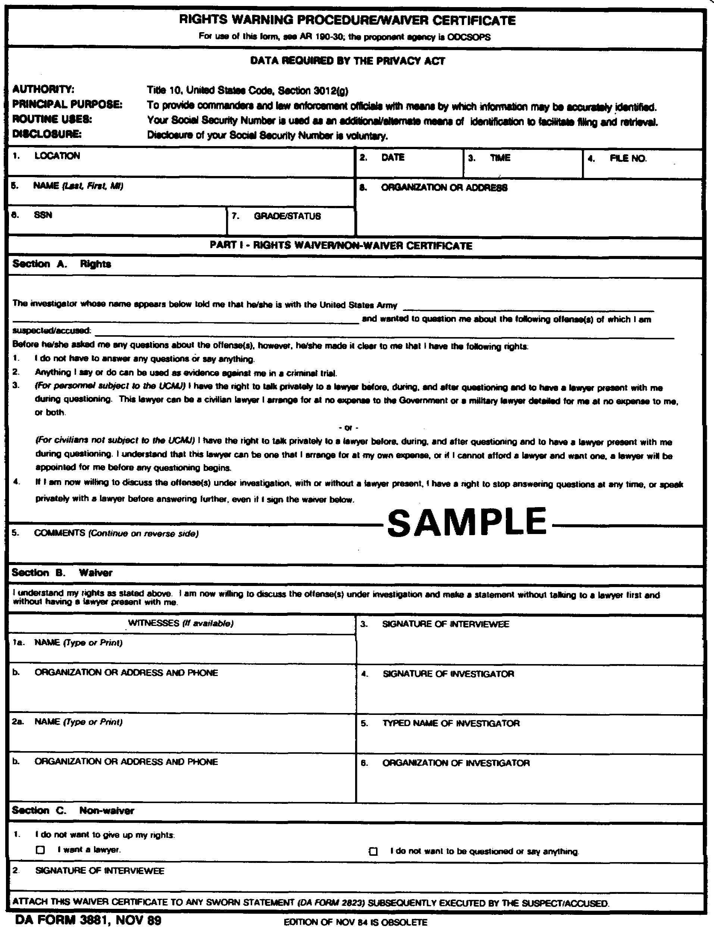
Figure 3-1. DA Form 3881 (front).

3-5 MP1016

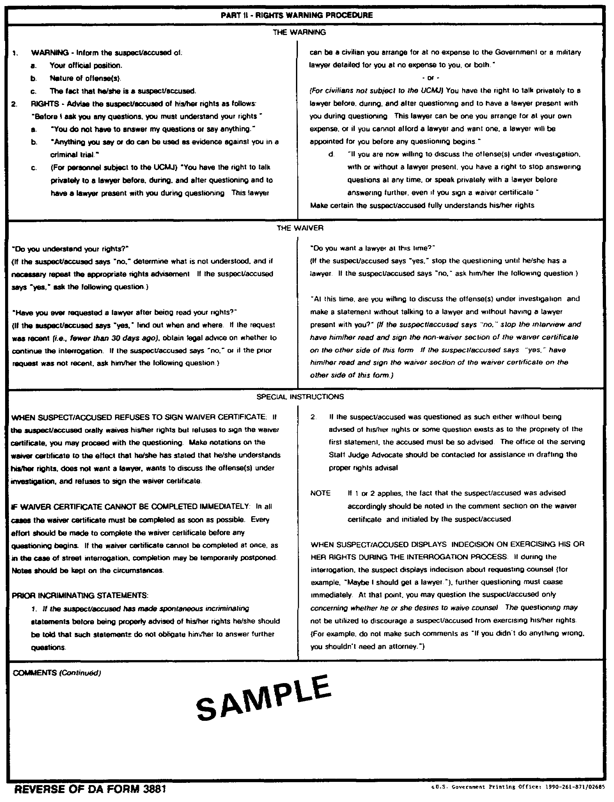
Figure 3-2. DA Form 3881 (reverse).

MP1016 3-6

EXAMPLE:

I, William T. ALFA, want to make the following statement under oath: At approximately 2000 hours on 19 Dec XX, I was on my way to my girl friend's house when I saw a 56 Dodge Sedan tear out from in front of the Post PX. I walked over by the front door and saw that it was wide open. I then went inside and called the military police desk.

(2) Question and Answer Form. This type statement is most useful when the SA is dealing with a stubborn person, or one whose low level of intelligence makes use of the narrative form impossible. This type is also useful when interviewing small children, or non-English speaking individuals through interpreters. In this type statement the SA's questions are followed by the maker's answers.

EXAMPLE:

I, William T. ALFA, want to make the following statement under oath:
Q: Where were you at approximately 2000 hours on 19 December XX?
A: I was over by the PX.
Q: Did you see anything unusual?
A: Yes, I saw a car tear out from in front of the PX as I walked up.
Q: Will you describe the car?
A: It was a 56 Dodge Sedan.
Q: What color was it?
A: It was black, etc.

(3) Combination Form. In this type statement, the SA will use the narrative form first and then switch to the question and answer method to clear up any discrepancies, or to add additional information.

EXAMPLE:

I, William T. ALFA, want to make the following statement under oath: At approximately 2000 hours, on 19 Dec XX, I was on my way to my girl friend's house when I saw a car tear out from in front of the Post PX. I walked over by the front door and saw that it was open. I then went inside and called the military police desk.

Q: Will you describe the individuals in the car?
A: I didn't see any of them close enough to do that.
Q: Will you describe their manner of dress?

3-7 MP1016

A: All three were dressed in Army uniforms.
Q: Did you see any rank or insignia?
A: No, etc.

b. Of the three types of statements, the combination form (narrative and question and answer) is considered to be the best method since it offers the most complete and descriptive account of what happened.

4. Format of Statements and Confessions.

a. Confessed criminals, or any witnesses, victims, or complainants, may have second thoughts about their confession or statement. They may deny their statement or their guilt, or claim they were forced or induced to give testimony. They may even say that they were forced to sign a blank piece of paper, and that their confession or statement was written after they had signed the paper. You must deny their claim and show that the statement or confession was freely and voluntarily given.

b. To aid you with proper statements and confessions, and to guard against a possible false accusation by the maker, the Department of the Army has developed two forms for use by CID investigators.

(1) DA Form 3881 (Figures 3-1 and 3-2), previously discussed, is used before obtaining a statement from persons accused or suspected of the offense.

(2) DA Form 2823 (Figure 3-3 and 3-4) is used to record all sworn statements, not only from the suspect, but from witnesses, complainants, or victims.

c. Body of Sworn Statement. The body of a statement or confession, whether it be on DA Form 2823 or not, has no definite form. The style may be either question-and-answer or narrative. If narrative, it should contain a complete chronological account of anything connected with the crime. The maker of the statement may be permitted to write it or dictate it, or you may write it for the maker being careful to keep within the limits of the maker's vocabulary, mode of expression, and range of knowledge. There are certain advantages and disadvantages in using each method. If the person is permitted to write or dictate a statement, he may be apt to leave out important details about the elements of proof. He may also wander from the details. You will usually prefer to write statements yourself, even though this is time consuming. After the complete statement has been prepared and is ready for signing, he should be given the chance to read it or have it read to him. He should also have a chance to make changes. When these are made, he should be asked to initial each one. You should make one or more intentional errors in statements you prepare for signature by a person suspected of an offense. When he corrects them, it tends to indicate that he read and understood his statement; if he fails to correct the intentional errors, they should be called to his attention and corrected. Each change should be numbered in sequence and initialed by the maker in the space provided at the bottom of each page of DA Form 2823.

MP1016 3-8

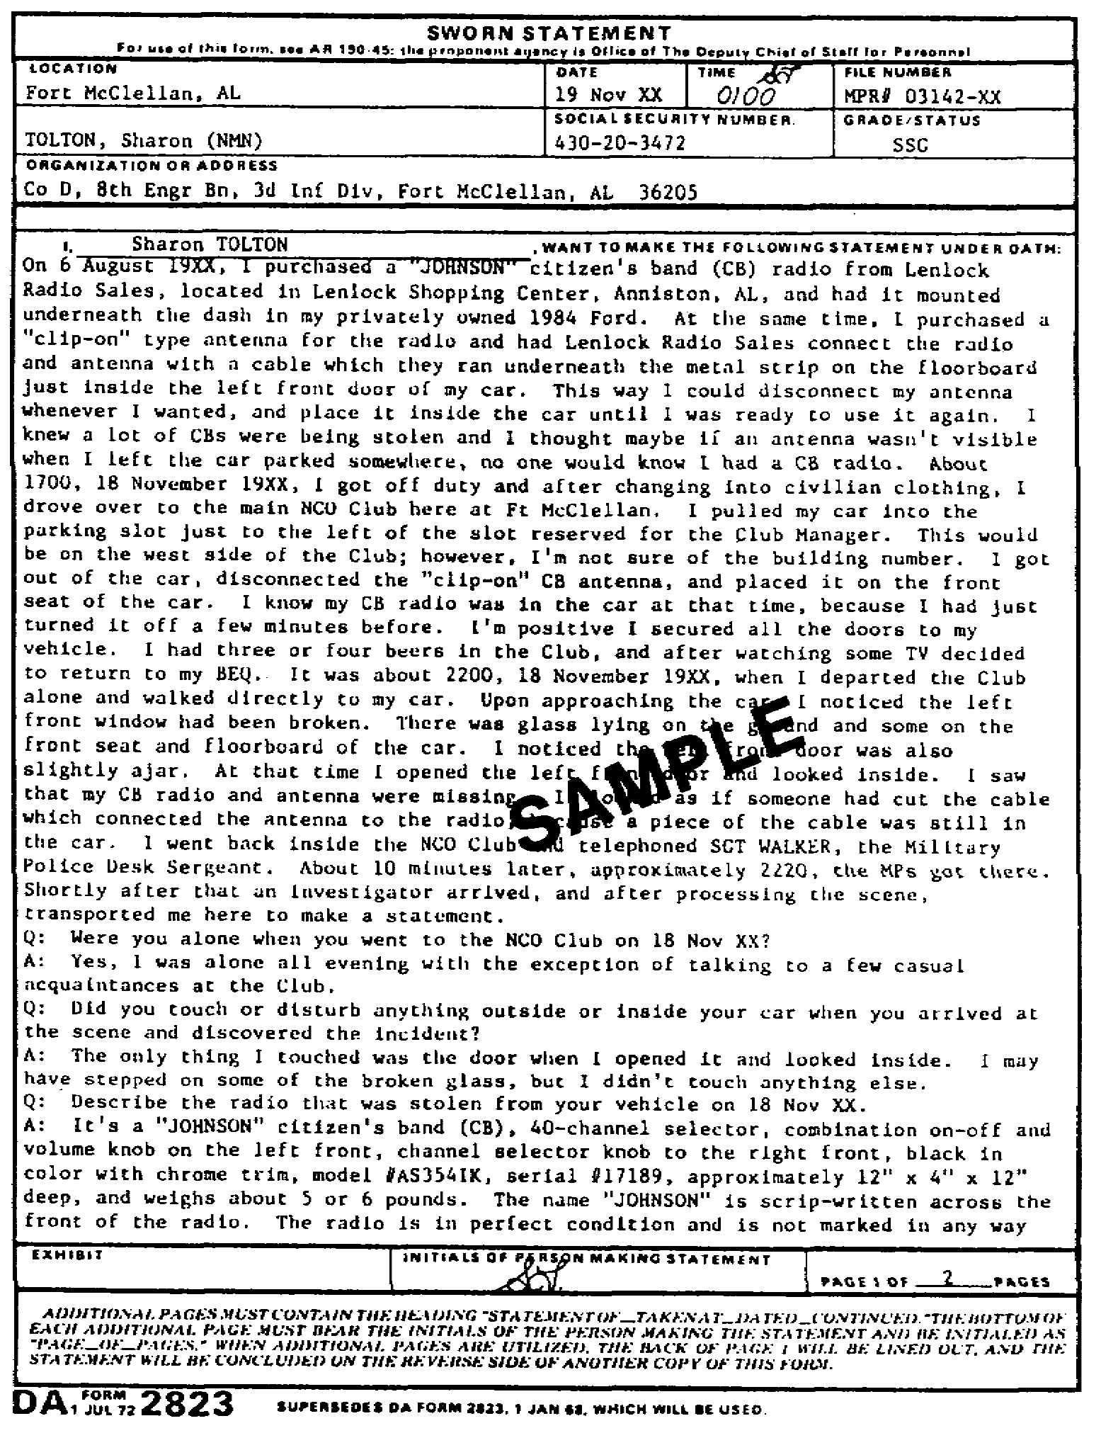
Figure 3-3. DA Form 2823 (front).

3-9 MP1016

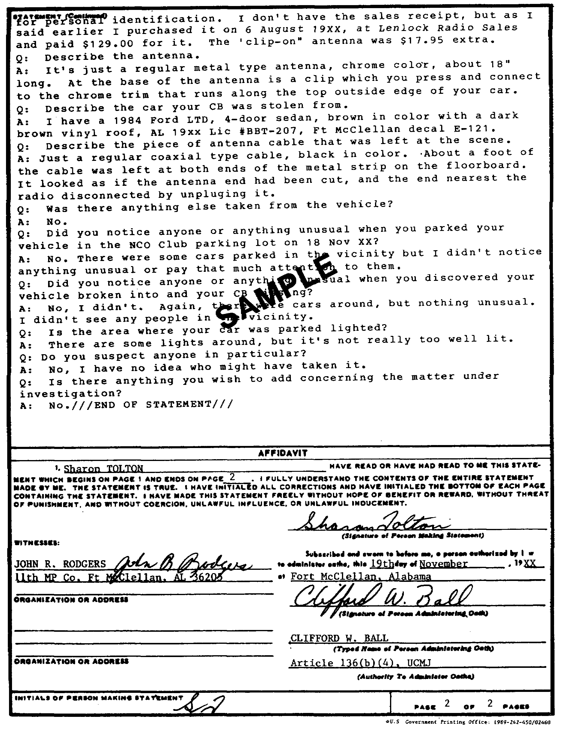
Figure 3-4. DA Form 2823 (reverse).

MP1016 3-10

d. The Affidavit. An affidavit is printed on the reverse side of the statement form. It is a statement by the maker that he has read, or has had read to him, the statement of a certain number of pages, that each page had been numbered and initialed by him, that all corrections or deletions have been initialed by him, and that it is a voluntary statement. His signature should be the same as the name identifying him in the heading of the statement. The reading and signing of a statement should be witnessed by someone other than the SA to whom the statement was made. The name and address of each witness should be typed or written in the space provided.

NOTE: See DA Form 2823 (Figures 3-3 and 3-4). The format is a completed heading and statement in the COMBINATION FORM; on the back, and the END OF STATEMENT and AFFIDAVIT.

5. Content and Preparation of Sworn Statements and Confessions.

a. A thorough criminal investigation should be conducted, background information on the maker should be collected, and all evidence or testimony should be evaluated.

b. A statement or confession should contain all the pertinent information that the maker is able to furnish about the crime or incident under investigation. This should NOT be limited to those matters on which the maker will be permitted to testify during a court-martial. Unrelated material, however, should never be sought or included in the statement or confession.

c. The heading or opening remarks of a sworn statement or confession should contain the following:

NOTE: Labeled spaces on DA form 2823 (Figures 3-3 and 3-4).

(1) Place, date, time, and file number of the place where the statement is taken.

(2) Complete identification of the maker to include: his full name, social security number, grade, and organization.

d. The affidavit should contain the following:

(1) Acknowledgement that the statement is made voluntarily.

(2) Signature of maker (identical to that used in heading).

(3) Signature of witness with name typed along with organization and address.

(4) Date and location where oath is taken.

(5) Signature of person administering oath with his name typed along with authority (Article 136 (b) (4), UCMJ).

3-11 MP1016

e. In the body of the statement of confession, the maker should always be referred to in the first person, even though the writer of the document may be the SA, or the stenographer. When a stenographer records a person's statement or confession, she should be briefed about the case and be given pertinent details, such as the maker's name and address, prior to entering the interrogation room. She should sit off to the side of the subject, and refrain from talking or asking any questions, except to ask the person to speak up or to repeat a point not heard.

f. When recording a confession, the only persons who should be present are the maker, the SA, and the stenographer. In addition to the psychological factor discussed in lesson one, there is the legal consideration of possible duress or coercion if too many witnesses are present.

g. Profanity or slang should not be in a statement unless they are key points and are the exact words of the maker. In some cases profanity may be the basis for the crime and is, therefore, essential to the statement.

h. Abbreviations should only be used when they are standard and accepted in the military service.

NOTE: If more pages are needed to complete the statement, blank, white 8 1/2" x 11" sheets will be used. To identify these pages the following heading will be used on each sheet:

STATEMENT OF CPL JOHN LEROY KLAXSON
TAKEN AT FORT MONMOUTH, NJ, DATED 22 MAR
XX CONTINUED

i. Once an oral statement or confession has been prepared in written form it should be signed immediately. A delay of a few hours or until the next morning may be too long. During the time before signing, the maker may have second thoughts, have talked to others, or have regained his resolve not to tell; he may even claim that he did not commit the crime or confess to it. Whenever a long delay follows the oral testimony and the signing of the written one, you should prepare a short, handwritten statement, a few sentences long, on the subject's testimony; this statement should, however, cover the main points of the confession statement. The subject should sign the handwritten statement upon its completion. This signed document may prevent a subject from having second thoughts or deny making the statement of confession.

j. Other suggestions regarding statements and confessions.

(1) A confession is not the end to an investigation. On the contrary, it may be only the beginning. Each confession must be supported by evidence gained through an independent investigation, as will be explained in paragraph 6d(l), established of corpus delicti.

(2) If a confession or statement was recorded by a stenographer,
her original (shorthand) notes should be kept. These notes may be useful if

MP1016 3-12

the confession or statement is attacked by the defense in any ensuing trial as not a true account of the actual statement or confession.

(3) To protect yourself against any possible charge of violation of Article 31, UCMJ, you should record the condition and circumstances under which the confession or statement was received. Record the condition of the interrogation room, the persons present, the witnesses, and time the interrogation was begun, the time it ended, and the time of the confession. It is also a good idea for you to have a general knowledge of the subject's activities once he came under police control; items such as the time he was picked up, or how long he was under police control prior to the interrogation or interview. Was he allowed to eat, smoke, drink, or use the latrine? Was the subject under undue restraint while in custody? The answers to these questions may have an effect on the validity of his statement of confession. If you are aware of any injustice to the subject, you should attempt to correct it before the interview or interrogation.

(4) If a subject is charged with more than one crime, or is confessing to more than one crime, you should make sure that each crime is a separate confession: one crime, one confession. The exception to this rule would be when the two crimes are so closely related, that the subject cannot discuss one without mentioning the other.

(5) A statement or confession should never refer to any past arrests or convictions.

6. Admissibility as Evidence.

a. Confessions and admissions are admissible as evidence during a trial as an exception to the hearsay rule. This is based on the theory that the accused should not be allowed to complain of a lack of opportunity to question his own credibility.

(1) Statements, on the other hand, fall under the hearsay rule, and, in general, are inadmissible as evidence if the person who made the statement is unavailable for cross-examination; the court cannot observe the person; and, the person was not under oath when the statement was made.

(2) Hearsay is an out-of-court statement offered in court in order to prove the truth of the matter stated.

b. In the obtainment of statements from suspects or accused and in the use of confessions or admissions in court, the criminal investigator is governed by the provisions of Article 31, UCMJ, and the Fifth Amendment to the U.S. Constitution. They provide that no person shall be compelled, in any criminal case, to be a witness against himself; no person shall be compelled to answer any questions, the answer to which may tend to incriminate him; and no person may compel any other person to incriminate himself.

(1) Neither the military policeman (MP) nor the criminal
investigator can compel a subject to give testimony, or to give an oral or

3-13 MP1016

written confession, if that confession or testimony will tend to incriminate him. To be valid testimony, a subject must cooperate, both mentally and physically, in supplying the information.

(2) The information must be freely and voluntarily given by the subject. The subject must have been warned of his rights, waived those rights, and consented to make a statement. A statement or other self-incriminatory evidence will not be admissible into evidence unless the voluntariness is established only if a good warning has been given and a proper waiver received.

c. On 13 June 1966, the U.S. Supreme Court decided Miranda v. Arizona, a decision which has had tremendous impact on the conduct of police interviews and interrogations, and on the voluntariness of the subject's statement or confession written by Chief Justice Warren, is reproduced here to aid the SA in ensuring that any statement taken by him will be valid and admissible in any court-martial.

"Presuming a waiver from a silent record is impermissible. The record must show, or there must be an allegation and evidence which show that an accused was offered counsel but intelligently and understandingly rejected the offer. Anything less is not a waiver."

There is, moreover, no room for the contention that the privilege is waived if the individual answers some questions or gives some information on his own prior to invoking his right to remain silent when interrogated.

Whatever the testimony of the authorities as to waiver of rights by an accused, the fact of lengthy interrogation or incommunicado incarceration before a statement is made is strong evidence that the accused did not validly waive his rights. In these circumstances, the fact that the individual eventually made a statement is consistent with the conclusion that the compelling influence of the interrogation finally forced him to do so. It is inconsistent with any notion of a voluntary relinquishment of the privilege. Moreover, any evidence that the accused was threatened, tricked, or cajoled into a waiver will, of course, show the defendant did not voluntary waive his privilege. The requirement of warnings and waiver of rights is fundamental with respect to the Fifth Amendment privilege and not simply a preliminary ritual to existing methods of interrogation.

The warning required and the waiver necessary are, in the absence of a fully effective equivalent, prerequisite to the admissibility of any statement made by a defendant. No distinction can be drawn between statements which are the direct confessions and statements which amount to "admission" to part or all of an offense. The privilege against self-incrimination protects the individual from being compelled to incriminate himself in any manner; it does not distinguish degrees of incrimination.

In dealing with statements obtained through interrogation, we do
not purport to find all confessions inadmissible. Confessions remain a
proper element in law enforcement. Any statement given freely and voluntarily

MP1016 3-14

without any compelling influence is, of course, admissible, in evidence. The fundamental impact of the privilege while an individual is in custody, is not whether he is allowed to talk to the police without the benefit of warning and counsel, but whether he can be interrogated. There is no requirement that police stop a person who enters a police station and states that he wishes to confess a crime, or a person who calls the police to offer a confession or any other statement he desires to make. Volunteered statements of any kind are not barred by the Fifth Amendment and their admissibility is not affected by our holding today.

d. Confessions and admissions then, are admissible into evidence when it can be shown that they are received without violation of a person's legal rights. However, prior to their admission into evidence before a military court-martial, the government must establish:

(1) Corpus Delicti. In the military a person cannot be convicted on the basis of only his confession. There must be independent evidence proving each element of the offense, except for the identity of the culprit. There must always be an independent criminal investigation, regardless of whether or not the accused has confessed.

(2) Proof of Voluntariness:

(a) Confession. Proof is required that it was voluntary prior to its admission into evidence.

(b) Admission. No proof of voluntariness is necessary unless the issue is raised by the defense.

7. Exclusionary Rule, Article 31d, UCMJ.

a. Confessions and admissions are damaging to the accused. They are difficult to defend against once entered into evidence. Special rules must govern their admissibility. The skilled SA and his supervisor must be aware of these rules and govern their conduct accordingly.

b. The exclusionary rule of Article 31, UCMJ, excuses any evidence obtained as a result of:

(1) Coercion. This is any physical or psychological force or threat thereof which deprives the person of the mental freedom to choose to speak or remain silent.

(a) Physical violence or threat thereof; e.g., threat to turn a rape suspect over to the victim's family.

(b) Mental pressures coming from other than the person's own conscience.

(c) Lack of food, sleep, toilet facilities, church attendance.

3-15 MP1016

(d) Prolonged interrogation will be strong evidence of coercion.

(e) Denial of the right to contact relatives or friends, or to receive visitors, phone calls, and letters.

(f) The point in time at which the statement is obtained - early in the investigation or late in the investigation specifically for the purpose of conviction - is important on the issue of coercion.

(2) Unlawful Influence. This is the use of superior rank to induce a statement or activity of a self-incriminatory nature, or the issuance of an order for that purpose.

(3) Unlawful Inducement. This exists when a statement is obtained from an accused by resorting to promises which are later disregarded. Examples:

(a) Statement will be held confidential.

(b) Charges will be dropped or reduced, including promise by victim (with SA's consent) not to press charges.

(c) Immunity will be granted.

(d) Implication that statement will be helpful to maker instead of harmful.

(e) Implying that conversation will be in private when room is "bugged."

(f) Promise that case will be closed.

If the promise is kept, then the person has received what he bargained for and has no grounds for complaint. This should be used only by experienced agents, and then only as a last resort.

c. Suppose, however, that an inexperienced agent obtains an improper confession. What can be done now?

(1) Improperly obtained confessions cannot be used in any way, directly as evidence, or indirectly as a source of other evidence.

(2) Another confession may be obtained by restoring the person's free will so that the confession is voluntary and not the product of the prior inadmissible confession.

(3) The following is a suggested procedure.

(a) Inform person that prior statements cannot be used against him in any way.

MP1016 3-16

(b) Give proper warnings.

(c) Obtain waiver, if possible.

(d) Proceed with proper questioning session.

(4) The government will bear the burden of proving, in order to use the second confession, that the "cat was back in the bag" before it was made. Similar problems and approaches may be used when confessions have been obtained through the use of the "fruits" of an illegal search.

8. Summary. If the SA is to make maximum use of the information obtained during an interview or interrogation, it must be recorded. The best record would be a sound recording, and whenever possible, one should be made. A sound recording, though, it not always practical, possible, or useful; a written transcript is, however. Therefore, for the SA to capitalize on the information obtained, he must transcribe that oral testimony into written form. It is not enough that he has the information or knows of a person's guilt. That information must be available to others, such as: the reviewer of CID reports is to make proper disposition in the case; and the trial and defense counsels if they are to ensure complete justice. The written statement, when properly received and recorded, can provide them with that information.

3-17 MP1016

LESSON 3

PRACTICE EXERCISE

REQUIREMENT: The following questions are multiple choice. There are four choices to each. You are to select the one that is correct. Indicate your choice by CIRCLING the letter beside the correct choice directly on the page. This is a self-graded lesson exercise. Do not look up the correct answer from the lesson solution sheet until you have finished. To do so will endanger your ability to learn this material. Also, your final examination score will tend to be lower than if you had not followed this recommendation.

GENERAL SITUATION. As a special agent assigned to Fort Blank Field Office, Third Region, United States Army Criminal Investigation Command (USACIDC), Fort Blank, you are investigating the larceny of $500 worth of government property (Article 121, UCMJ). The larceny occurred at approximately 2000, 7 Dec XX. The items taken were from the Fort Blank maintenance yard and included tool sets, lumber, a five kilowatt generator, and a welding set.

SPECIAL SITUATION. You are now preparing to question a suspect in the larceny in hopes of obtaining a statement of confession. The maker of the statement is a 25-year-old Army sergeant, Sergeant Tango, from Los Angeles, California. He is a college graduate, has been in the Army four years, and works as the issue officer in the maintenance area. Although you have no evidence linking the sergeant to the crime, he is a prime suspect since you believed it to be an inside job. You have also learned that Sergeant Tango owes approximately $400 in pressing debts which he cannot pay. The sergeant has professed his innocence and wants to make a statement to clear up his involvement.

1. Which one of the following would be the DA Form(s) used to investigate Sergeant Tango's involvement in the crime?

A. DA Forms 3881 and 2823, because the sergeant is suspected of committing a crime.

B. DA Form 2823 because the sergeant has knowledge of a crime.

C. DA Form 3881 and 2823, because the suspect is a member of the military.

D. DA Form 2823 because the suspect is willing to tell what he knows about the crime in question.

MP1016 3-18

2. Which type of form or statement would you consider best to use recording Tango's statement?

A. Narrative form.

B. Combination form.

C. Manuscript form.

D. Question and answer form.

3. Since SGT Tango is willing to talk, you conduct an interview. You should consider the information he gives you during this interview as:

A. a statement.

B. a confession.

C. an oral assertion.

D. self-incrimination.

4. What provisions of the law are most applicable to SGT Tango?

A. Article 31 and the Sixth Amendment.

B. Fifth and Sixth Amendment.

C. Article 31.

D. Article 98.

5. While listening to SGT Tango's oral statement regarding his activities on the night of the larceny, the suspect mentions a pertinent fact that would be hearsay evidence during any ensuing court-martial. What should you do with this fact?

A. Include it in the statement only if the statement will not be used as evidence in a court-martial.

B. Exclude it from the statement.

C. Include it in the statement.

D. Exclude it from the statement if it cannot be substantiated by other independent evidence.

3-19 MP1016

6. You decide to write SGT Tango's statement for him. Which of the following statements would you use in describing Tango's activities?

A. On 7 Dec XX, SGT Tango spent the night with a friend, one SFC Alfa.

B. I spent the night of 7 Dec XX with an old friend, SFC Alfa.

C. SGT Tango, on 7 Dec XX, spent the night with a friend.

D. According to SGT Tango, he and SFC Alfa were together all night Sat, 7 Dec XX.

SPECIAL SITUATION. You have obtained SGT Tango's statement and have checked his alibi for the night in question. You are not convinced that SGT Tango did not commit the larceny. Approximately a day later you were sitting at your desk trying to decide where to check next in the larceny case, when a worker from the maintenance yard came into the office. He sat down next to your desk and told you that he had some important evidence on the larceny. You started to ask him his name when he blurted out that he committed the crime and didn't know why he did it, and that he has never been in trouble before; then he started to cry. You finally got him to stop crying, gave him a cup of coffee, and took him to the interrogation room. You found out that his name was Charlie Foxtrot, a civilian worker in the maintenance yard, 39 years old, single, and with an IQ approximately 85. He lives in the city adjacent to Fort Blank, and has worked for the Army for 10 years. He has no criminal record.

7. What is the status of Foxtrot's confession to the crime given to your prior to a warning or waiver?

A. It would be admissible evidence in any trial.

B. It could only be used as admissible evidence in a trial by court-martial.

C. It would not be admissible evidence in a trial since he was not warned of his rights.

D. It would not be admissible evidence in a trial, because it is hearsay evidence.

MP1016 3-20

8. After Foxtrot's confession, prior to further questioning of Foxtrot, you should advise him of his rights using which of the following forms?

A. DA Form 2823.

B. DA Form 3881.

C. Either DA Form 3881 and DA Form 2823.

D. DA Form 3975.

9. What is the name given to the substantial and fundamental fact necessary to prove that Foxtrot committed the crime?

A. Confession.

B. Conviction.

C. Corpus delicti.

D. Substantial evidence.

10. If Foxtrot is willing to provide a statement confessing to the offense under investigation, which form would you utilize to document the statement of Foxtrot?

A. DA Form 3881.

B. DA Form 3975.

C. DA Form 2823.

D. DA Form 3638.

11. What should you do if the stenographer's typed copy of the confession contains errors?

A. Have the stenographer retype the statement.

B. Have the suspect correct and initial it.

C. Correct and initial all errors yourself.

D. Disregard the errors.

3-21 MP1016

12. Approximately two hours have elapsed since the close of the questioning and the complete typing of the confession. In the interim, Foxtrot has been turned over to the military police to be taken to supper. Which statement is correct in regard to the signing of the confession?

A. The confession should be signed as soon as possible after the subject returns from the dining facility.

B. You should wait until morning, after Foxtrot has had a good night's sleep.

C. A lapse of a few hours will not matter in getting the confession signed.

D. Since this was a voluntary confession, there is no need to hurry to get it signed. It can even be signed the next day.

13. Which two or more of the following would be correct after you have Foxtrot's confession signed by him and yourself?

I. Have the confession witnessed.

II. Write your report of investigation and close the case.

III. Substantiate the confession with other evidence.

IV. Ensure that the stenographer's shorthand notes of the confession are destroyed.

V. Jot down the conditions under which the confession was obtained.

A. I, III, IV, V.

B. I, III, V.

C. I, II.

D. II, V.

14. Which of the following should you check when reviewing Foxtrot's statement?

A. Foxtrot's initials are at the bottom of each page of the statement containing the confession.

B. Foxtrot has signed the rights certificate portion of DA Form 2823.

C. The confession is admissible in a court of law.

D. The confession is not more than two pages long.

MP1016 3-22

15. Foxtrot's confession required more than one sheet of paper. What heading should be placed at the top of each additional sheet?

A. Confession of Charlie Foxtrot
Taken by CID Special Agent Alfa
Ft Blank, Resident Agency

B. The following is a continuation of the confession of Mr. Charlie Foxtrot, dated 14 Dec XX

C. Statement of Mr. Charlie Foxtrot
Taken by CID Agent Alfa
Dated 14 Dec XX

D. Statement of Mr. Charlie Foxtrot
Taken at Ft Blank
Dated 14 Dec XX Continued

16. Which of the following would be correct for completion of the affidavit portion of the DA Form 2823?

A. Date block would be the date crime was committed.

B. Signature of person administering oath should be an officer of Staff Judge Advocate's Office.

C. Signature of person making statement is the investigator's signature taking the statement.

D. Your signature as Signature of Person Administering Oath.

17. Suppose that, after you had given Foxtrot a cup of coffee, he requested to use the latrine prior to being questioned. In your zeal to obtain his confession you refused his request, but promised that he could right after he told his story again, this time with a stenographer present. Foxtrot again asked to use the latrine, and again you refused. Foxtrot then gave his confession, and was allowed to relieve himself. What, if any, factor may be present to exclude Foxtrot's confession from a trial?

A. None.

B. Coercion.

C. Duress.

D. Unlawful inducement.

3-23 MP1016

18. Which one of the following is correct as to the affidavit part of the statement form?

A. It indicates that the maker has made a voluntary statement.

B. It shows that the maker was warned of his rights, waived his rights, and consented to make a statement.

C. It need only be completed when the maker of the statement is a suspect or accused.

D. It should not be completed when the statement form is used to record a confession.

19. What should you do if you must write the statement for the maker?

A. Use only correct English.

B. Be careful to complete the statement in the language of the maker.

C. Write the statement in your own words.

D. Include profane language if the maker uses it to emphasize points.

MP1016 3-24

LESSON 3

PRACTICE EXERCISE

Answer Key and Feedback

Item Correct Answer and Feedback

1. A. DA Forms 3881 and 2823, because the sergeant is suspected of committing a crime.
To aid you with proper... (page 3-8, para 4-1&2)

2. B. Combination form.
In this type statement... (page 3-7, para 3).

3. A. A statement....
a written or oral assertion... (page 3-2, para 1-3).

4. A. Article 31 and the Sixth Amendment.
U.S. Constitution, Amendment... (page 3-3, para 2&3).

5. C. Include it in the statement.
A statement or confession... (page 3-11, para 5b).

6. B. I spent the night of 7 Dec XX with an old friend, SFC Alfa.
In the body of the statement... (page 3-12, para 5e).

7. A. It would be admissible evidence in any trial.
Confessions and admissions are... (page 3-13, para 6a).

8. B. DA Form 3881.
Review the Rights and... (page 3-4, para 2).

9. C. Corpus delicti.
The substantial and fundamental.. (page 3-2, para 1-7).

10. C. DA Form 2823.
Body of Sworn Statement... (page 3-8 para 4c).

11. B. Have the suspect correct and initial it.
He should also have... (page 3-8, para 4c).

12. A. The confession should be signed as soon as possible after the subject returns from the dining facility.
Once an oral statement or confession... (page 3-12, para 5i).

13. B. I, II, V Have the confession witnessed, substantiate the confession with other evidence, and jot down the conditions under which the confession was obtained.
To protect yourself against any... (page 3-13, para 5-3).

3-25 MP1016

14. C. The confession is admissible in a court of law.
Confessions and admissions are... (page 3-13, para 6a).

15. D. Statement of Mr. Charlie Foxtrot
Taken at Ft. Blank.
Dated 14 Dec XX continued
If more pages are needed... (page 3-12, para 5h).

16. D. Your signature as signature of person administering oath.
Signature of person... (page 3-11, para 5d).

17. B. Coercion.
This is any physical or...(page 3-15, para 7-1).

18. A. It indicates that the maker has made a voluntary statement.
It is a statement by... (page 3-11, para 4d).

19. B. Be careful to complete the statement in the language of the maker.
Profanity or slang should not be... (page 3-12, para 5g).

MP1016 3-26

LESSON 4

COORDINATE POLYGRAPH REQUESTS

CRITICAL TASK: 191-390-0134

OVERVIEW

LESSON DESCRIPTION:

At the end of this lesson, you will be able to:

1. Discuss the basic operation of the polygraph.

2. Discuss the prerequisites of authorization for a polygraph examination.

3. Identify the limitations and capabilities of the polygraph.

4. Utilize polygraph examinations.

5. Discuss the legal aspects of polygraph utilization.

TERMINAL LEARNING OBJECTIVE:

ACTION: Coordinate polygraph examinations.

CONDITION: You will have this subcourse, pencil, and paper.

STANDARD: You must complete all exercises for each lesson, take the final examination and obtain a score of at least 75 percent correct answers.

INTRODUCTION

1. INTRODUCTION.

a. The modern special agent (SA) has numerous technical investigative aids available to assist him in his quest for the facts of a crime or incident. One of these is the polygraph. This is not an electrical device that detects lies or truth, but is an instrument on much the same order as the electroencephalograph, electrocardiograph, or the X-ray. With it, a competent polygraph examiner can ascertain truth or deception.

b. In order for the SA to obtain the greatest value from the polygraph,
he should know its capabilities and limitations; the assistance he can render
the examiner; and the directives and regulations pertaining to its use.
Remember that a polygraph instrument can only be of value when utilized

4-1 MP1016

properly, and is not a substitute for a thorough investigation or as a crutch for a poor one.

2. Definitions.

a. Polygraph. An instrument designed to continuously record the occurrence of physiological phenomena of the human body on a moving chart. The standard Army polygraphs record pulse and blood pressure variations, respiration rate and relative volume, and changes in skin resistance (Figure 4-1).

b. Polygraph Test. A series of relevant, irrelevant, and control questions prepared by the examiner, for the matter under investigation, and asked of the person being examined.

c. Authorizing Representative. Persons who may approve the conduct of a polygraph examination are designated under the provisions of AR 195-6. Polygraph examination authorization for CID: "Polygraph examinations will be authorized by the Commanding General, USACIDC. The redelegation: Deputy Commander, USACIDC; Director, US Army Crime Records Center (USACRC), USACIDC; Chief, Polygraph Office, USACRC; Commander, Second Region, USACIDC; Commander, Seventh Region, USACIDC; and Commanders of the First, Third, and Sixth Regions, USAIDC, only in emergencies."

3. Theory. The polygraph technique is based upon the theory that a conscious mental effort on the part of a normal person to deceive causes a physical change within him which may be detected and recorded by the polygraph instrument. The polygraph does not, and cannot, detect truth or deception. It produces a chart record of the physiological changes caused by a person's emotional responses during the test. From the chart record an examiner may form an opinion that an examinee was not emotionally disturbed by the questions during the test and was therefore, truthful. He may form an opinion than an examinee was deceptive since physical responses were present as a result of the emotional disturbance caused by the questions. Interpretation of test charts depends upon the training, experience, capabilities, and skill of the examiner.

MP1016 4-2

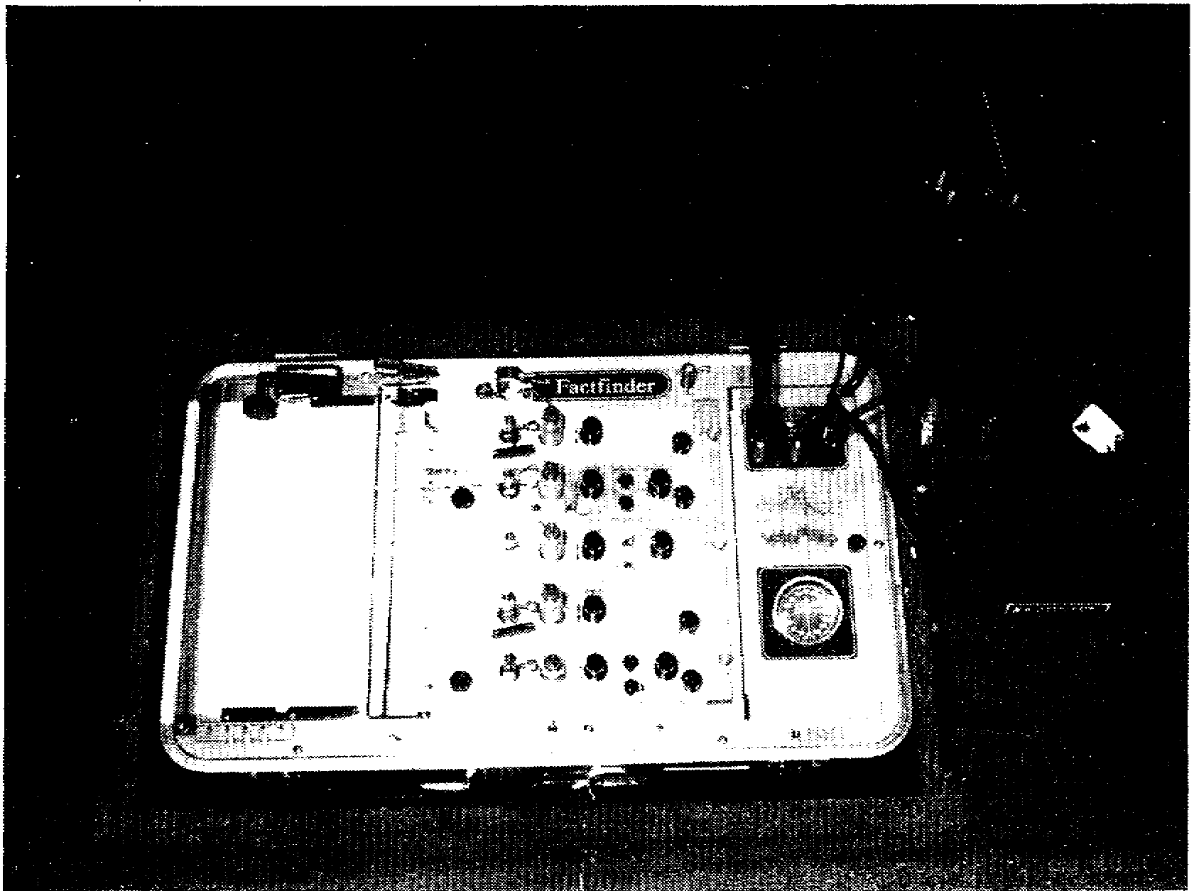
Figure 4-1. Polygraph.

4. Operation of the Polygraph.

a. The polygraph does not ring a bell, flash a light, or produce some other quick response when the examinee tells a lie. What it does is record within on a paper strip or chart the changes of relative blood pressure, pulse rate, galvanic skin reflex (skin resistance), and respiration cycles of examinees under controlled conditions. There are several types of polygraphs available. They all basically operate in the same manner. They all have as the most important factor involved in their use, the ability and integrity of the examiner.

b. The operation and attachment of the polygraph instrument is as follows:

(1) Pneumograph Components. The pneumgraph tubes are ten-inch corrugated rubber tubes that are fastened around the examinee's chest and abdomen. During the test, as the examinee's lungs expand with each inhalation of air, the tubes stretch, and as the examinee exhales, they contract. This movement produces pressure changes in the tubes that are transmitted through rubber hoses to recording units which move pens on the chart paper.

4-3 MP1016

(2) Galvanograph Component. The Galvanic Skin Reflex (GSR) is measured by attaching a set of electrodes to the surface of the hand, or to the fingers of the hand. By means of the passage of an imperceptible electrical current through the hand or fingers bearing the electrodes, the galvanograph unit records the variations in the flow of the electrical current.

(3) Cardio-sphygmograph Component. A blood pressure cuff, or the type used by physicians, is fastened around one of the examinee's arms. When cuff is inflated, it monitors changes in the mean blood pressure and heart rate. The impulses are received from the examinee's arm through the cuff and tubing, past a sphygmomanometer (pressure recording device) to a sensitive bellows system that operates another recording pen. Heart pulsations also appear on their part of the chart recordings. Sometimes the pulse signal is split to a second electronically enhanced recording unit.

(4) Kymograph Component. This component moves the chart paper at a timed rate of speed, 6 inches a minute on present instruments, so that the blood-pulse pressure, respiration, and GSR can be continuously recorded all at one time.

c. Polygraph records will usually permit a competent examiner to draw a reliable conclusion about the examinee's truth or deception.

5. Authorization of a Polygraph Examination.

a. A polygraph examination cannot be conducted without authorization as designated by AR 195-6.

b. The agency requesting authorization for a polygraph test submits, to the authorizing representative, an electrical message for approval prior to the conduct of the test. In the event message facilities are not available a DA Form 2805 (Polygraph Examination Authorization) may be used.

c. The authorizing representative will make a decision, and so indicate on a return message to the requestor.

d. The request must indicate that:

(1) The investigation by other means has been as thorough as possible. The development of more information by means of a polygraph test are essential.

(2) The offense for which the request is submitted is punishable under the Manual for Courts-Martial for a term of one year or more.

(3) The person to be tested has been interviewed under rights advisement. There is reasonable cause to believe that he has criminal involvement and/or knowledge in the matter under investigation. That the person to be examined has consented to a polygraph examination.

MP1016 4-4

(4) Names of persons polygraphed were previously authorized for the same case.

(5) Names of persons previously tested on the same case, and the name of the examiner, date of the test, results, and quality control results (if known).

(6) The proposed test is to be conducted as per AR 195-6.

e. Requests submitted by elements outside USACIDC to USACIDC CONUS field elements will be forwarded with recommendations to USACRC for action. Request for polygraph assistance from others, such as investigating officer/boards, inspector general, other government agencies, or other civilian law enforcement agencies, may be approved by the authorizing representative, provided the requirements of AR 195-6 are met. Care must be taken in approving requests from civilian law enforcement agencies to ensure that the Posse Comitatus Act is not violated.

6. The Role of the Investigator.

a. To a large measure, the success of any polygraph test will depend upon the investigator. If the case has not been investigated properly, the polygraph may not contribute to its successful conclusion. He must orient his investigation upon evidence secured through skill and technique, rather than upon an expected self-disclosure through the polygraph test; however, he should never discount the polygraph. He should make a thorough effort to interrogate any person suspected of lying before submitting a polygraph request.

b. The investigator must obtain the authorization for the examination from the authorizing representative. When this has been approved, he presents a copy of the message of approval to the examiner for the polygraph case file.

c. The investigator must be able to brief the examiner on minute details. General facts, theories, and suspicions are not enough; the examiner must have detailed, verified facts. He should make available to the examiner the personnel records of the person and all statements, documents, and evidence. Some of the information the examiner must have include the:

(1) Specific articles or exact amounts of money stolen.

(2) Exact time the offense occurred.

(3) Peculiar aspects of the offense or any strange or obscene act committed at the scene.

(4) Known facts about a suspect's actions or movements.

(5) Facts indicating a connection between suspects, victims, and witnesses, especially when they deny any connection.

4-5 MP1016

(6) Exact type of firearm, weapon, or tool used.

(7) Results of laboratory tests.

(8) Background information pertaining to the person.

d. He should inform the examiner of any unpublicized facts which could be known only to the victim or the offender. This could include the exact amount of money stolen, the caliber or make of the weapons used, or the means of entry. These will enable the examiner to construct specific tests which may provide accurate reactions and results.

e. The investigator, with the examiner, should set the exact time, date, and place of the test. He should brief the examinee on the night prior to the test, emphasizing that he should get plenty of sleep and not drink any alcohol or take any drugs. On the day of the test, he should accompany the examinee to the place of the test and introduce him to the examiner. During the test, the investigator should remain there. If the room is equipped with sound equipment or a two-way mirror, he should watch and listen to the test. If required, he should arrange for the examinee's meals. If the examinee is a female, a female witness must be present.

f. Practices that the investigator must guard against include the following:

(1) Never conduct a prolonged interrogation of the examinee just before a polygraph test.

(2) The polygraph technique should never be described as infallible.

(3) The polygraph instrument will not be used as a psychological prop in conducting interrogations.

(4) A prospective examinee should never be informed that his innocence or guilt will be decided based on the results of the test. Courts will make this decision; the polygraph can only assist in the process.

(5) Do not request a mass screening of possible suspects (entire companies, platoons, or large groups) to produce a real suspect. This violates the policy of the Department of the Army, in that all investigative techniques and procedures have not been applied, leads exhausted, and normal investigations completed.

(6) Consult the examiner when in doubt about a person's fitness. The examiner will, in turn, consult with medical, legal, or other personnel, if necessary.

(7) Never assume the investigation is completed with the
polygraph examination. Information from the use of the polygraph normally leads to

MP1016 4-6

facts which must be collected or evaluated for completion of the investigation.

7. Obtaining the Person's Consent to Take a Test.

a. The success of a polygraph test will also depend in part on how the examinee was treated before he was asked to take it, and how he was treated while awaiting it. Talk openly and freely to the examinee about the test.

b. To aid in obtaining a person's comment to a polygraph test;

(1) Offer it as a means of establishing the truthfulness of the person's statements.

(2) Describe the polygraph as a "champion of the innocent" or a "truth verifier" rather than a "lie detector."

(3) Depict the examiner as a "searcher for truth."

(4) Assure the person that the examiner is a qualified person who is impartial toward all the persons involved in the case.

(5) Explain that all polygraph tests are voluntary.

c. On the other hand, the investigator should avoid any claim for the instrument or the operator that is not backed up by fact. Never use a request to take a polygraph test as a bluff or as a means of exerting pressure. Offer a polygraph just before saying "Goodbye" to a suspect.

d. If the person objects to a polygraph test, determine the cause (fear, nervousness, misconception). Arrange a consultation between the person and the examiner so that the examiner may assist in overcoming his objections.

8. Responsibilities of the Polygraph Examiner.

a. He must conduct the test in accordance with regulations. The objective is to assist the investigators; it may be requested as a means of freeing from blame. In either case, it must be given under controlled conditions. The examiner cannot, and must not, conduct a competent test when, in his opinion, the examinee is:

(1) Mentally or physically fatigued. This precludes a successful test, since the best precept depends upon his ability to respond physically to mental stimuli.

(2) Unduly emotionally upset, intoxicated, or under the influence of narcotics, marijuana, or dangerous drugs. Any of these conditions work to the detriment through modification of physical response.

(3) A known addict to narcotics. This does not preclude the examination of rehabilitated addicts.

4-7 MP1016

(4) Known to have a mental disorder. Psychosis and severe neurosis and, in some instances, pathological behavior patterns render a person unfit for the examination.

(5) Having great physical discomfort or physical disabilities or defects which might cause abnormal responses.

(6) Below the age of reason. Young children who have not matured to a full misunderstanding of responsibilities are not suitable examinees.

(7) Unable to communicate. The examiner and the person must be able to understand and communicate with each other, if necessary, through an interpreter.

b. Practices that the polygraph examiner must guard against include the following:

(1) He cannot conduct a test unless it has been authorized.

(2) He cannot probe into thoughts or beliefs, or ask questions which are not relevant to the offense or the technique. Areas which should not be probed, unless relevant, include religious beliefs and affiliations, racial matters, political beliefs and affiliations of a nonsubversive nature, and opinions of legislative policies. The examiner uses control questions which may not appear related to the offense in question; however, these are an essential part of the technique, and are used to validate the interpretation of the test charts. These questions though, must not be from the prohibited lists.

(3) He cannot try to identify himself as other than an examiner by the wearing of a laboratory coat to create a clinical effect, or by making statements that he is other than a polygraph examiner.

(4) He cannot attempt to make a physical or psychiatric diagnosis.

(5) He cannot examine any person when, in his opinion, that person is not a suitable subject. If any doubt or question exists in his mind, the test will be postponed pending physical or mental evaluation of the person by competent medical authorities.

(6) He cannot examine personnel of the Department of the Army, or personnel outside the Department of the Army, requiring access to classified information except as authorized by AR 195-6.

9. The Pretest Interview.

a. The polygraph examiner should greet the examinee in a friendly, business-like manner, introduce himself as a special agent, display his credentials and badge, and state that he is a certified polygraph examiner. He must then, before any test can take place, explain to the person his following rights:

MP1016 4-8

(1) That he is informed of the offense for which he is suspected or accused and the purpose of the test.

(2) That he has the right to consult with counsel and to have counsel present to observe the test. That he may retain counsel at his own expense or have counsel appointed for him at no expense to him.

(3) That he has the right to remain silent. That any statement he may make may be used as evidence against him in a criminal trial. This is a restatement of a person's rights per Article 31, MCM, and the Fifth Amendment to the U.S. Constitution.

(4) That the test is voluntary and will be conducted only with his prior written consent (DA Form 2801, Polygraph Examination Statement of Consent, Figure 4-2), and that no adverse action will be taken against him because of a refusal to consent to a test.

(5) Whether the area in which the test is to be conducted contains a two-way mirror or other device whereby he can be observed without his knowledge; and whether the test will be monitored in whole or in part by any means.

b. After the examinee has been advised of his rights and has given his verbal consent to undergo the test, he will read and sign DA Form 2801, Polygraph Examination Statement of Consent. Persons refusing to submit to a test will not be required to sign any type of statement of refusal. No adverse action can be taken against any person that refuses to consent, and no record of his refusal will be filed in any personnel files, to include informing the company commander.

c. The remainder of the pretest interview will be devoted to completing CID Form 2, Polygraph Worksheet (see Figures 4-3 and 4-4); providing an explanation of the nature of the test; reviewing all questions to be asked during the test; and explaining the complete operation of the instrument. When the examiner feels the subject is ready, he is to proceed into the testing phase.

10. The Polygraph Test.

a. This must be conducted in a quiet, private place, with only the examiner and the examinee present. (An exception to this would be when the examinee desires to have his counsel present, or in the case of a female who desires to have another female present, who would observe from a separate room). A soundproof room is best, but a regular interview room or other private room may be used. A room near an area with a relatively high noise level should never be used. The room should be free of distracting objects such as pictures, calendars, wall ornaments, or unusual furnishings.

4-9 MP1016

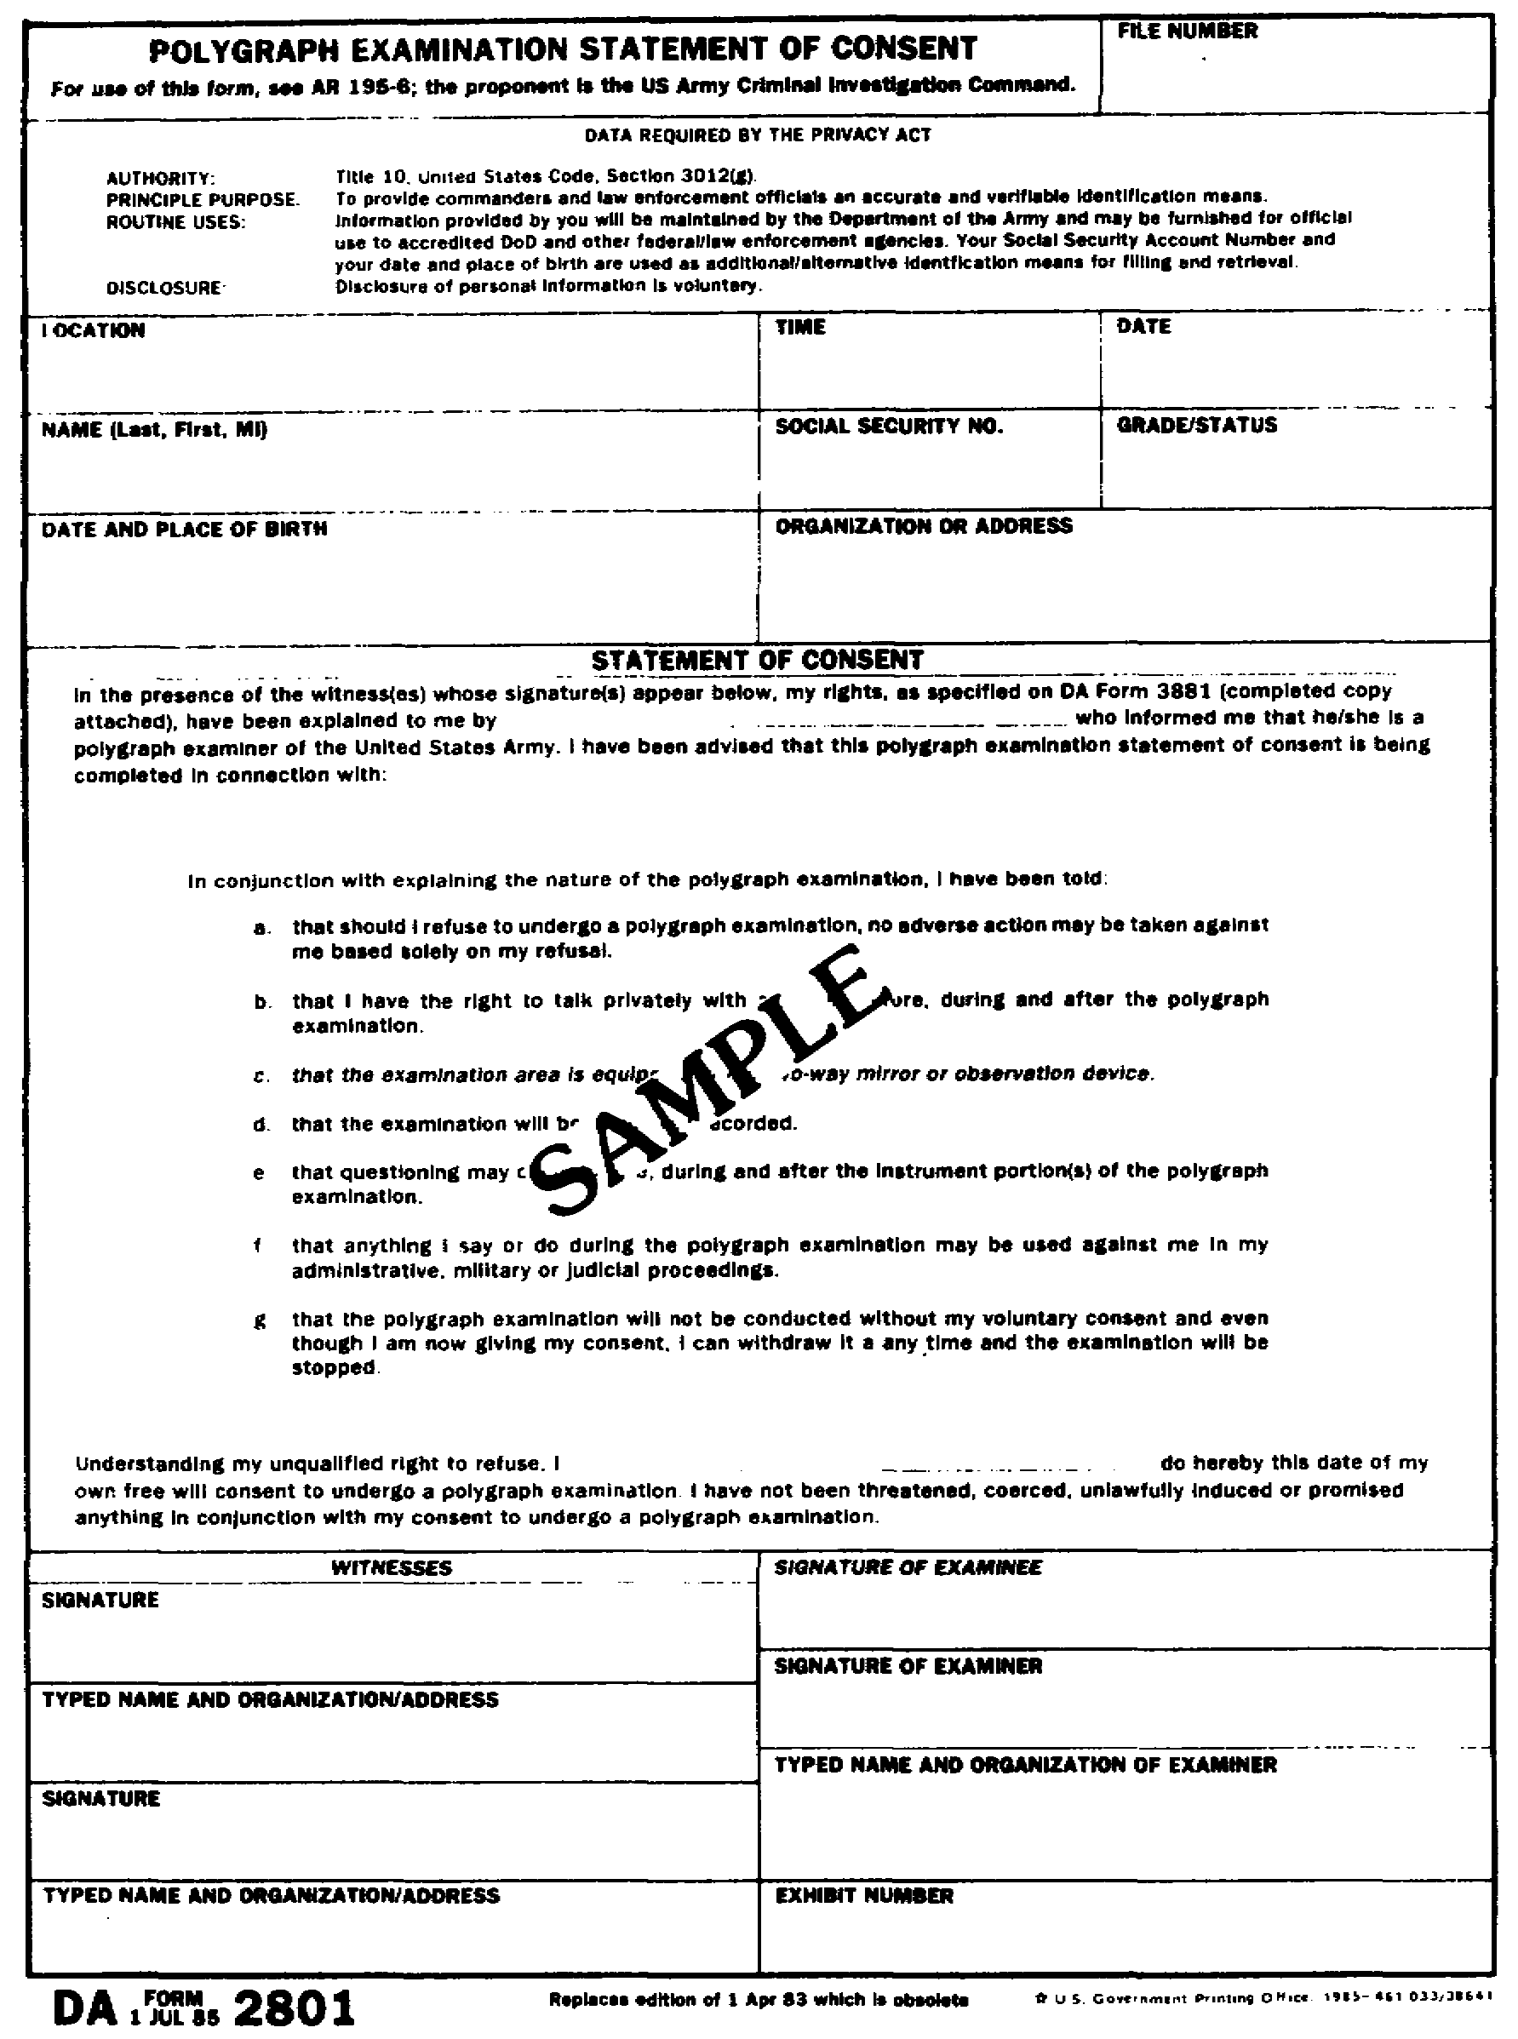
Figure 4-2. Polygraph Examination Statement of Consent,
DA Form 2801.

MP1016 4-10

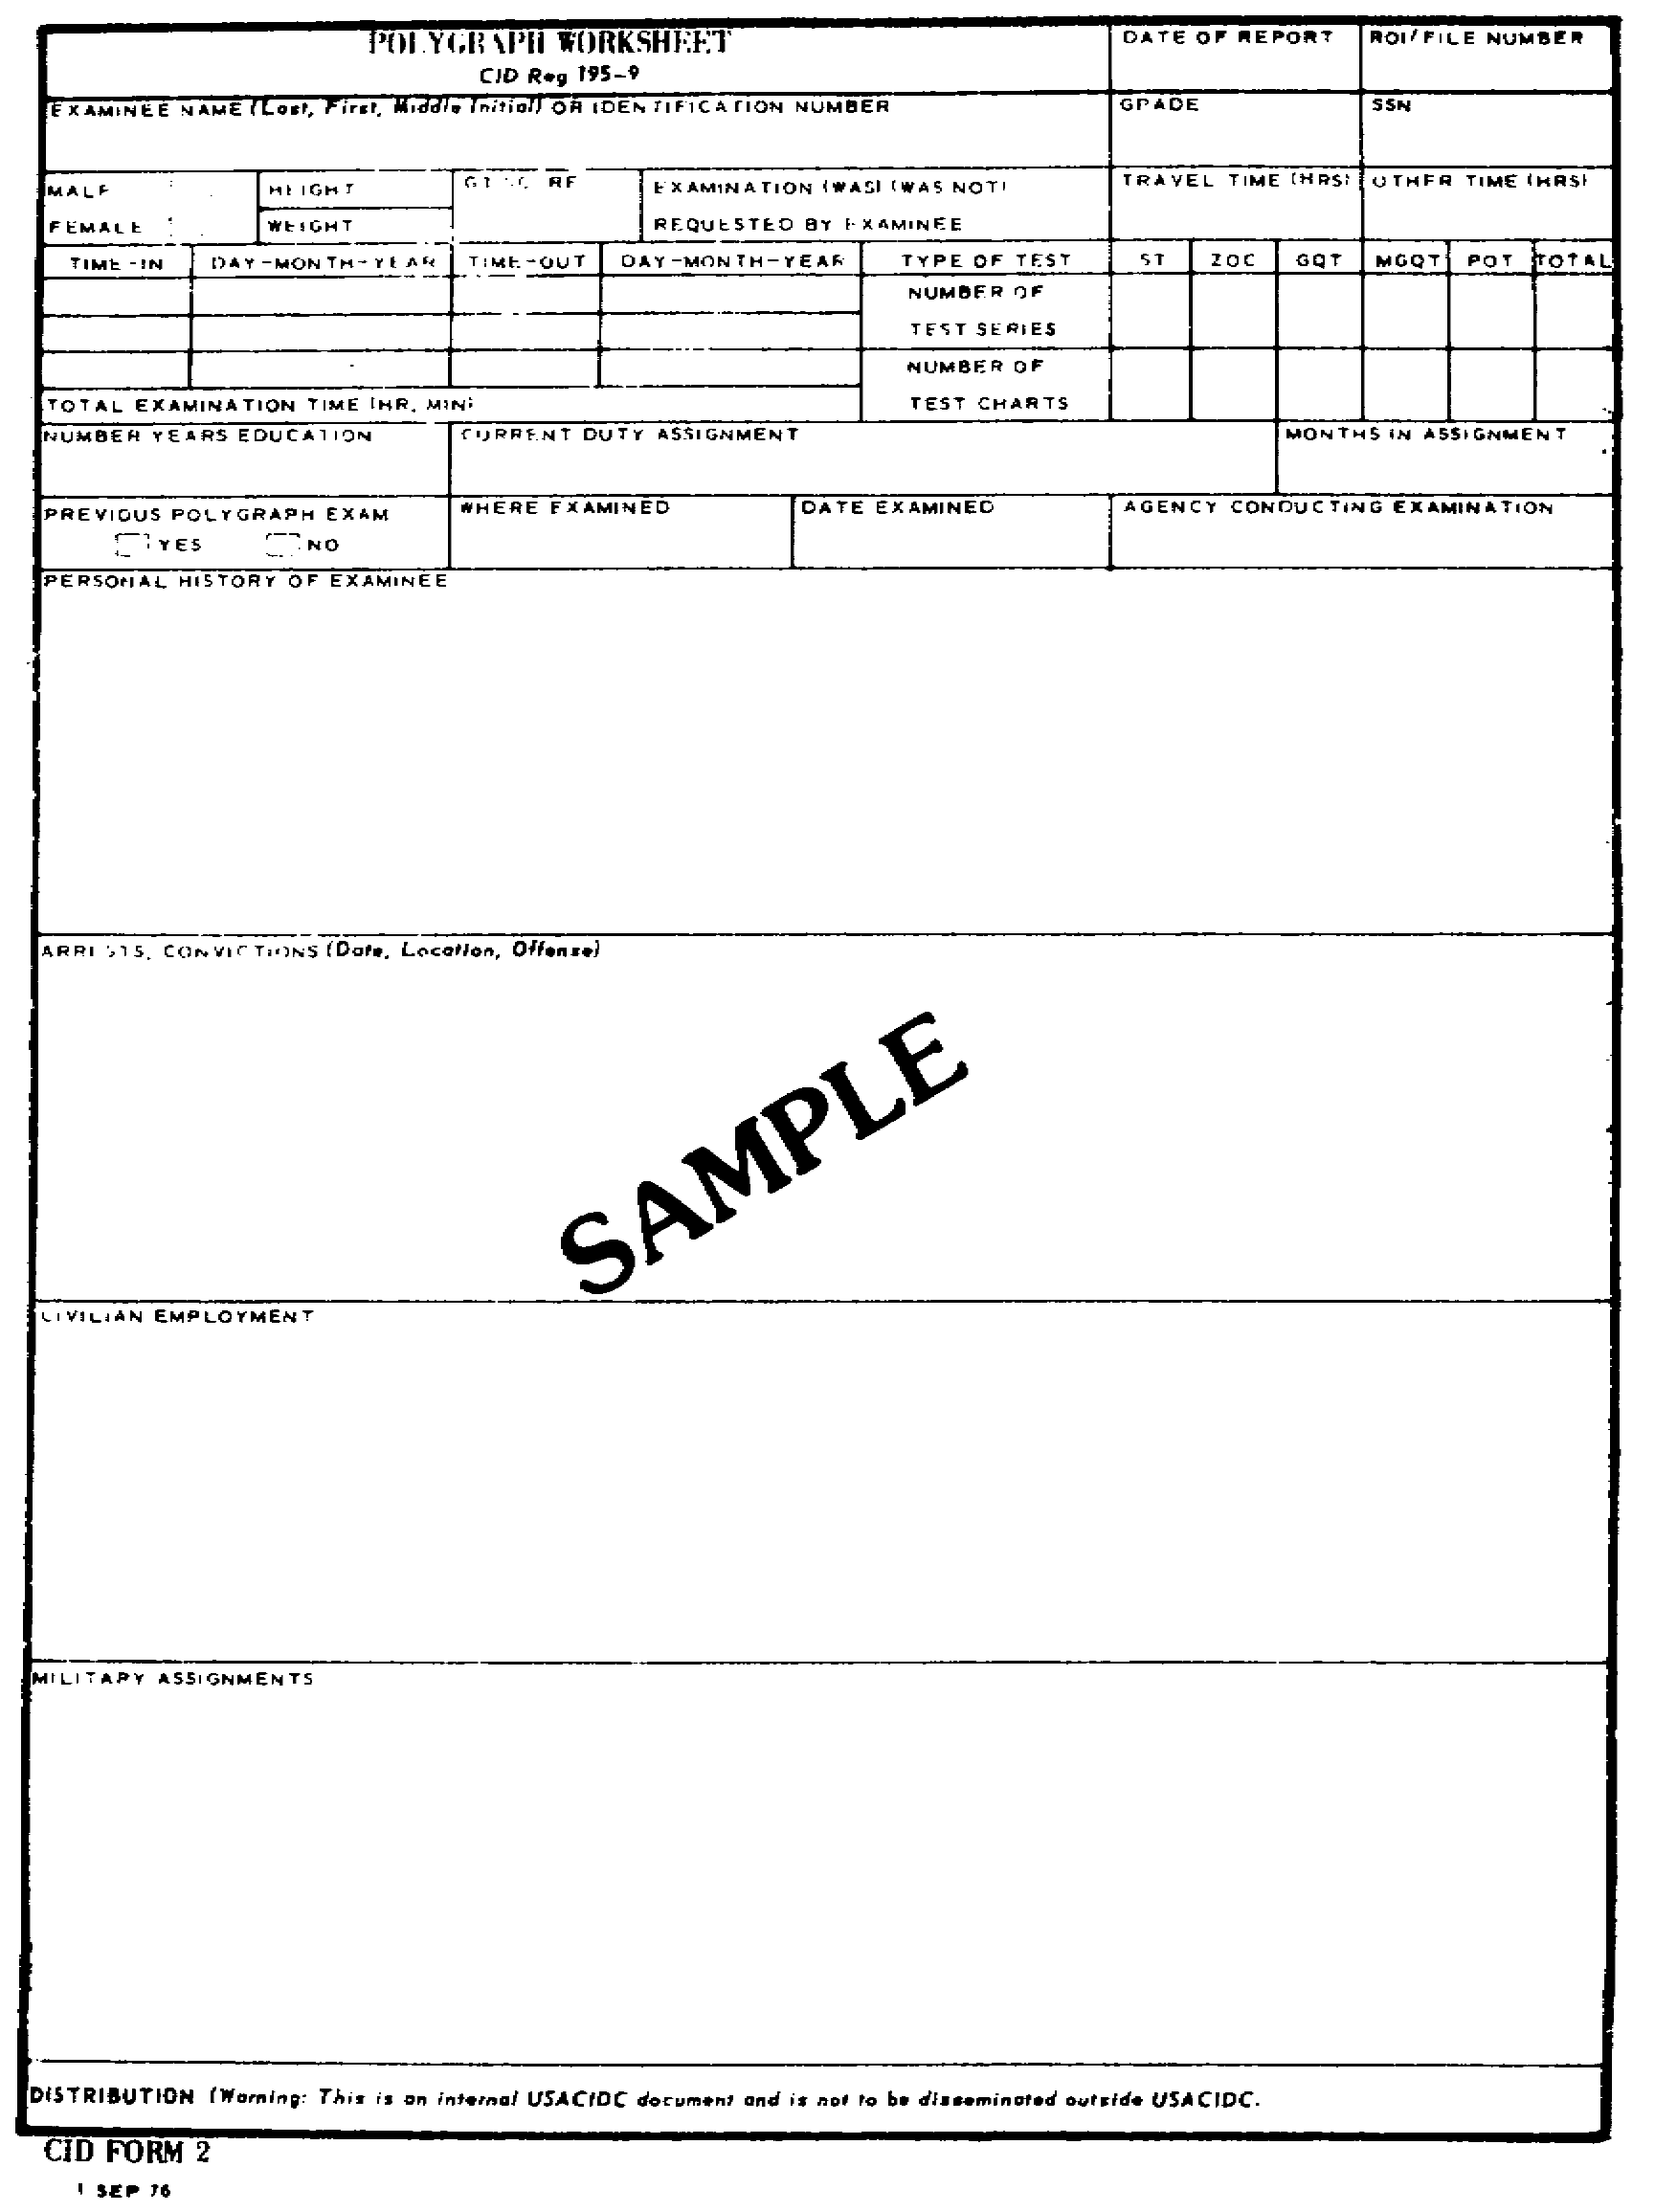
Figure 4-3. CID Form 2,
Polygraph Worksheet (front).

4-11 MP1016

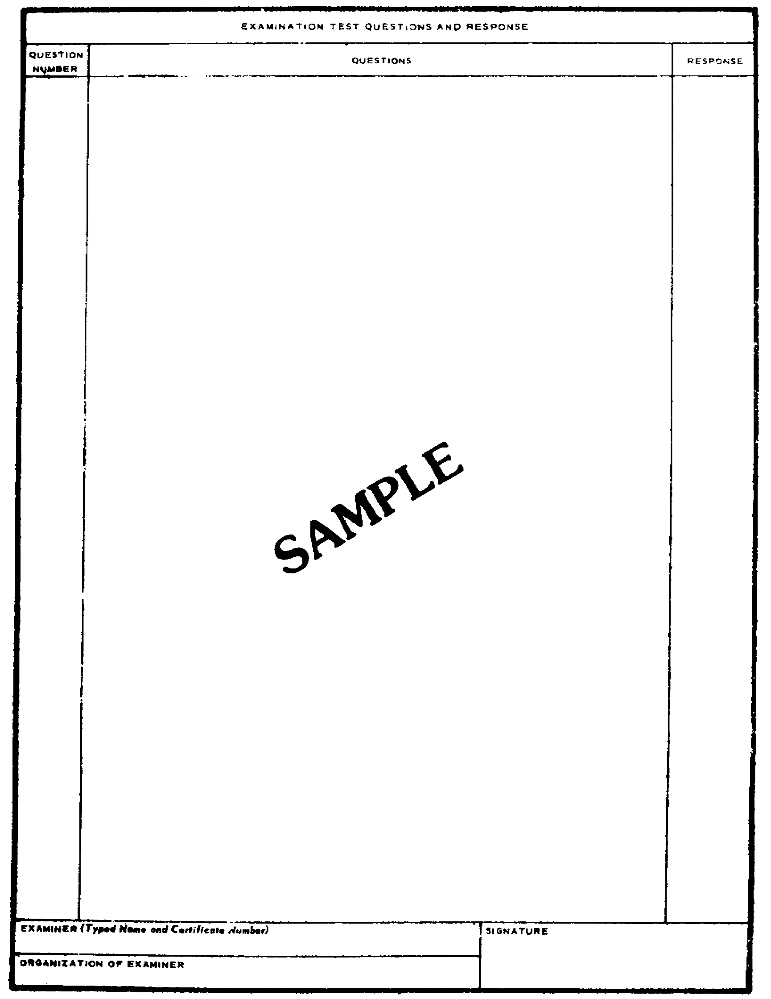
Figure 4-4. CID Form 2,
Polygraph Worksheet (back).

MP1016 4-12

b. The test consists of a series of questions and the simultaneous recording by the polygraph of the physiological changes during the response to these questions. The examiner prepares the test questions on the basis of the information he has obtained from the investigator and the examinee.

c. The procedures to be used will vary slightly with the person to be tested, and the facts of the offense. Generally, three techniques are available: The modified general question test, the zone of comparison test, and the peak of tension test.

(1) The modified general question test consists of a series of questions asked in a planned order. Relevant questions are asked in order to cause a specific response if the examinee is emotionally concerned about the question. Irrelevant questions are asked to give him a relief after the pertinent questions and to establish a normal tracing standard on the test chart. Control questions are used to determine whether he is a suitable subject for the polygraph test and if he is capable of producing a specific physical response.

(2) The zone of comparison is also comprised of relevant, irrelevant, and control questions. In this technique, various zones of specific responses are compared with control response zones to enable the examiner to more easily interpret any specific responses which may be present on the chart.

(3) The peak of tension test is designed to build an examinee up to his peak of tension (emotional disturbance). The test is constructed with but one relevant question; the remainder are irrelevant. The examinee is informed of the exact order in which the questions will be asked. An examinee who will be emotionally disturbed by the one relevant question tends to build up to a peak at this question and decline after it has been asked. A subject who will not be too concerned about the one relevant question tends to produce flat tracings with no indication that tension is present. This technique may be used only where unpublicized information about an offense is available only to the examinee, investigator, and examiner, such as the amount of money stolen in a robbery. These tests are also used to see if a person is capable of response.

d. The length of the test will vary from one to several hours, depending on the number of charts run (generally three or more are obtained), the physiological tracings recorded, the thoroughness of the interviewing between charts, the physical and mental condition of the examinee as well as other delays. These interruptions or breaks in the test are not meant as the commencing of a new examination and the requiring of additional approval. In fact, second tests conducted within 30 days of the first do not require additional approval or a new request.

e. Polygraph examinations are conducted only by certified personnel. Interns or other examiners who have been required to complete a refresher period of internship, can conduct a polygraph examination only under the direct supervision of a certified polygraph examiner.

4-13 MP1016

11. Posttest Interview. Upon completion of the actual testing phase of the examination, the examiner studies the chart tracing and arrives at one of three conclusions. He may conclude the results to be "DECEPTION INDICATED," "NO DECEPTION INDICATED," or "INCONCLUSIVE."

a. If a "NO DECEPTION" conclusion is made:

(1) The examinee is informed that the test has been completed and that the preliminary review of the charts is similar to a doctor's reading of a wet X-ray and that a final conclusion cannot be made until the charts have been subjected to a detailed analysis. The examinee is assured that evaluation of the charts will take a few days and that the investigator assigned to the case will furnish him the results. It should be emphasized to the examinee that if he is not contacted he may be assured that his responses to the specific test questions did not indicate deception. He is informed, however, that the test covered only a specific area of the investigation, and a later one may develop more information. At this time, he should be dismissed from the room.

(2) Within 72 hours of the completion of the test, the examiner will forward the polygraph charts along with a polygraph examination report (Figures 4-5 and 4-6) and all allied documents to the Crime Records Center, Polygraph Division, USACIDC, for quality control review.

b. If a "DECEPTION" conclusion is made, the examiner conducts an interview with the examinee. He attempts to determine the causes of the specific physiological response on the charts. The questioning techniques used by the examiner are similar to those used by any investigator. He selects his questioning approach before the test begins based on the information from the investigator and on the examinee's background. During the test, he will modify or change his approach according to the results of the test and the effect it seems to be having on the person.

c. When a conclusion cannot be reached after the testing, including continuation on later dates, the examiner interviews the examinee to determine the cause of responses noted on the chart tracings. If, after the interview, he is still of the conclusion that further testing would not be productive, he will render an "INCONCLUSIVE" report. The examiner would then confer with the investigator and the authorizing representative. He will explain why he believes there should be no further testing.

d. He may render a "NO OPINION" conclusion, when an examination has not been completed. This may be necessitated should the examinee refuse to continue prior to the running of charts, or before enough charts have been obtained upon which an opinion of "DECEPTION INDICATED" or "NO DECEPTION INDICATED" may be based.

e. Upon completion of the test and posttest interview, the
investigator discusses the results with the examiner. If during the test, the examinee made an oral admission, confession, or other type statement, the investigator should obtain a written one. The procedure helps keep the

MP1016 4-14

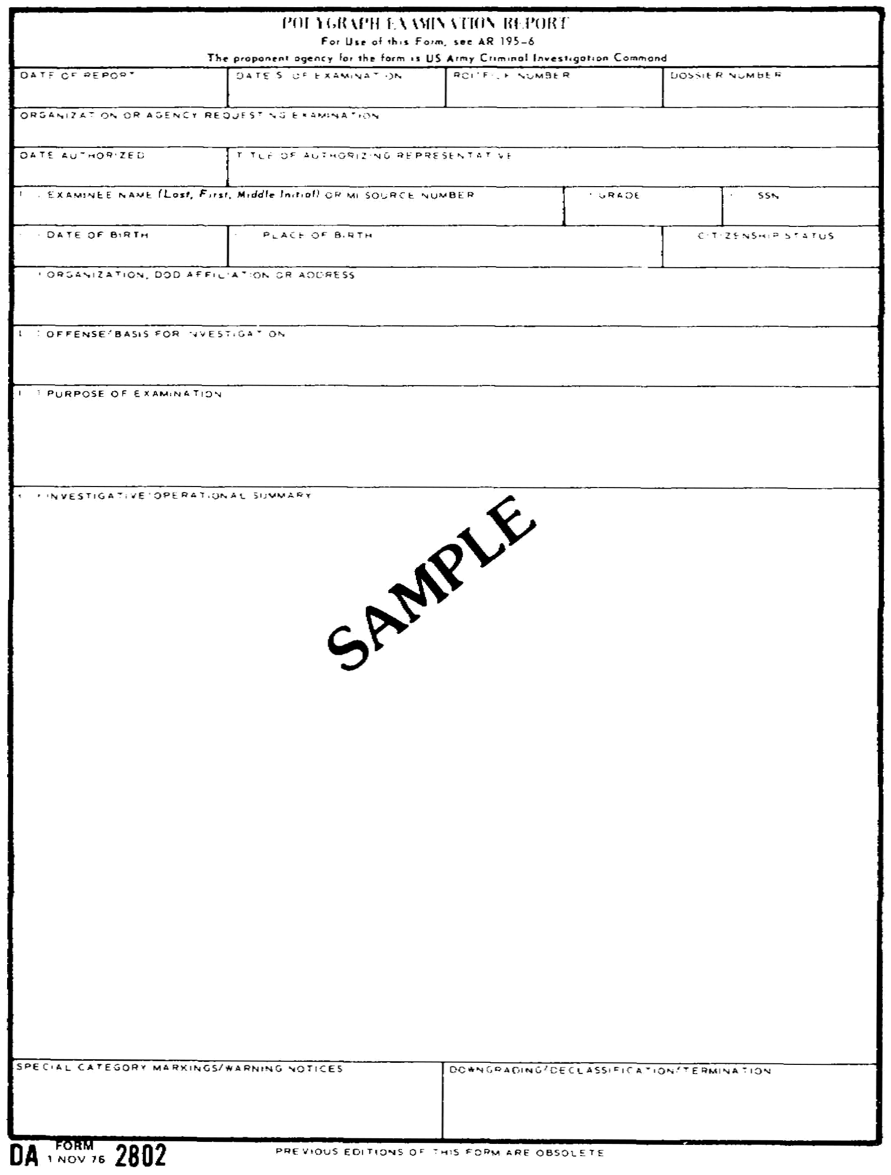
Figure 4-5. Polygraph Examination Report,
DA Form 2802 (front).

4-15 MP1016

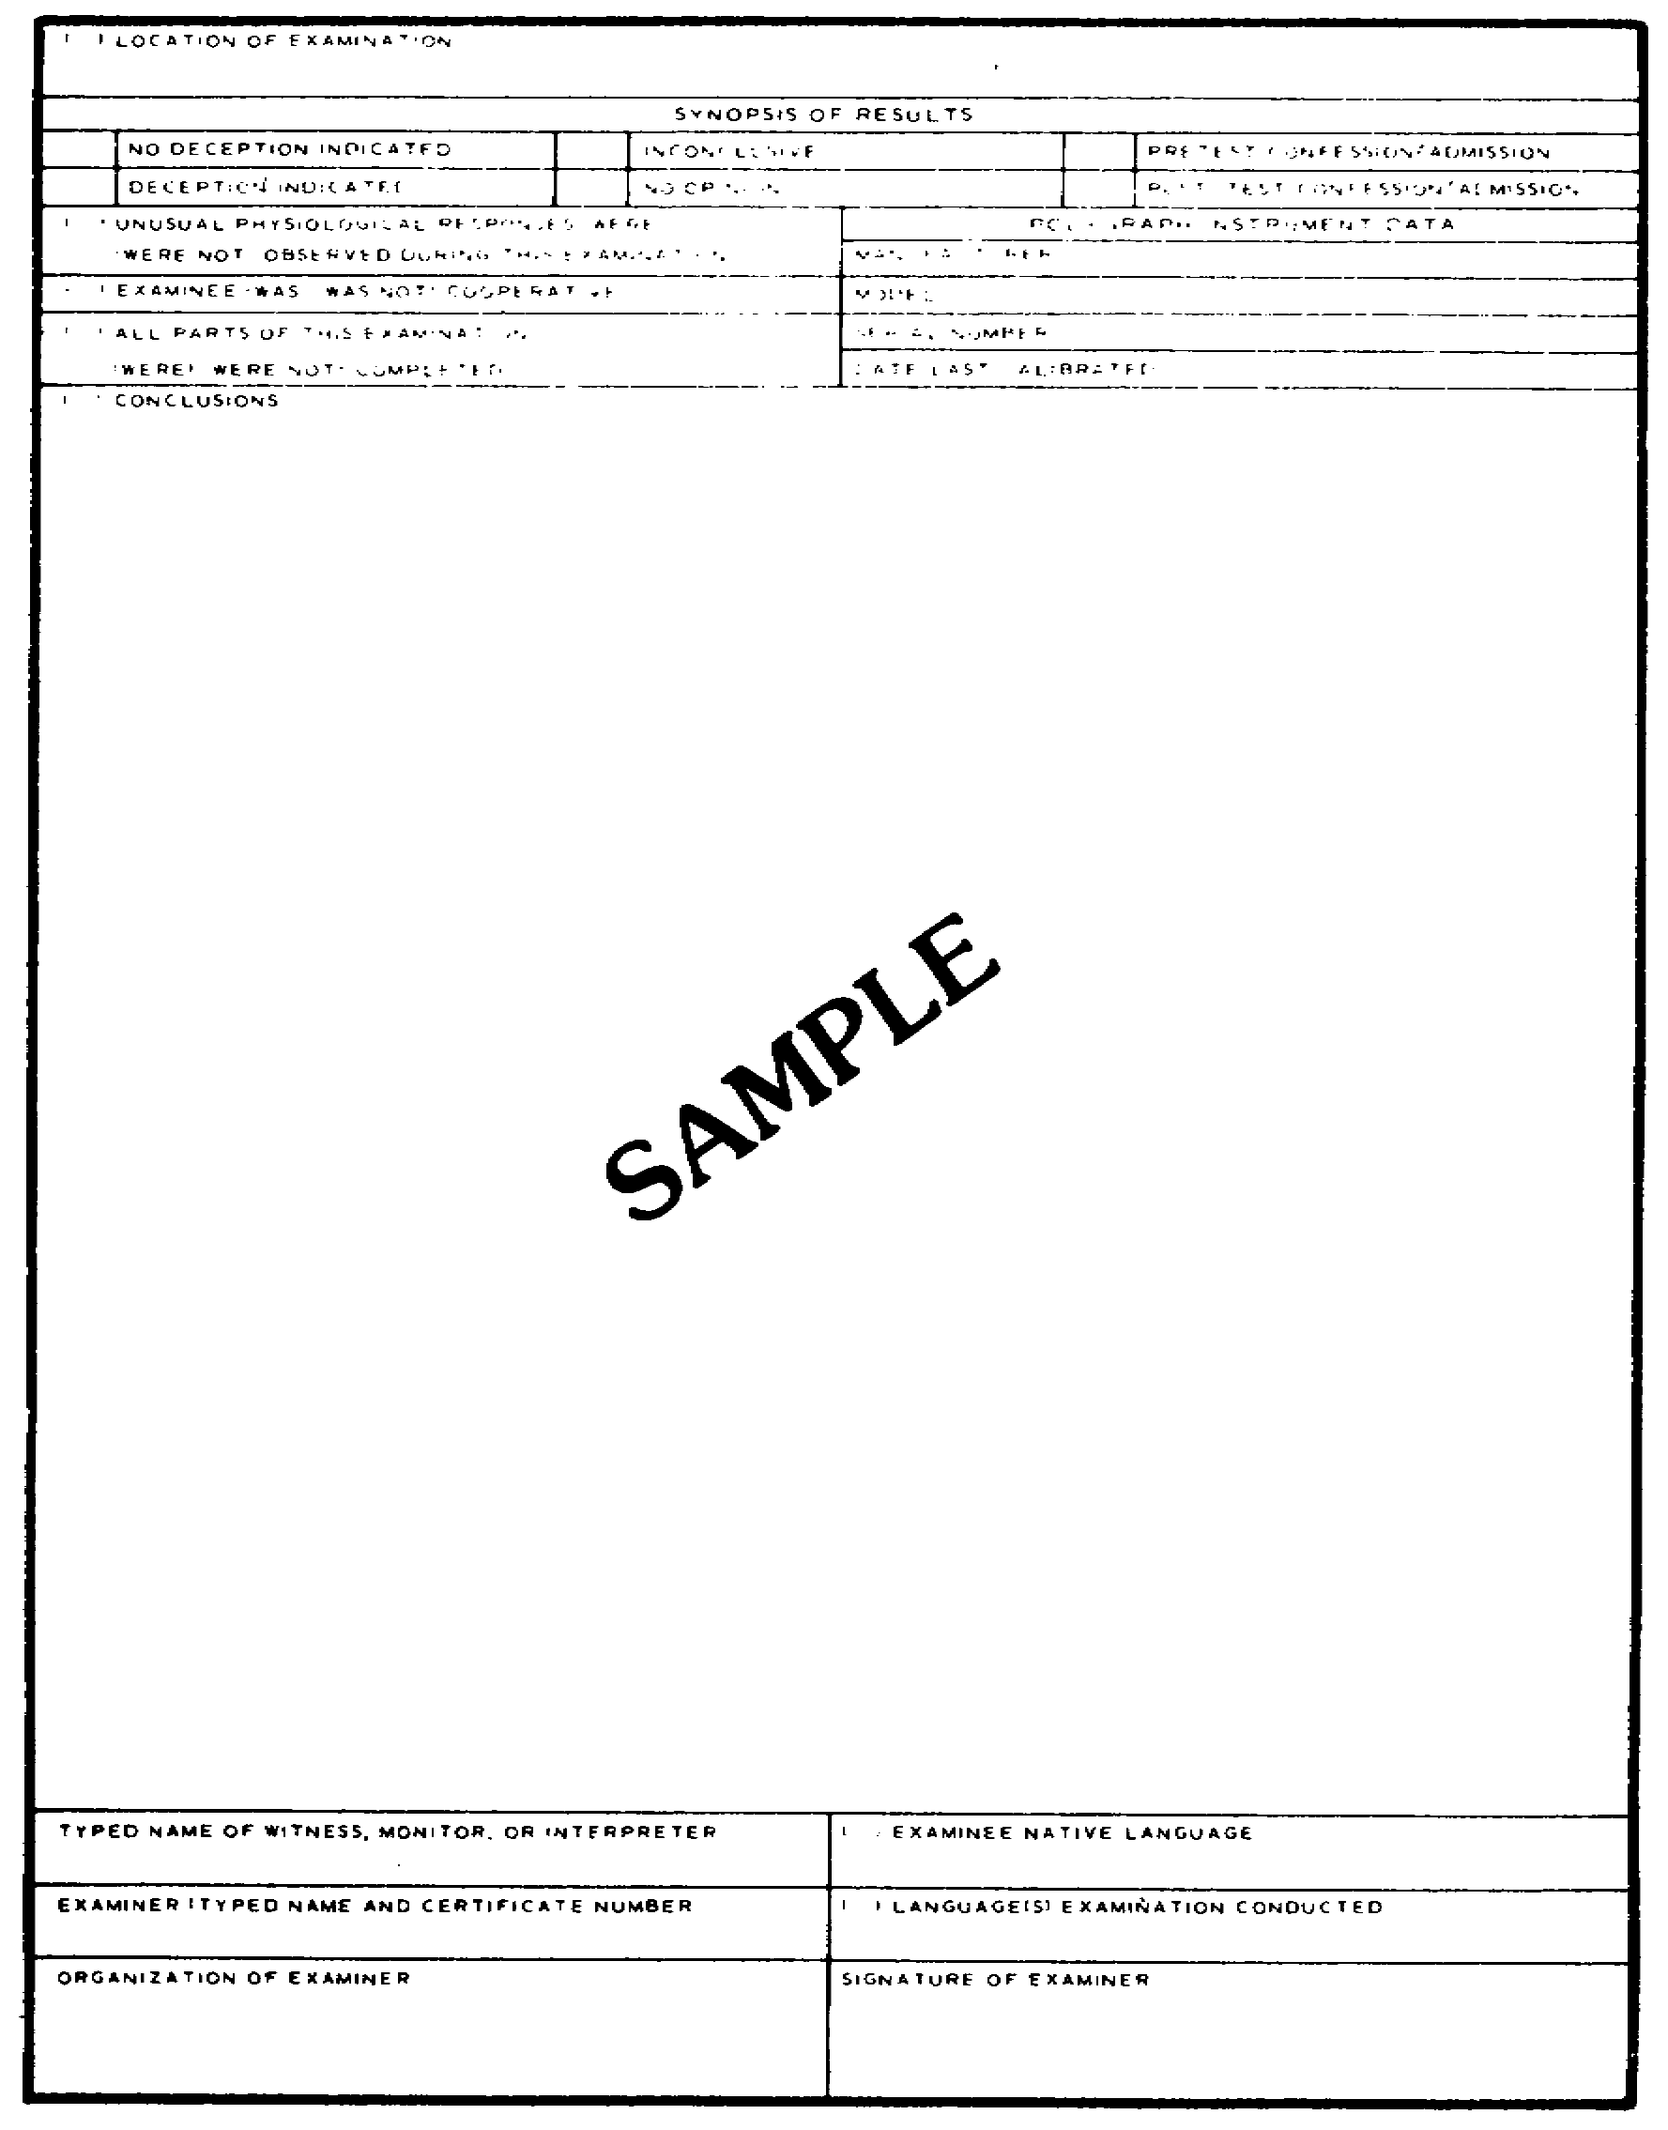
Figure 4-6. Polygraph Examination Report,
DA Form 2802 (back).

MP1016 4-16

examiner out of court and provides an additional witness to verify the voluntary nature of the statement obtained.

The investigator would then make proper disposition of the examinee. Normally, it is not necessary to readvise the examinee of his rights before obtaining a written statement.

12. Capabilities and Limitations of the Polygraph.

a. The capabilities of the polygraph include the fact that statements made by subjects and witnesses can be rapidly and accurately verified or discredited; it is also an aid in obtaining truthful statements from subjects or witnesses, locating hidden evidence, or revealing additional leads.

b. On the other hand, the polygraph is limited in that only what the subject or witness believes to be true can be verified or discredited, not the actual facts. It is a test where the accuracy is dependent upon the examiner. The results are dependent upon the thoroughness of the prior investigation. Physically and mentally unfit and emotionally disturbed persons cannot be examined.

13. Polygraph Records and Reports.

a. The forms used by the polygraph examiner include the DA Form 2801 (Statement of Consent); DA Form 2802 (Polygraph Examination Report); DA Form 3881 (Rights Warning Procedure/Waiver Certificate); and CID Form 2 (Polygraph Examination Interview Worksheet).

b. Polygraph Examination Report. The DA Form 2802 must be completed by the examiner on every test conducted. This form along with the polygraph charts, a copy of the DA Form 3881, and the original DA Form 2801 must be forwarded to the Crime Records Center within 72 hours of the completion test. The DA Form 2802 contains an investigative summary, conclusion section, and the results of the posttest interview. Any admissions made by the examinee will be placed on the second page of the DA Form 2802.

c. The examiner is required to maintain a copy of the DA Form 2802 for the requesting agency, which will be provided then upon receipt of the quality control review and acceptance message.

d. The requesting agency then attaches the DA Form 2802 (copy) to the original of the report of investigation (CRC copy). The DA Form 2802 cannot be released outside of investigative channels except as provided for in AR 195-6.

e. The CID Form 2 is an internal polygraph document, and will not normally be provided to the investigator and/or agency requesting the examination. Additionally, the DA Form 2801 is normally not provided to the agency. The original of both of these forms are forwarded to the Crime Records Center by the examiner.

4-17 MP1016

f. The original of the DA Form 3881 is normally provided to the investigator and/or his agency. A copy of the DA Form 3881 is normally provided to the examiner for inclusion with the original polygraph report for the Crime Records Center.

g. The results of the examination are strictly controlled. Neither the results of a test nor any reference to a refusal to submit to one may be reflected in the investigative summary, the CID report of investigation, or in any statement attached thereto.

h. The investigator, however, may attach a single copy of the DA Form 2801 as an exhibit to the report of investigation. No other polygraph forms and/or records will be attached. Any copy of the examination report released external to USACIDC will contain the following entry either typed or stamped on each page of the report:

"This document will be destroyed upon completion of your action for which it was requested (para 2-6h, AR 195-6). The original, to include related polygraph records, is at the U.S. Army Crime Records Center, USACIDC, 2301 Chesapeake Avenue, Baltimore, MD 21222-4099. Reproduction of this document or its contents is prohibited."

14. Supervision.

a. Polygraph examiners, other than those assigned to Crime Records Center and Department of Defense Polygraph Institute (DODPI), receive quality control and other technical supervision from the Crime Records Center. They are centralized and operationally controlled by their USACIDC Region Commander. The rater for field examiners will be the region polygraph coordinator or, if that person is unable to rate, the rater will be other region supervisory personnel.

b. Polygraph examiners will be used in the conduct of polygraph examinations, monitoring and assisting intern polygraph examiners, and assisting other special agents in the conduct of interviews and interrogations in support of criminal investigations. They will also perform as action officers on polygraph related matters, and review on-going cases to determine potential polygraph utilization.

c. Polygraph quality control supervisors at the Crime Records Center will exercise technical supervision of all USACIDC polygraph examiners. They will conduct a complete review of each examination performed by a USACIDC polygraph examiner. They will continually monitor and counsel all USACIDC polygraph examiners to assure that they remain proficient.

15. Release of Examination Results.

a. Other than as provided in b below, and in accordance with a strict need-to-know policy, the results are available only to:

MP1016 4-18

(1) The Secretary of the Army, the Chief of Staff, and their immediate advisors.

(2) Department of the Army officials responsible for personnel security, law enforcement, or the administration of justice, to include counsel in judicial or administrative proceedings arising as a result of the investigation.

b. The results are not available outside the Department of the Army except to:

(1) Officials of the Office of the Secretary of Defense or another DOD component corresponding to those listed in paragraph 1-7i, AR 195-6.

(2) Other federal officials, charged with intelligence, security, or law enforcement responsibilities with a clear need to know.

(3) State law enforcement officials where the results indicate an alleged violation of state law or that a serious crime is likely to be committed.

(4) Legal counsel for the person examined, upon request, and is therefore, subject to provisions for safeguarding defense information.

(5) And other persons as the Secretary of the Army personally may determine.

c. Any request received by an investigative agency from the agencies listed in 15b(3) above, will be referred to the USACIDC. Any request received from any of the other agencies listed in a above, may be filled by the investigative agency concerned, provided that examination results are still available; if all copies have already been destroyed, the request will be forwarded to USACIDC.

16. Legal Status.

a. If a person agrees to a polygraph test after having been advised of his rights (paragraph 9), then his rights have not been violated. The facts obtained can be used.

b. A legally obtained statement, admission, or confession obtained during a polygraph test may be entered into evidence; the use of the polygraph does not alter this fact. If the examiner received an oral statement, admission, or confession, he may testify in court about it. The investigator should, however, take the written statement. The examiner, then, may be called, if necessary, to testify in court as to the voluntary nature of the statement, admission, or confession.

c. Polygraph examiners and their equipment must not be used in
violation of the Posse Comitatus Act. This law prohibits the Armed Forces
from executing civil law in the United States, its territories, and

4-19 MP1016

possessions. The Act does not apply in occupied areas where the military commander has supreme jurisdiction over the civilian inhabitants, or in any area under marital rule. The law has been interpreted to mean that military polygraph examiners:

(1) Will not examine a person who is not subject to the UCMJ for the purpose of assisting civil police in enforcing civil laws.

(2) May examine a soldier accused of an offense against both the civil law and the UCMJ, at the request of civil police even though the soldier will probably be tried in a civil court if, at the same time, a military investigation is being conducted, and AR 195-6 has been met.

(3) May examine a person not subject to the Code in connection with the military investigation of an offense against the Code committed on a military reservation. The investigation must be for a military purpose, and not for the purpose of imposing criminal liability by a civil court for the offense, and AR 195-6 has been met.

17. Selection of Army Polygraph Examiners. AR 195-6. No person will be selected as a candidate for the position of examiner or for training as an examiner unless the following minimum requirements are met:

a. U.S. citizen.

b. At least 25 years of age.

c. A graduate of an accredited college (Baccalaureate Degree), plus 2 years as an investigator with a recognized government agency.

d. Successfully screened, on the basis of a background or character investigation, as being a person of high moral character and sound emotional temperament (passed a polygraph examination in the screening process).

e. Military personnel must be accredited in one of the following MOS: 311A, 351B (was 971A), 351C (was 972A). (MOS 311A is that of a Criminal Investigation Warrant Officer while the others are in the intelligence field.)

18. Training.

a. Training programs for prospective Department of the Army polygraph examiners are conducted at the DOD Polygraph Institute, Fort McClellan, AL. The satisfactory completion of the Polygraph Examiner Training Course is a prerequisite for certification as a qualified examiner.

b. The training program is designed to assure that no person is certified as a qualified examiner without having demonstrated an understanding of the following:

MP1016 4-20

(1) Investigative techniques.

(2) Methods of interrogation.

(3) The basic elements of normal, abnormal, and criminal psychology.

(4) Constitutional and other legal considerations.

(5) Physiology.

(6) The functions of the polygraph instrument.

(7) The procedures and techniques of using the polygraph.

(8) Regulations of the DOD and Department of the Army concerning the use of the polygraph.

(9) The training described in (3), (4), and (5) above, is conducted by professional medical and legal personnel.

(10) The training described in (1), (2), (6), (7), and (8) above, is conducted only by a certified polygraph examiner.

c. Before being certified as a qualified polygraph examiner, each candidate serves an internship under a certified examiner. Such internship is for a period of not less than six months, following the basic training course. During his period of apprenticeship, the candidate is required to conduct a minimum of 50 (USACRC Quality Control Requirement) polygraph examinations under the direct supervision of the certified polygraph examiner.

d. Special agents wishing to make application for training and eventual certification as a polygraph examiner will apply by letter application through command channels to the USACIDC. This application must provide evidence that the prerequisites listed in paragraph 18 have been met. If the applicant is accepted for training, his application, together with a school quota for attendance at the Polygraph Examiner Training Course, will be returned to the applicant through channels.

e. Once an investigator has been certified as a polygraph examiner, that certification is effective until it is withdrawn by the certifying official. However, the retention of certification is dependent on the examiner's continued proficiency based on the regular conduct of polygraph examination and meeting biannual training requirements.

4-21 MP1016

LESSON 4

REVIEW EXERCISE

REQUIREMENT. The following questions are multiple choice. There are four choices to each. You are to select the one that is correct. Indicate your choice by CIRCLING the letter beside the correct choice directly on the page. This is a self-graded lesson exercise. Do not look up the correct answer from the lesson solution sheet until you have finished. To do so will endanger your ability to learn this material. Also, your final examination score will tend to be lower than if you had not followed this recommendation.

1. Which of the following are prerequisites of the conduct of a polygraph examination?

I. The examinee must be a member of the military.

II. The offense must violate either the U.S. Code or the Uniform Code of Military Justice.

III. The offense is punishable by death or one year or more confinement.

IV. The offense is punishable by imprisonment for 6 months or more.

V. The only prerequisite is the approval of the authorizing representative.

A. I, II, III.

B. II, III.

C. II, III, IV.

D. V.

2. Before the actual testing phase of a polygraph examination, the examiner formulates the questions he tends to ask during the test. After the questions have been prepared, and still prior to the actual examination, the examiner:

A. will go over each and every question with the examinee.

B. will explain the relevant questions to the examinee only when using the peak of tension test.

C. reviews the irrelevant and control questions with the examinee.

D. will NOT go over any of the questions with the examinee.

MP1016 4-22

3. The polygraph examiner will normally be called upon to testify at a court-martial relative to:

A. his opinions as to the examinee's deception.

B. the polygraph examination's results.

C. the examinee's truthfulness or deception.

D. any statements made by the examinee during the examination.

4. The accuracy of a polygraph examination to a large measure is dependent upon the:

I. thoroughness of the investigation prior to the examination.

II. proficiency of the examiner.

III. the examinee and his ability to control his emotions.

IV. the type of instrument used during the examination.

A. I, II, III.

B. I, III, IV.

C. I, IV.

D. I, II.

5. The originals of the DA Form 2801, DA Form 2802, and CID Form 2 for each examination will be:

A. destroyed within a specified period of time after completion of the examination.

B. filed by the investigative agency requesting the polygraph examination.

C. retained by the polygraph examiner in his file for a period not to exceed one year.

D. forwarded to the Crime Records Center by the examiner conducting the examination.

4-23 MP1016

6. A specific requirement for the use of the peak of tension test is the necessity for the investigator to furnish the examiner with:

A. pertinent information concerning the person.

B. all the relevant facts about the investigation.

C. information that is not or would not be public knowledge.

D. information pertaining to the amount of money taken, any weapon used by the person, or the person's means of entry.

7. Prior to the conduct of a polygraph examination, the investigator should provide the examiner with:

I. all the general facts surrounding the investigation.

II. any theories or suspicions he may have regarding the offense.

III. detailed, verified facts regarding the offense.

IV. a copy of all written statements made concerning the offense.

V. information concerning the personal history of the person.

A. III.

B. III, IV.

C. II, III, IV.

D. I, II, III, IV, V

8. An examinee who has consented to take a polygraph examination reneges and refuses to cooperate once inside the examination room. Because of his refusal after the paperwork has been completed and the examination arranged, the examinee:

A. should made a written statement of refusal.

B. must attach a statement indicating his reasons for refusal to his already signed Statement of Consent, DA Form 2801.

C. must attach an explanation statement to DA Form 2805, Polygraph Examination Authorization.

D. will not be required to complete any type of statement.

MP1016 4-24

9. Which of the following is a capability of the polygraph technique?

I. Verify statements made by subjects and witnesses.

II. Aid in obtaining truthful statements from subjects and witnesses.

III. Locate hidden evidence.

IV. Reveal additional investigative leads.

A. I, III, and IV only.

B. II and IV only.

C. I, II, III, and IV.

D. III and IV only.

10. During the course of a polygraph examination, the examinee confesses to the examiner that he did in fact commit the crime under investigation. The:

A. examinee's confession should immediately be reduced to writing by the examiner.

B. confession cannot be introduced into evidence during any ensuing court-martial because it was obtained through the use of a polygraph.

C. investigator should be the one to take and reduce the examinee's confession to writing and not the examiner.

D. investigator can only use the confession as an investigative aid to develop further proof of the examinee's guilt.

4-25 MP1016

11. A polygraph examiner has run three sets of charts on a subject and has formed the opinion that the examinee has not been telling the truth. In an effort to obtain the truth, the examiner interrogates the examinee for over two hours. After the interrogation, the examiner desires to conduct a fourth examination. Which of the following statements regarding the conduct of this fourth examination is TRUE?

A. Before another examination can be conducted, regardless of the time limit, the examinee must be advised of his rights and a new polygraph Statement of Consent signed.

B. The examinee should not be examined until the following day; at this time it is necessary to advise the examinee of his rights.

C. Before a fourth examination can be conducted, a new Polygraph Examination Authorization must be executed.

D. The examiner should conduct the fourth examination immediately after the interrogation.

12. Which of the following is a component of the polygraph instrument?

A. Pneumograph component.

B. Cardio-sphygmograph component.

C. Galvanograph component.

D. All of the above.

13. A polygraph examination has been conducted at the request of a soldier's defense counsel. Since a CID investigation has not been initiated against the soldier, the polygraph records and charts will be:

A. destroyed within 90 days.

B. filed by the examining unit.

C. turned over to the defense counsel.

D. forwarded to the Crime Records Center.

MP1016 4-26

14. Which of the following statements concerning the polygraph is FALSE?

A. The polygraph technique is infallible.

B. The polygraph can be used as a means to indicate the truthfulness of the examinee.

C. Even though a confession has been obtained during the examination, the polygraph examination is not the end of an investigation.

D. The accuracy and success of a polygraph examination will depend upon the competency of the examiner.

15. The special agent should NEVER:

I. conduct an investigation in a room where there is a polygraph instrument.

II. interrogate a person immediately prior to a polygraph examination.

III. assure the examinee that the examiner is a qualified person who is impartial toward all the persons involved in the case.

IV. try and trick a person into confessing or making a statement by threatening him with a polygraph examination.

A. II.

B. II, III, IV.

C. I, II, IV.

D. I, II, III, IV.

4-27 MP1016

LESSON 4

PRACTICE EXERCISE

ANSWER KEY AND FEEDBACK

Item Correct Answer and Feedback

1. B. II, III.
The offense for which... (page 4-4, para 5-2).

2. A. Will go over each and every question with the examinee.
The remainder of the pretest... (page 4-9, para 9c).

3. D. Any statements made by the examinee during the examination.
If the examiner received an oral... (page 4-19, para 16b).

4. D. I, II.
To a large measure, the... (page 4-5, para 6a).

5. D. Forwarded to the crime records center by the examiner conducting the examination.
Polygraph Examination Report... (page 4-17, para 13b, e).

6. C. Information that is not or would not be public knowledge.
The peak of tension test is designed... (page 4-13, para 10-C(3)).

7. D. I, II, III, IV, V.
The investigator must be able... (page 4-5, para 6c).

8. D. Will not be required to complete any type of statement.
After the examinee has... (page 4-9, para 9b).

9. C. I, II, III, IV.
The capabilities of the polygraph... (page 4-17, para 12a).

10. C. Investigator should be the one to take and reduce the examinee's confession to writing and not the examiner.
Upon completion of the test... (page 4-14, para lie).

11. B. The examinee should not be examined until the following day; at this time it is necessary to advise the examinee of his rights.
If a "DECEPTION" conclusion is made... (page 4-14, para 2b).

12. D. All of the above.
Pneumograph, cardio-sphymograph, kymograph. (page 4-3 - 4-4, para 4b).

MP1016 4-28

13. D. Forwarded to the Crime Records Center.
Polygraph examination reports... (page 4-17, para 13b).

14. A. The polygraph technique is infallible.
The polygraph technique... (page 4-6, para 6f(2)).

15. A. II.
Never conduct a prolonged...(page 4-6, para 6f(l)).

4-29 MP1016

LESSON 5

OBSERVATION AND DESCRIPTION

CRITICAL TASK: 191-390-0150

OVERVIEW

LESSON DESCRIPTION:

At the end of this lesson, you will be able to:

1. Observe and describe persons, objects, places and events.

2. Scrutinize observations, descriptions, and identifications provided by witnesses.

TERMINAL LEARNING OBJECTIVE:

ACTION: Observe and describe persons, objects, places and events.

CONDITION: You will have this subcourse, pencil, and paper.

STANDARD: You must complete all exercises for each lesson, take the final examination and obtain a score of at least 75 percent correct answers.

INTRODUCTION

1. INTRODUCTION:

a. Observation in investigation work means the perception of details pertaining to persons, objects, places, and events through the use of one or more of the five senses--sight, hearing, touch, smell, and taste.

b. You must be able to observe accurately in order to spot infractions of the law, and/or persons and objects of interest to law enforcement and crime prevention programs; this is also necessary to perceive leads, to evaluate statements, and to make accurate reports. Your ability to observe accurately is developed through practice and experience.

c. Unless you can observe accurately and completely, and then correctly describe what you have observed, you will be nonproductive in the investigative field. In addition, you are faced with the everyday cask of trying to determine what others have observed. Events and remarks that mean nothing when seen or overheard by the layman may be important to you as an experienced special agent (SA). To assist your recall, make extensive use of photographs, sketches, notes, and other methods.

5-1 MP1016

2. Techniques of Observations.

a. Observing Persons. Observe persons either for the purpose of being able to describe them or to identify them from descriptions made by others. Such observations should proceed as follows:

(1) First, general traits, such as sex, race, color of skin, height, build, weight, and age.

(2) Second, specific traits, such as color of hair and eyes, shape of head and face, distinguishing marks and scars, mannerisms, and habits.

(3) Third, changeable features at time of observation such as clothing worn, use of cosmetics and others, such as hair styling.

When attempting to identify a person from a description, this pattern may be modified or even reversed, especially if the person sought has some very noticeable feature; for example, a man with a limp or a very tall woman. After first noting this, further observation such as height, weight and age and additional characteristics may then complete the identification as the person being sought.

b. Observing Objects. When observing physical objects for later description or in the attempt to locate a previously described object, follow a pattern of proceeding from general to specific. This should proceed as follows:

(1) General type of the item, including size and color.

(2) Specific distinguishing features, such as a convertible top or a portable radio or typewriter.

(3) Make and model designation, when applicable.

(4) Distinguishing marks, indicating damage or alteration, such as a broken headlight, a repainted fender, or a missing handle or scratch on the surface of a piece of luggage.

(5) Identifying number(s), marking(s), or label(s), when present.

c. Observing Places. Usually, detailed observations of places and locales are made to mark the exact scene of an incident of crime, or detect relevant evidence. In addition, the purpose may be to relate to an incident or crime such information as has been obtained from witnesses as the result of their observation of persons, objects, or events. The basic pattern of observing places may vary depending upon whether the place is in the open or outside a building or structure.

(1) Outdoors. Most outdoor areas will either contain or be near natural
or manmade landmarks that may be used to pinpoint the location. However,
outdoor locales may not have well-defined boundaries, such as roads,

MP1016 5-2

fences, streams, buildings, or wood lines. You must then develop the ability to assign mentally practical limits to the area that is to be observed. Normally, the method procedure is to observe the following:

(a) General location and its nearness to such terrain features and landmarks as roadways, railways, streams, or shorelines.

(b) Exact location in relation to fixed or semifixed features, such as buildings, fences, bridges, trees, and pathways.

(c) Outstanding objects or features within the scene.

(d) Details of the scene and details of items of special interest.

(2) Indoors. Observation of indoor scenes will be simplified by obvious and definite boundaries, such as the walls of a room, the areas of a hallway or basement, or the confines of an apartment. On the other hand, indoor areas may contain many and various objects which may slow the task of completion observation. Because of this, it is important in the case of indoor scenes that a pattern of observation be used. Normal procedure is to determine, in order, the following:

(a) Location of the place to be observed, including section of building in which located, such as front or rear, floor level. Relationship to building entrances and distances to stairways and elevators should be noted.

(b) Room number, or other designation.

(c) Details of immediate entrance(s) to the specific area of interest.

(d) Objects located within the area. Use a clockwise or other method of observation from a starting point.

(e) Exact location, in relation to other objects, or items of interest.

d. Observing Events. In most instances, you will be called to the
scene after an incident has occurred or a crime committed. Hence, you will
seldom observe the complete event as it is occurring. However, your observation
of connected actions that may occur subsequent to the event itself may supply
major clues as to that which had already occurred. Such a small but
significant action or circumstances as a casual remark, a state of excitement,
a furtive gesture or glance, unusual curiosity, interest, disbelief, or an
unlikely lack of knowledge may often provide you with the necessary lead to
develop an important aspect of an investigation. Similarly, significant information may often be deduced from such details as the way a fire burns,
the presence of certain fumes or odors, the pitch of a voice, or the warmth of a body. This may aid in the reconstruction of an event in respect to its

5-3 MP1016

cause or origin and progression. The ability to recognize and interpret acts or conditions and relate them to an event is a skill that you must develop. To this end, persons, objects, and places involved, as well as incidents or events should be observed as discussed above.

(1) Facts to be determined concerning an event are the time of occurrence, location, sequence of action, objects and persons involved, and results.

(2) A method of applying the senses to aid in determining the progress of an event is hard to prescribe. You must develop this through practice. Develop within yourself an external sensory stimulation of not only sight, but of hearing, touch, taste, and smell as well. Apply trained and logical analysis to these in determining the relationship of one occurrence with another. Determining the relationship of factors you have observed may be difficult. It may involve the pursuit of a number of false clues. However, it is only through perception of all facets present at the scene of an event that proper observation will be accomplished. Only when this is achieved is it possible that clues will not be overlooked. Analysis may then establish the true leads to a sequence of actions and circumstances.

(3) If you are present at the time of the event, you must be able to observe objectively, accurately, and rapidly, factors of time, place, persons, objects, and actions involved, as well as the results. These factors are involved in the questions of when, where, who, what, and why of complete observation and investigation. The ability to observe actions and events through use of all fives senses is a skill which is developed only through hard training and practice. Complete and accurate observation is the result of conscious, applied effort rather than luck. Habitual methods of observation which use all five senses will improve your sensory perception.

3. Techniques of Description.

a. Description will normally be written or verbal. It may also include any other means such as signs, gestures, or sketches.

b. Describing Persons. Every person has some trait which sets him apart from other persons. These features are the most important part of a person's description. It is important that this be complete and accurate so that others will be able to recognize him readily. As in the case of observation, description is aided by following a pattern which proceeds from general to specific characteristics.

(1) General characteristics. The following accepted words, terms, and methods are used in describing general characteristics:

(a) Sex. Male or female.

(b) Race. Caucasian, Negro, American Indian, Spanish American, Oriental American, Puerto Rican, Filipino, Hawaiian, or Eskimo.

MP1016 5-4

(c) Height. Exact or estimated. When the height is estimate, this fact should be stated. Estimated heights may be stated in 2-inch blocks, e.g., 5 feet 8 inches to 5 feet 10 inches.

(d) Build (including posture).

1. General. Large, average, or small (slight).

2. Specific. Obese (very stout), stout, stocky, medium, or slim (slender) (Figure 5-1).

5-5 MP1016

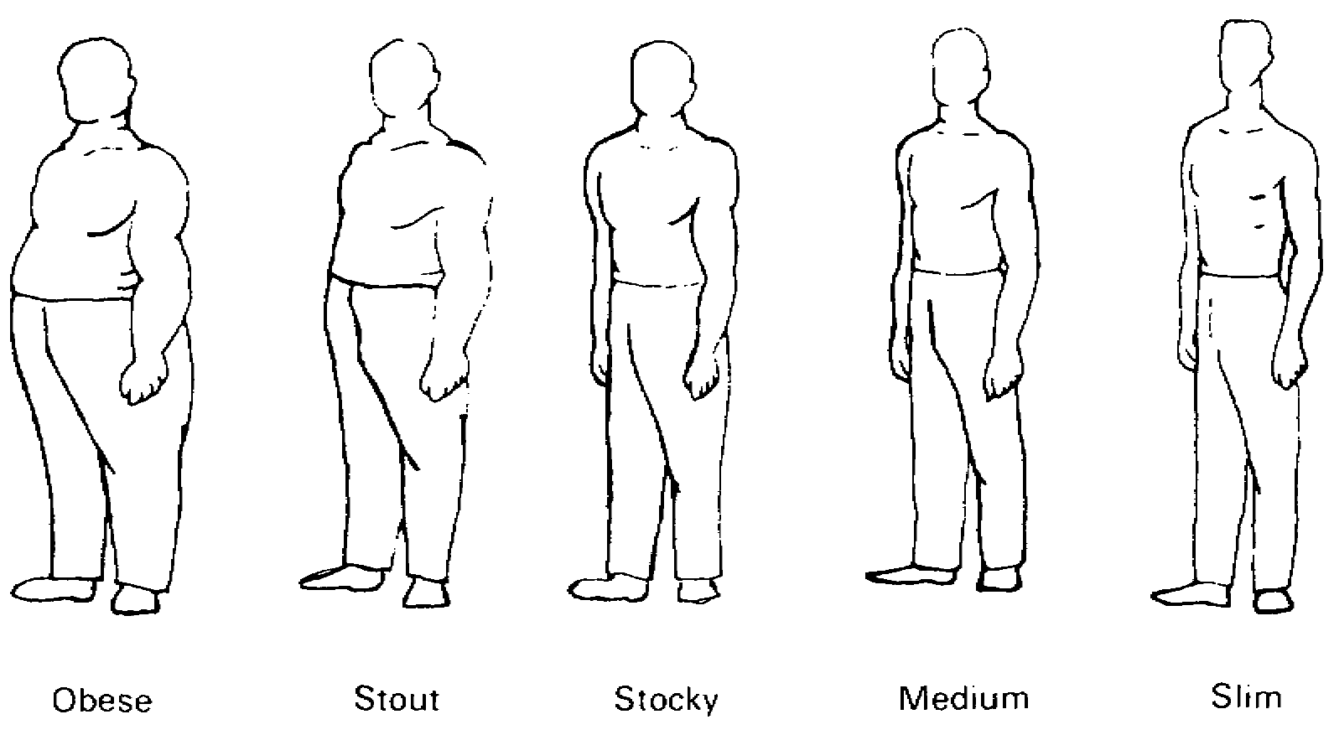
Figure 5-1. Build.

3. Posture. Straight (erect), medium, stooped, or other applicable term (Figure 5-2).

4. Females. In describing the build of a woman, bear in mind that, while the terms listed in 1. through 3. may be used, the basic differences in build and body proportions between the male and the female should be known. The musculature of the female figure is normally smooth and rounded while that of the male figure tends to be angular and distinct. In the female figure the shoulders are narrower than the hips, while in the male figure the reverse is normally true. An important part of the description of the build of a woman is the appearance of the bust. This should be described as flat, medium, heavy, or other term or phrase (Figure 5-3). It is most useful to obtain a description of both the natural as well as the artificial appearance of a woman.

(e) Weight. Exact or estimated. When the weight is estimated, this fact should be stated. Estimates should not be in terms of exact number of pounds, but rather stated in ten-pound increments, e.g., 160-170 pounds.

MP1016 5-6

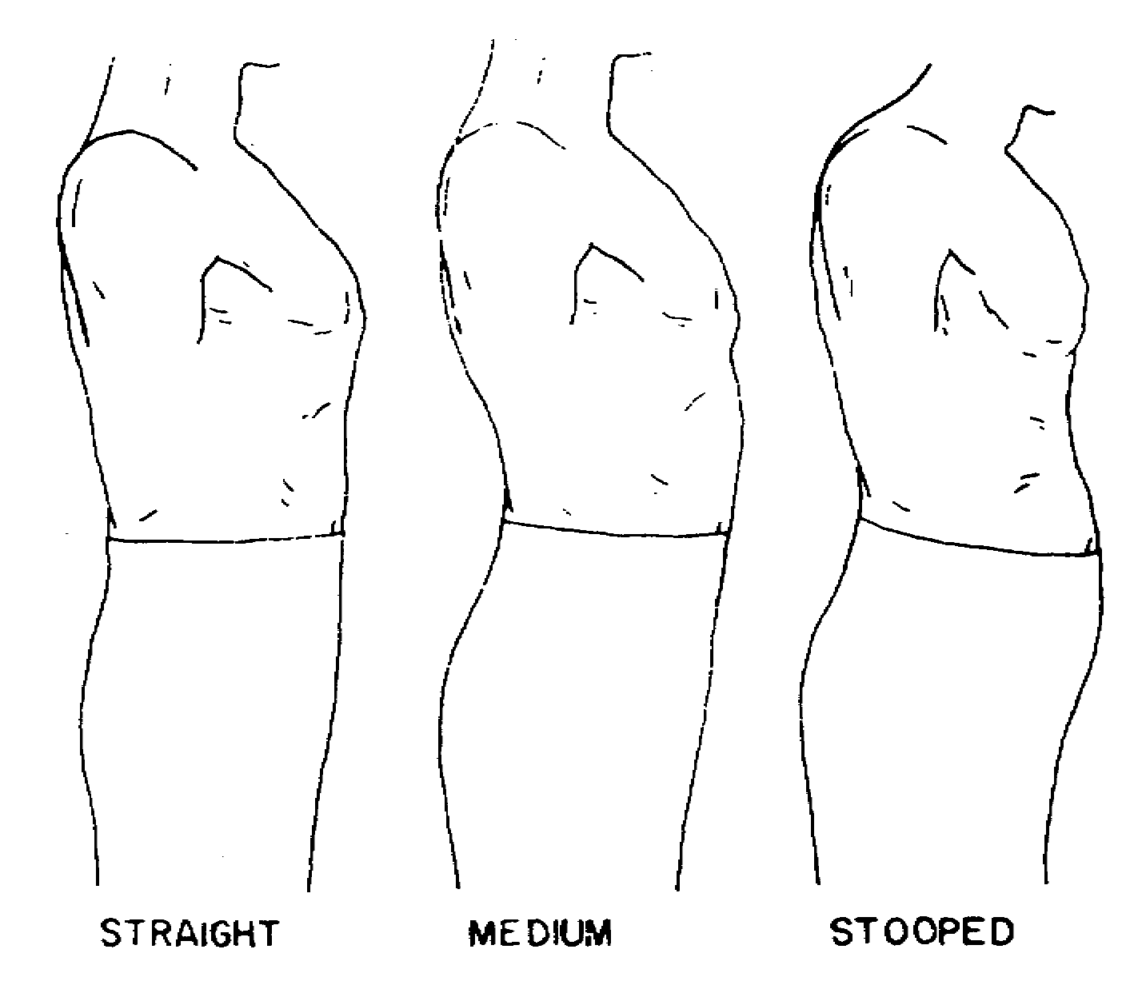
Figure 5-2. Posture.

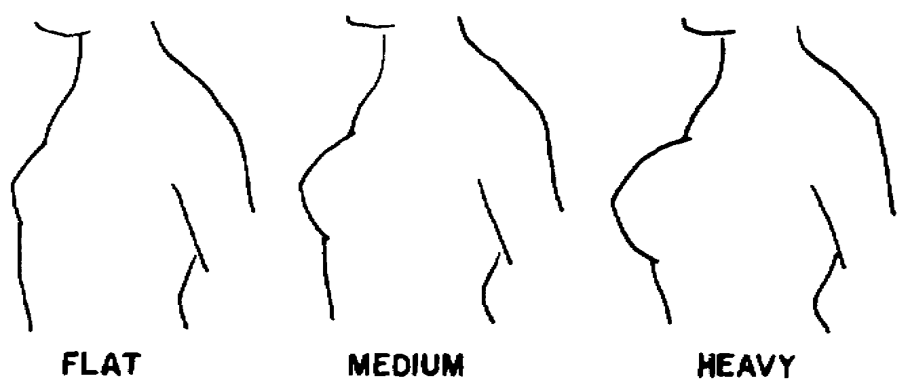
Figure 5-3. Bust.

5-7 MP1016

(f) Age. Actual or estimated. When the age is estimated, this fact should be stated. Age may be estimated in multiples of five years. In describing the age of a woman, indicate not only the actual age but also the general age indicated by appearance.

(g) Complexion. Pale, fair, dark, ruddy, sallow, or florid (flushed); clear, pimpled, blotched, freckled, or pockmarked. In the case of a woman, include makeup habits, such as none, light, heavy, or other term or phrase. For persons of the Negro race, complexion should be described as light brown, medium brown, dark, or olive.

(2) Specific Characteristics. Pattern both your observation and description of the person along systematic lines, beginning with the head and progressing downward the following words, terms, phrases, and methods are recommend for standard use:

(a) Head.

1. Size and shape. Large, medium, or small, long or short, broad or narrow, round, flat in black, flat on top, egg-shaped, high in crown, or bulging in back. (Figure 5-4).

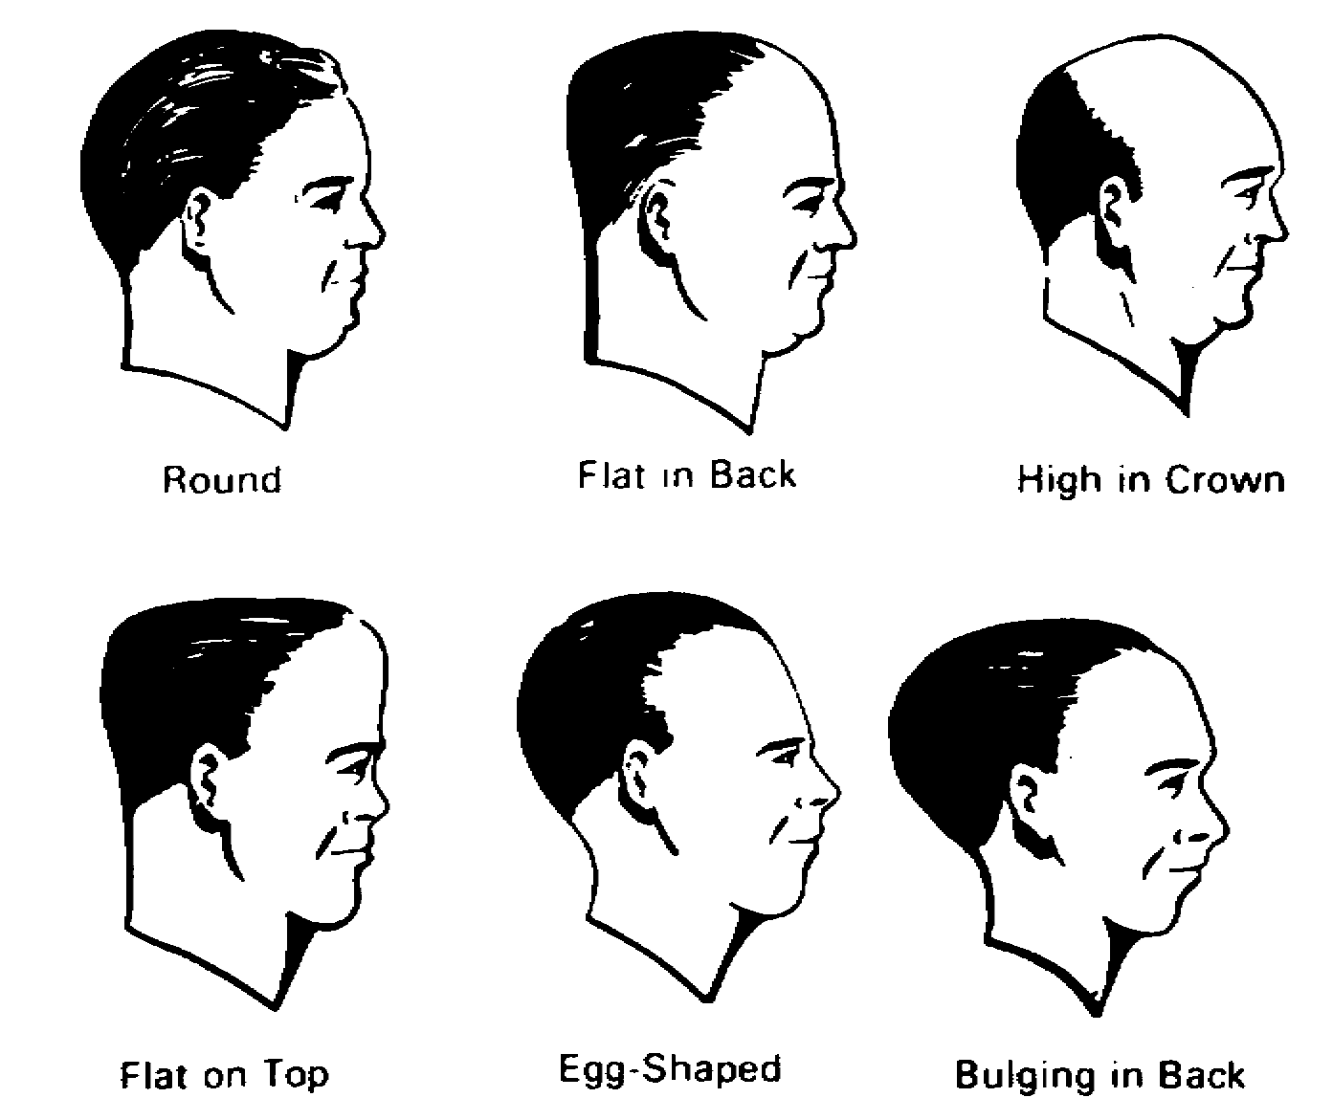
Figure 5-4. Shape of the Head.

MP1016 5-8

2. Profile. Divided mentally into three parts or sections as indicated in Figure 5-5; each third is then described in its relationship to the whole and in separate detail. Except in the case of peculiarities, the profile is not as important for identification as is the frontal view of the face.

3. Face. Round, square, oval, broad, or long (as seen from the front) (Figure 5-6).

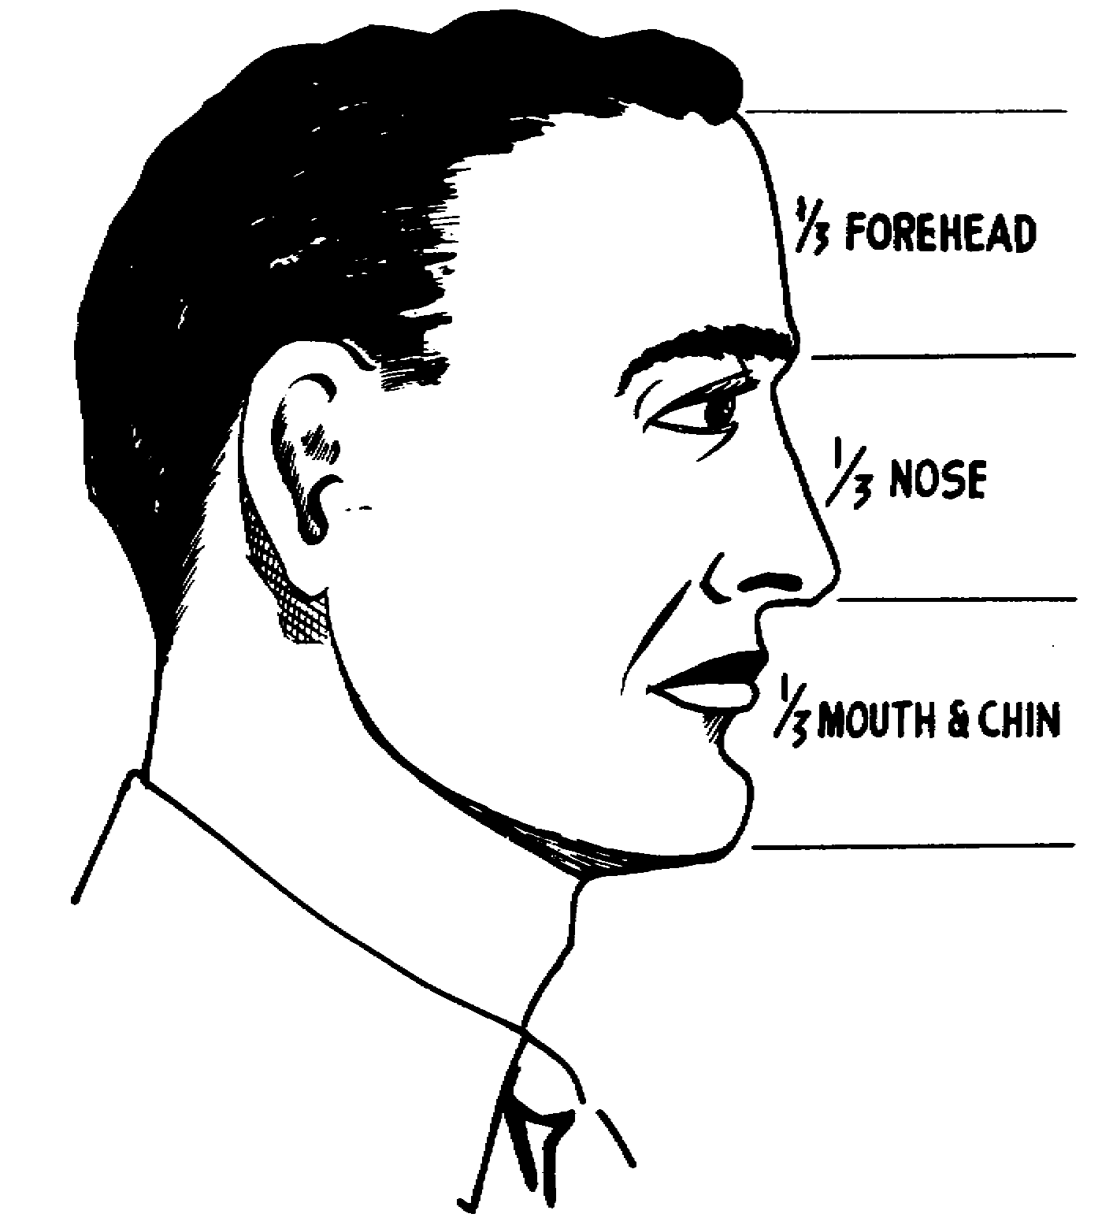
Figure 5-5. Division of the Profile.

5-9 MP1016

4. Hair. Color as blond (light or dark), brown (light or dark), red (light or dark), auburn, black, gray, streaked with gray, or white; in the case of bleached, tinted, or dyed hair, both the artificial and the natural color should be stated when possible. Density as thick, medium, thin, or sparse. Hairline as low, medium, receding, or receding over temples. Baldness should be described as complete, whole top of head, occipital (back), frontal, receding, or a combination of types (Figure 5-7). Hair types as straight, wavy, curly, or kinky. Hair texture as fine, medium, or coarse. Appearance as neat, bushy, unkept, oily, or dry. Hair styles as long, medium or short; parted on left, parted on right, parted in center, or not parted. Current terms of hairstyles which are readily and widely understood should be used. Wigs, toupees, and hairpieces should be described carefully and in detail. The careful observer can usually determine whether a person is wearing a toupee or other hairpiece from such indications as differences in hair texture, color, density, type, or appearance; furthermore, the arrangement of false hair will often be too nearly perfect. The edges of the hairpiece will often be evidence upon close scrutiny.

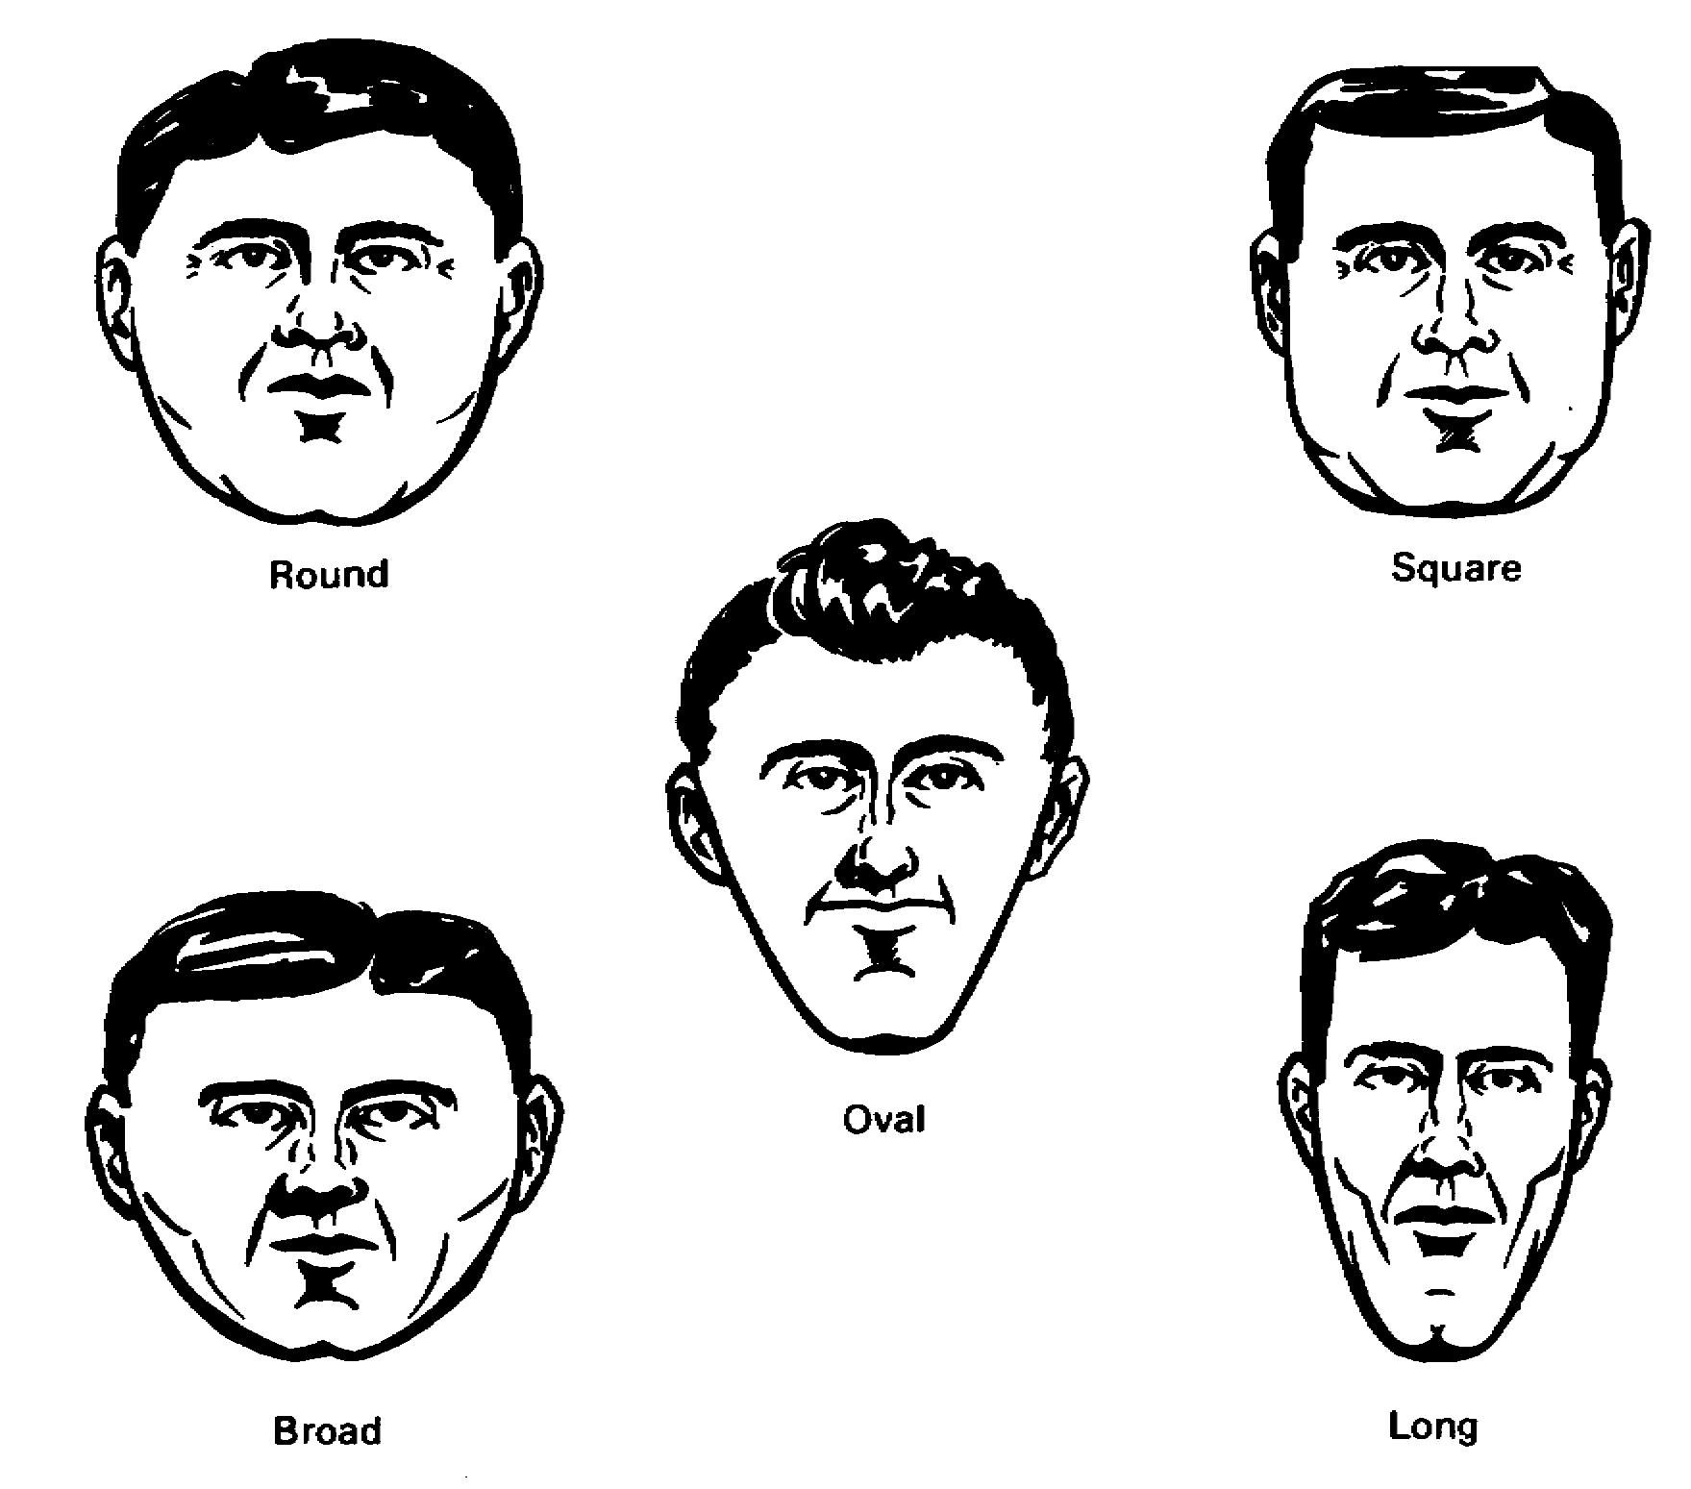
Figure 5-6. Shape of the Face.

MP1016 5-10

5. Forehead. High, medium, or low; slope as receding medium, vertical, prominent, or bulging; width as wide, medium, or narrow wrinkles or age lines as none, light, deep horizontal, curved (up or down), or vertical (Figure
5-8).

6. Eyebrows. Color, including any difference from hair color; slant from center (horizontal, slanted up, slanted down); line as straight or arched; separated or connected; texture as heavy, medium, or thin, hair as short, medium, or long; plucked; penciled. In describing women, it is often important that both the natural and the artificial appearance and contour of the eyebrows be indicated.

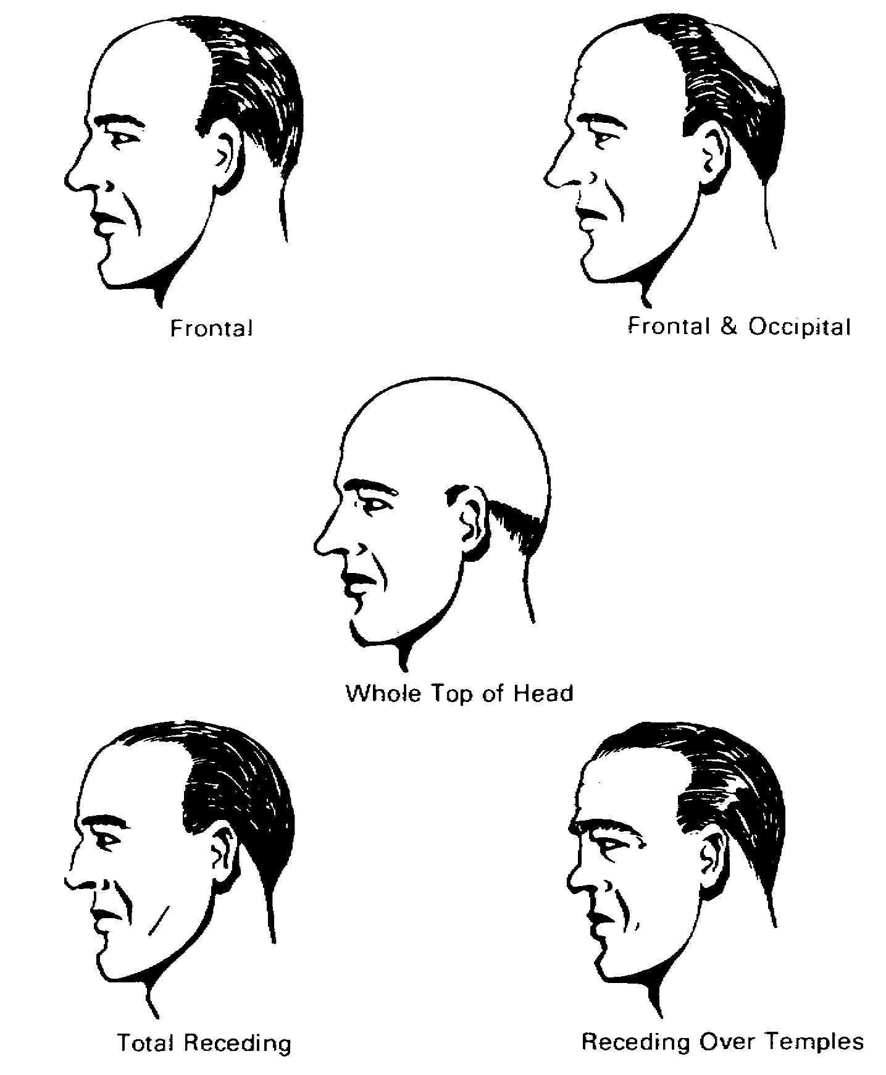
Figure 5-7. Types of Baldness.

5-11 MP1016

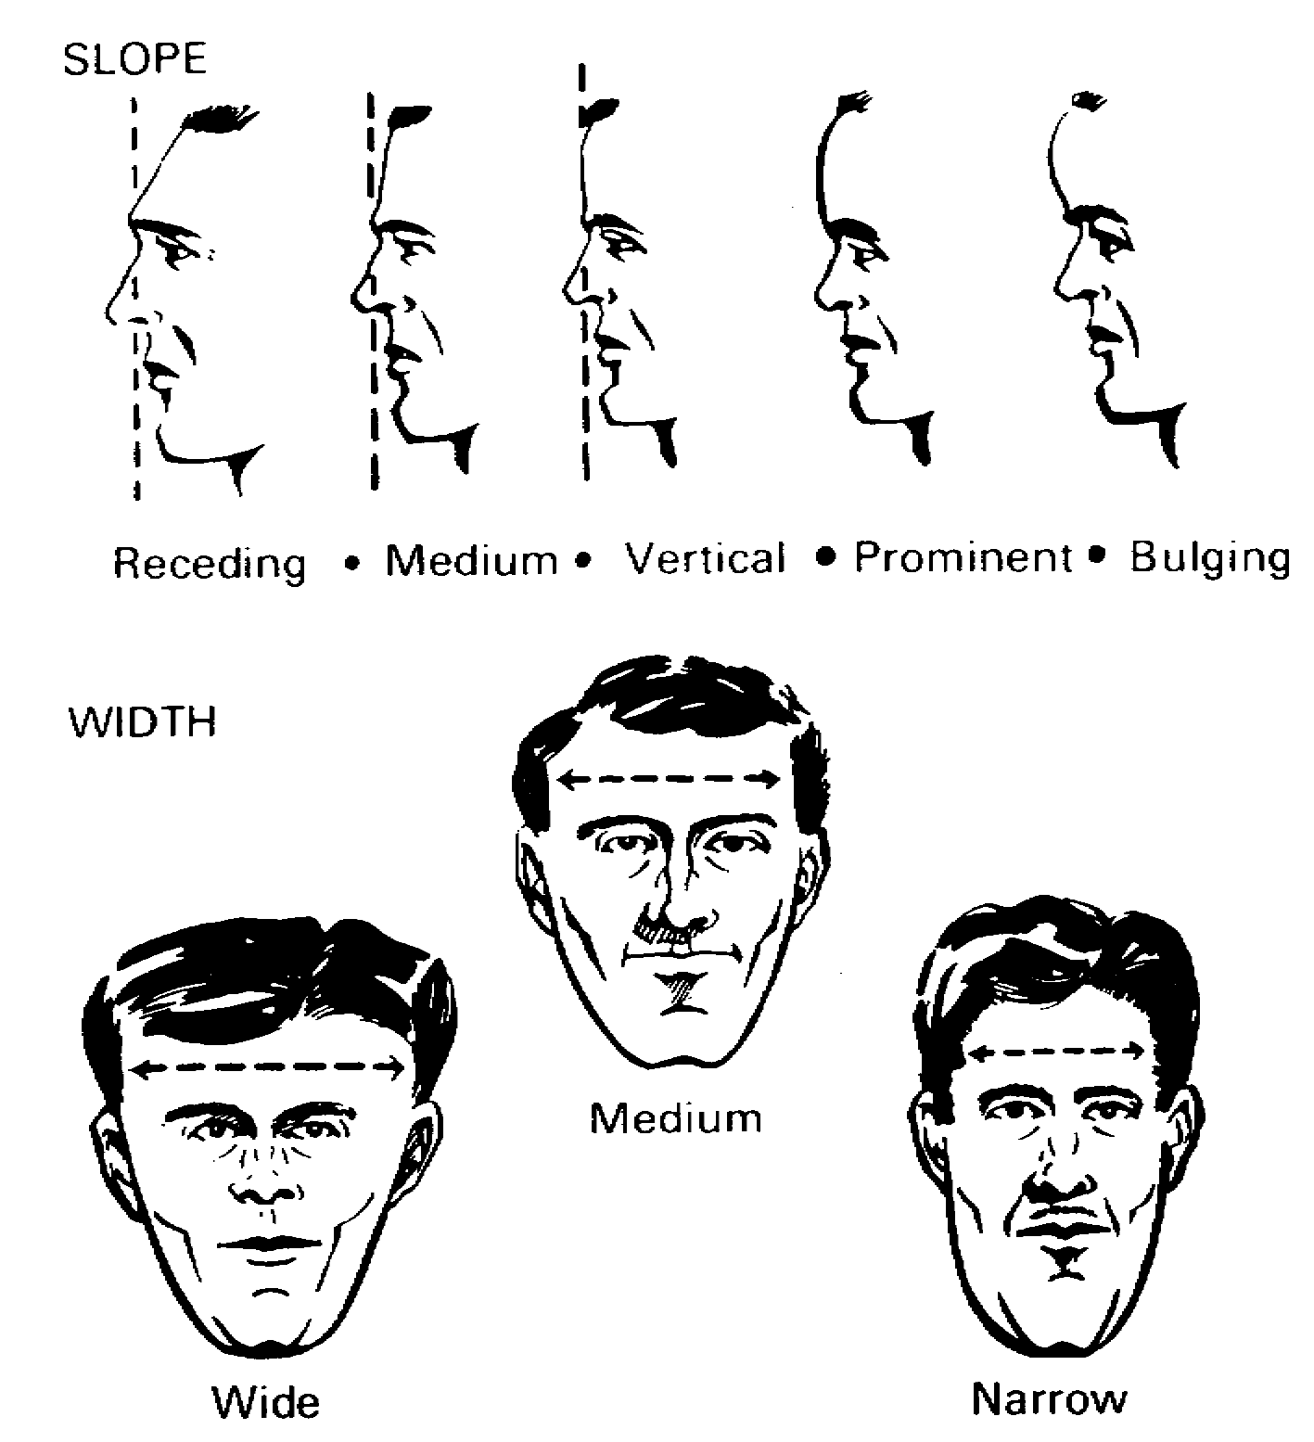
Figure 5-8. The Forehead.

7. Eyes. Deep-set (sunken), medium, or bulging; separation as wide, medium, or narrow; crossed, watery, red, or other noticeable peculiarity; color; long, medium, or short; straight, curled, or drooping. Eyeshadow as none, light dark, or irregular. In describing women, the normal eye makeup habits should be noted as to color, type, and extent.

MP1016 5-12

8. Eyeglasses (if worn). Eyeglasses should be described in detail to include style and color or frames, type and color of lenses, and method of attachment to face. Contact lenses may prove difficult to observe; however, the careful special agent will note such indications of the presence of contact lenses as watery eyes and excessive blinking. Special types of eyeglasses, such as monocles, lorgnettes, and pince-nez, should be carefully noted.

9. Nose. Length as short, medium, or long; width as thin or narrow, medium, or thick; projection as long, medium, or short; base of the nose as turned up, horizontal, or turned downward (Figure 5-9). The root of the nose (juncture with the forehead) should be described as flat, small, medium, or large; and the line of the nose should be described as concave, straight, convex (hooked), roman, or aquiline (Figure 5-10). Nostrils should be indicated as medium, wide or narrow; large or small; height or low; round, elongated, or flaring. Peculiarities, such as broken, twisted to right or left, turned up, pendulous, hairy, deep-pored, etc. should be carefully noted and reported.

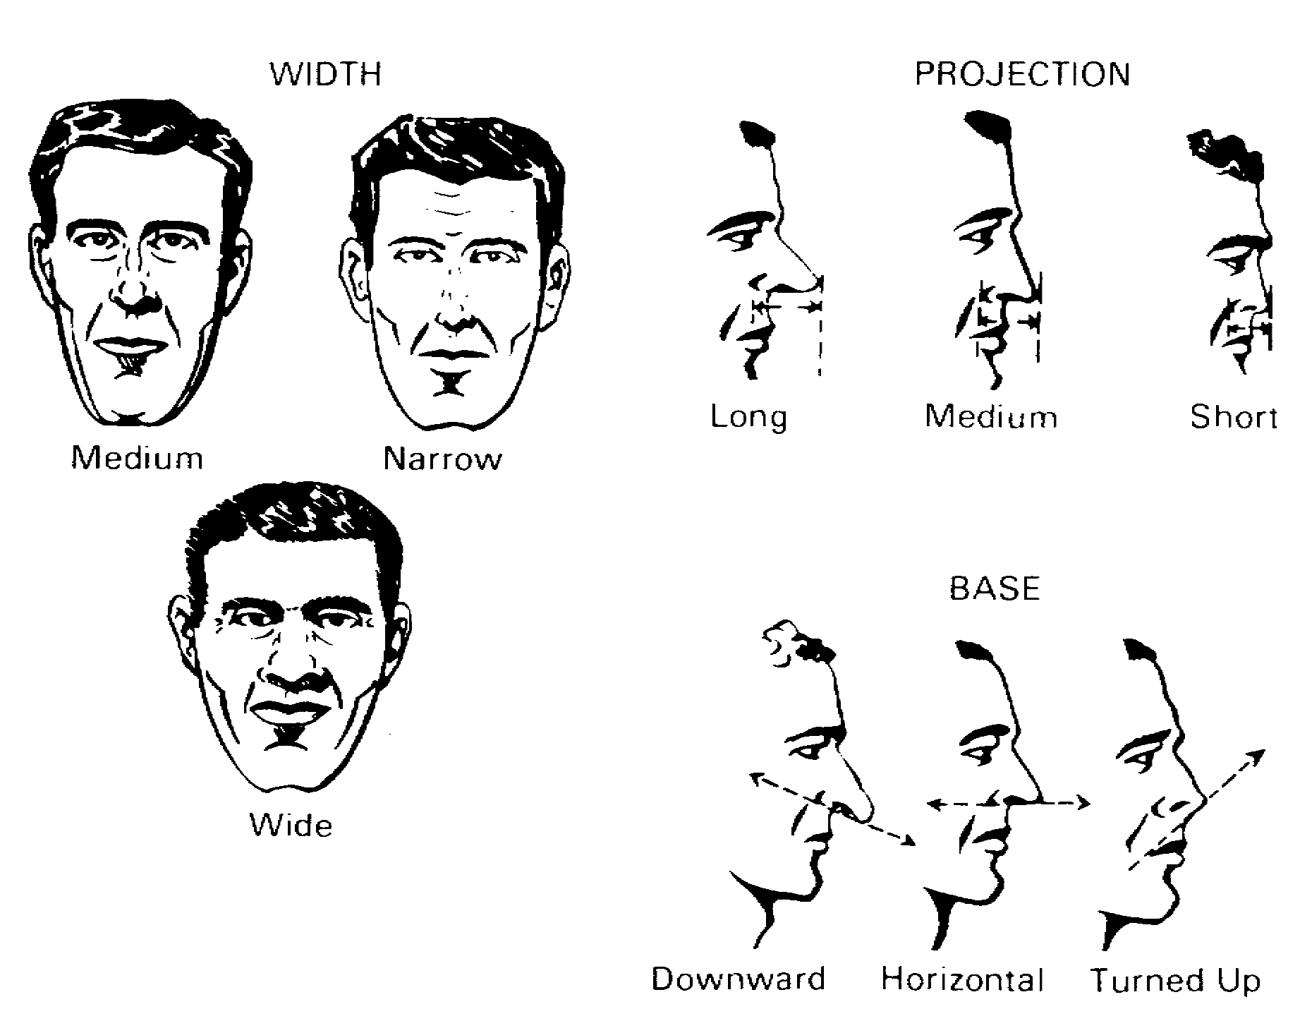
Figure 5-9. The Nose: Base, Width, and Projection.

5-13 MP1016

10. Mouth. Size (as viewed from front), small, medium, or large; expression as stern, sad (corners drooping), pleasant or smiling. Peculiarities, such as prominent changes made when speaking or laughing, twitching, or habitually open, should be clearly indicated (Figure 5-11).

11. Lips. Thin, medium, or thick (as viewed from front), long, medium, or short (as viewed in profile); position as normal, lower protruding, upper protruding, or both protruding; color; appearance as smooth, chapped, puffy, loose, compressed, tight (retracted over teeth), moist, dry, etc. (Figure 5-11).

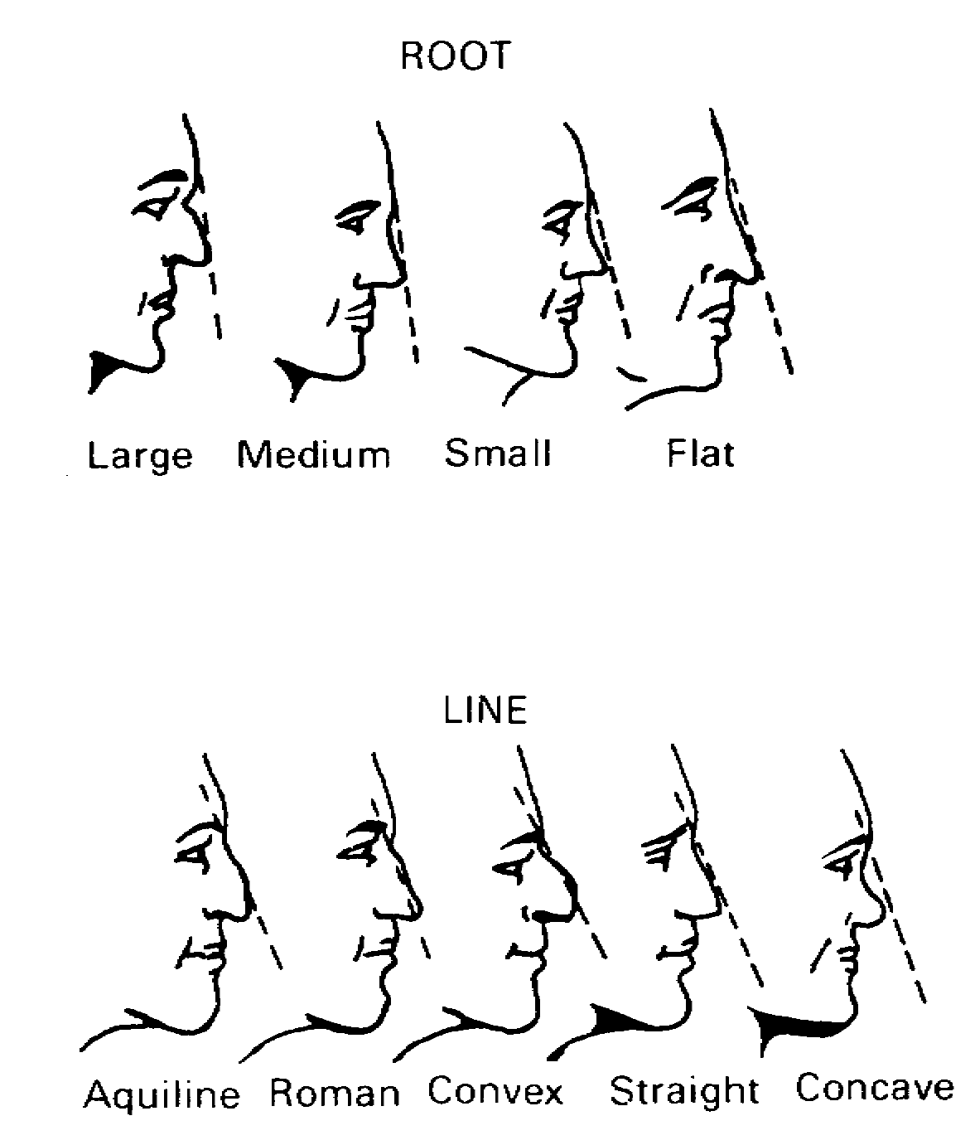
Figure 5-10. The Nose: Root and Line.

MP1016 5-14

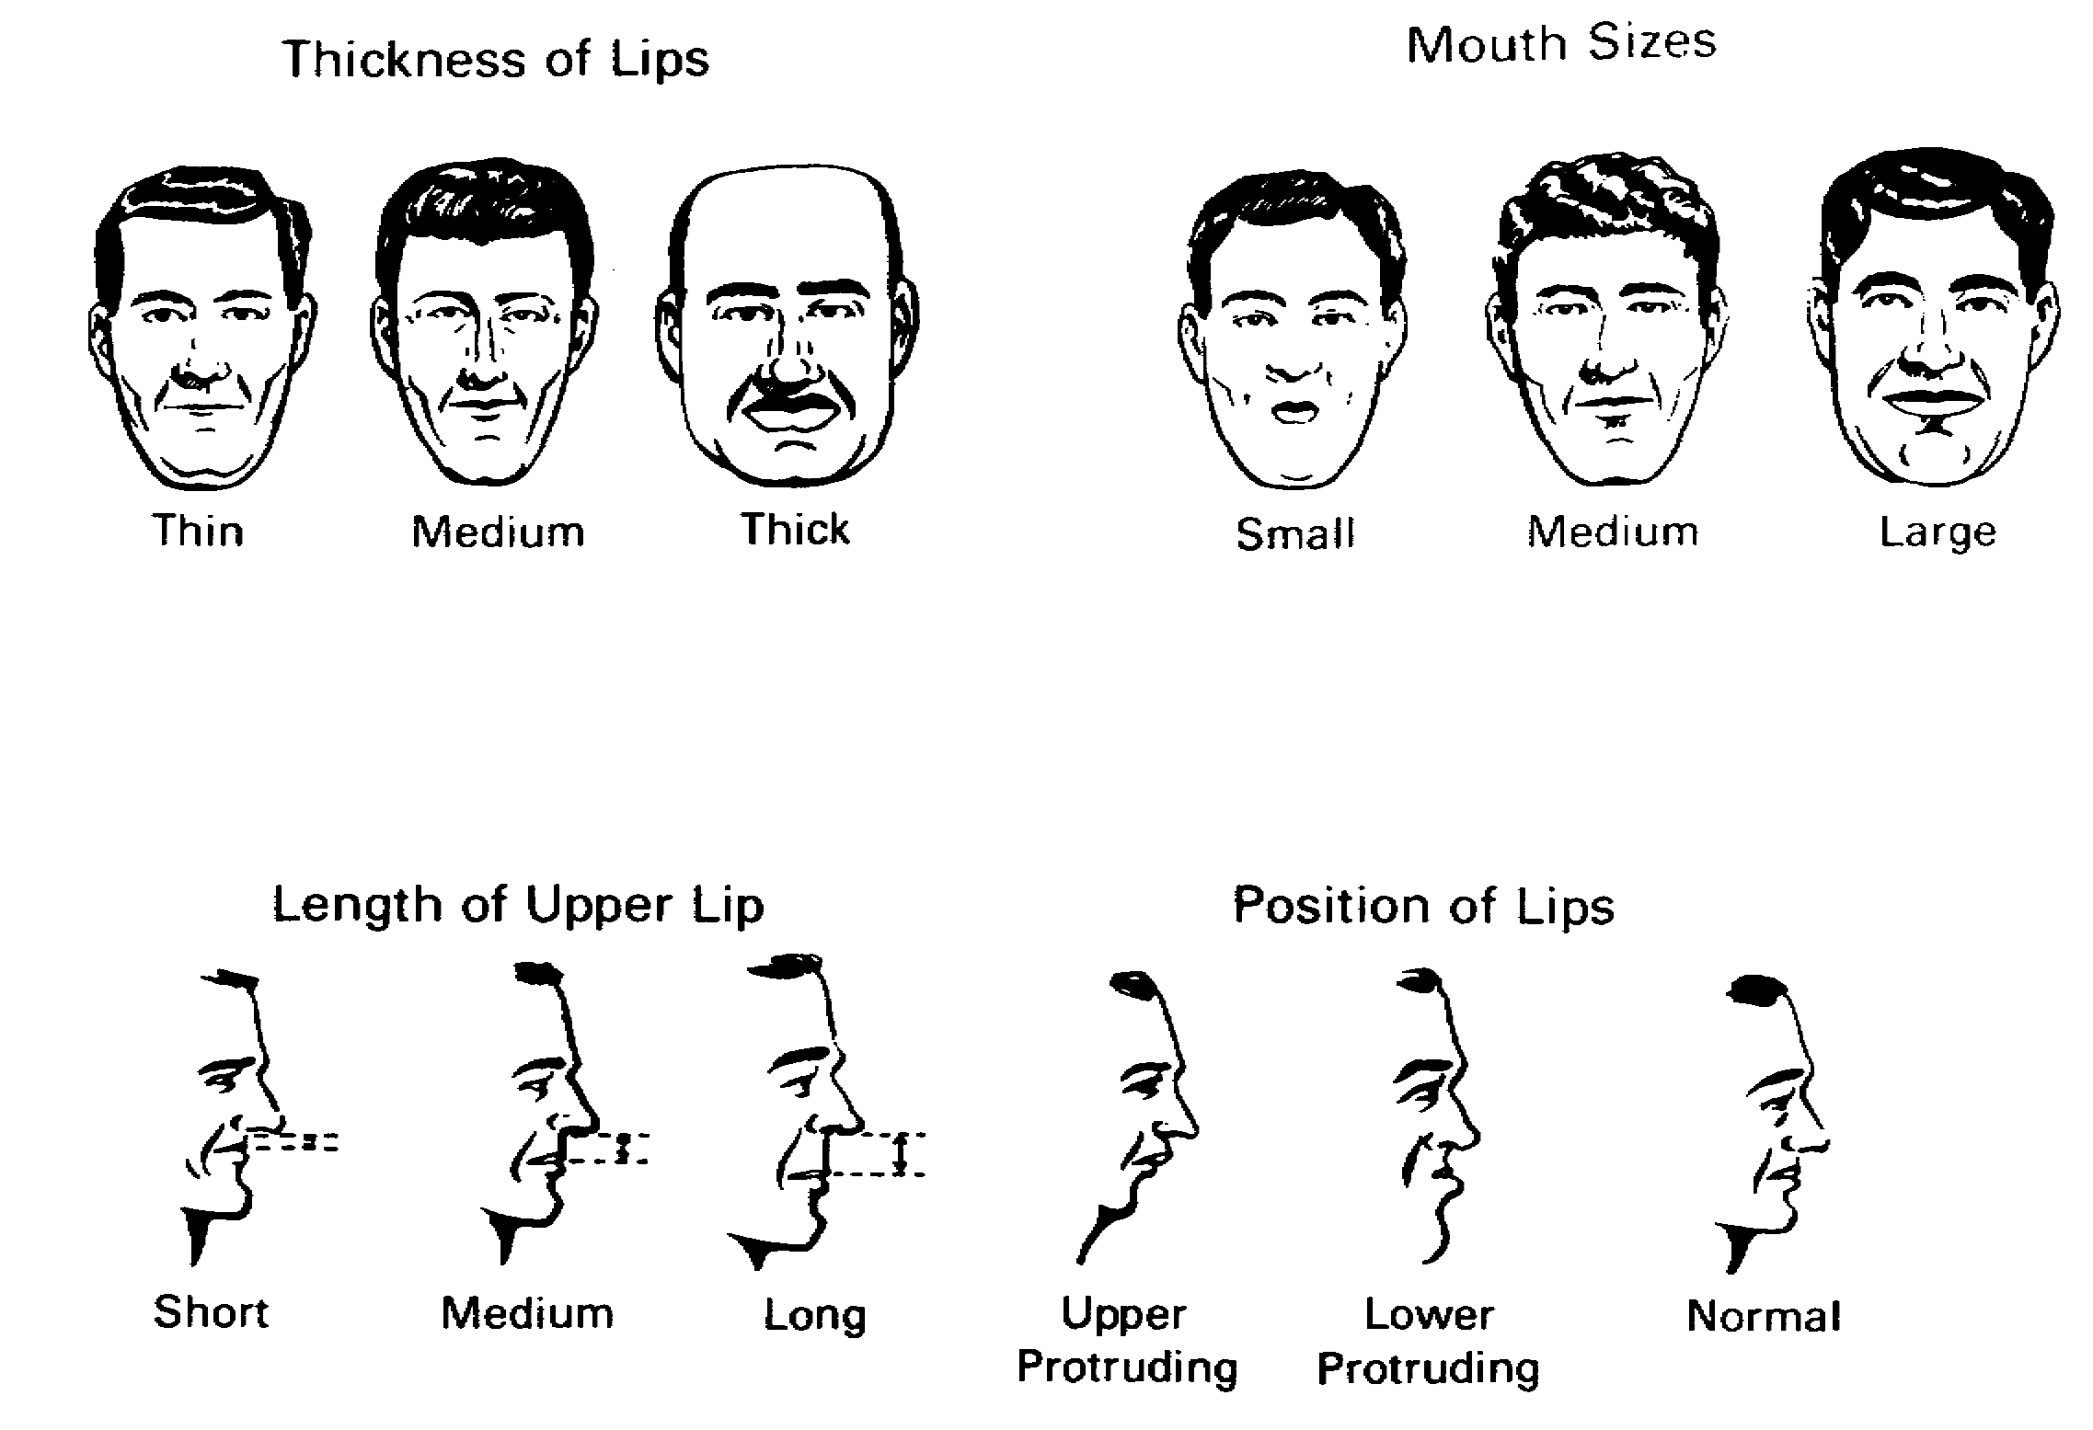
Figure 5-11. The Mouth and Lips.

Harelip and other peculiarities should be carefully noted. In the case of women, the color type, and extent of lip rouge should be described; in this connection, be alert for the use of lip route to alter or accent the natural appearance of the lips (Figure 5-12).

5-15 MP1016

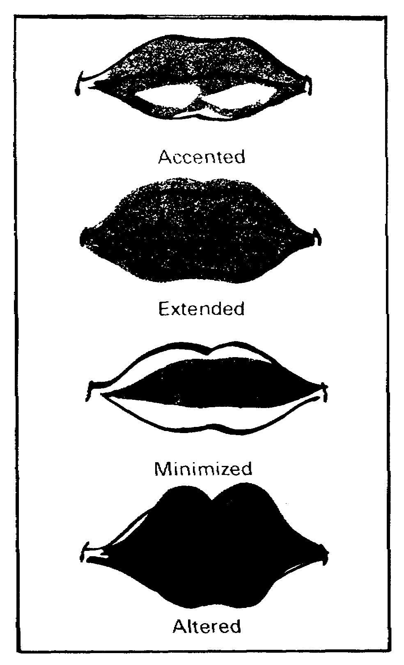
Figure 5-12. Application of Lip Route.

12. Mustache and beard (when appropriate). Color, including any difference from hair color; style and configuration; and state of grooming (Figures 5-13 and 5-14).

13. Teeth. Color; receding, normal or protruding; large, medium, or small, stained, decayed, very white, broken, false, gold, flared, uneven, or missing.

MP1016 5-16

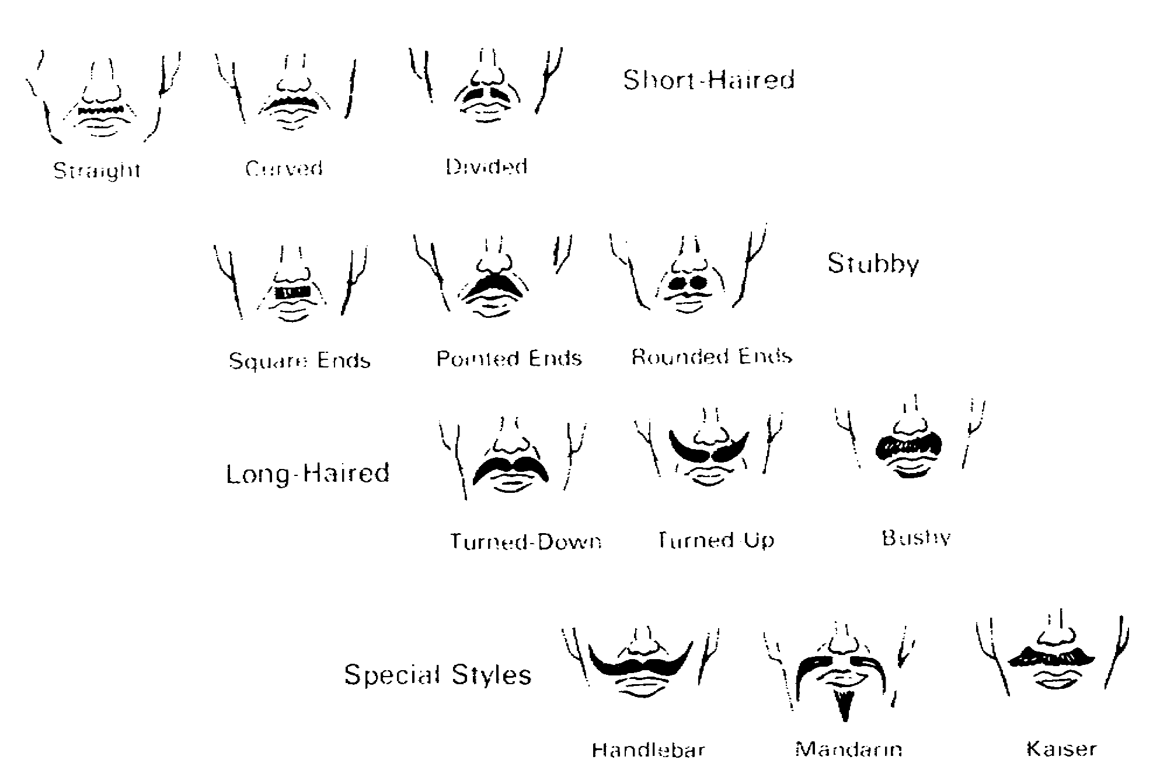
Figure 5-13. Mustaches.

14. Chin. Normal, receding, or jutting (as viewed in profile); short, medium, or long (as viewed from the front); small, large, pointed, square, dimpled, cleft, or doubt (Figure 5-15).

15. Ears. Small, medium, or large; shape as oval, round, triangular, rectangular, or other appropriate term; lobe as descending, square, medium, or gulfed (Figure 5-16). Separation from the head should be described as close, normal, or protruding; and setting (based on a line extended horizontally back from the outside corner of the eye, which crosses the normally set ear at the upper third) should be indicated as low, normal, or high (Figure 5-17).

5-17 MP1016

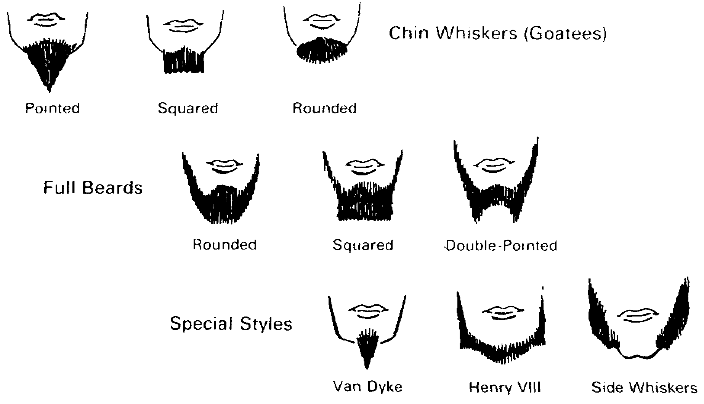
Figure 5-14. Beards.

16. Hearing aids (when appropriate). Hearing aids should be described in detail as to type (such as inside the ear, behind the ear, with cord, or cordless), color, and ear in which worn.

17. Cheeks. Full, bony, angular, fleshy, sunken, or flat; cheekbones as high (prominent), medium, or receding; in the case of women, makeup habits should be noted.

(b) Neck. Short or long; straight or curved; thin or thick; Adam's apple as large (prominent), medium, or small.

(c) Shoulders. Small, medium, or heavy; narrow, medium, or broad; square or round; level or one side lower; as seen in profile, straight, slumped, or humped (Figure 5-18).

MP1016 5-18

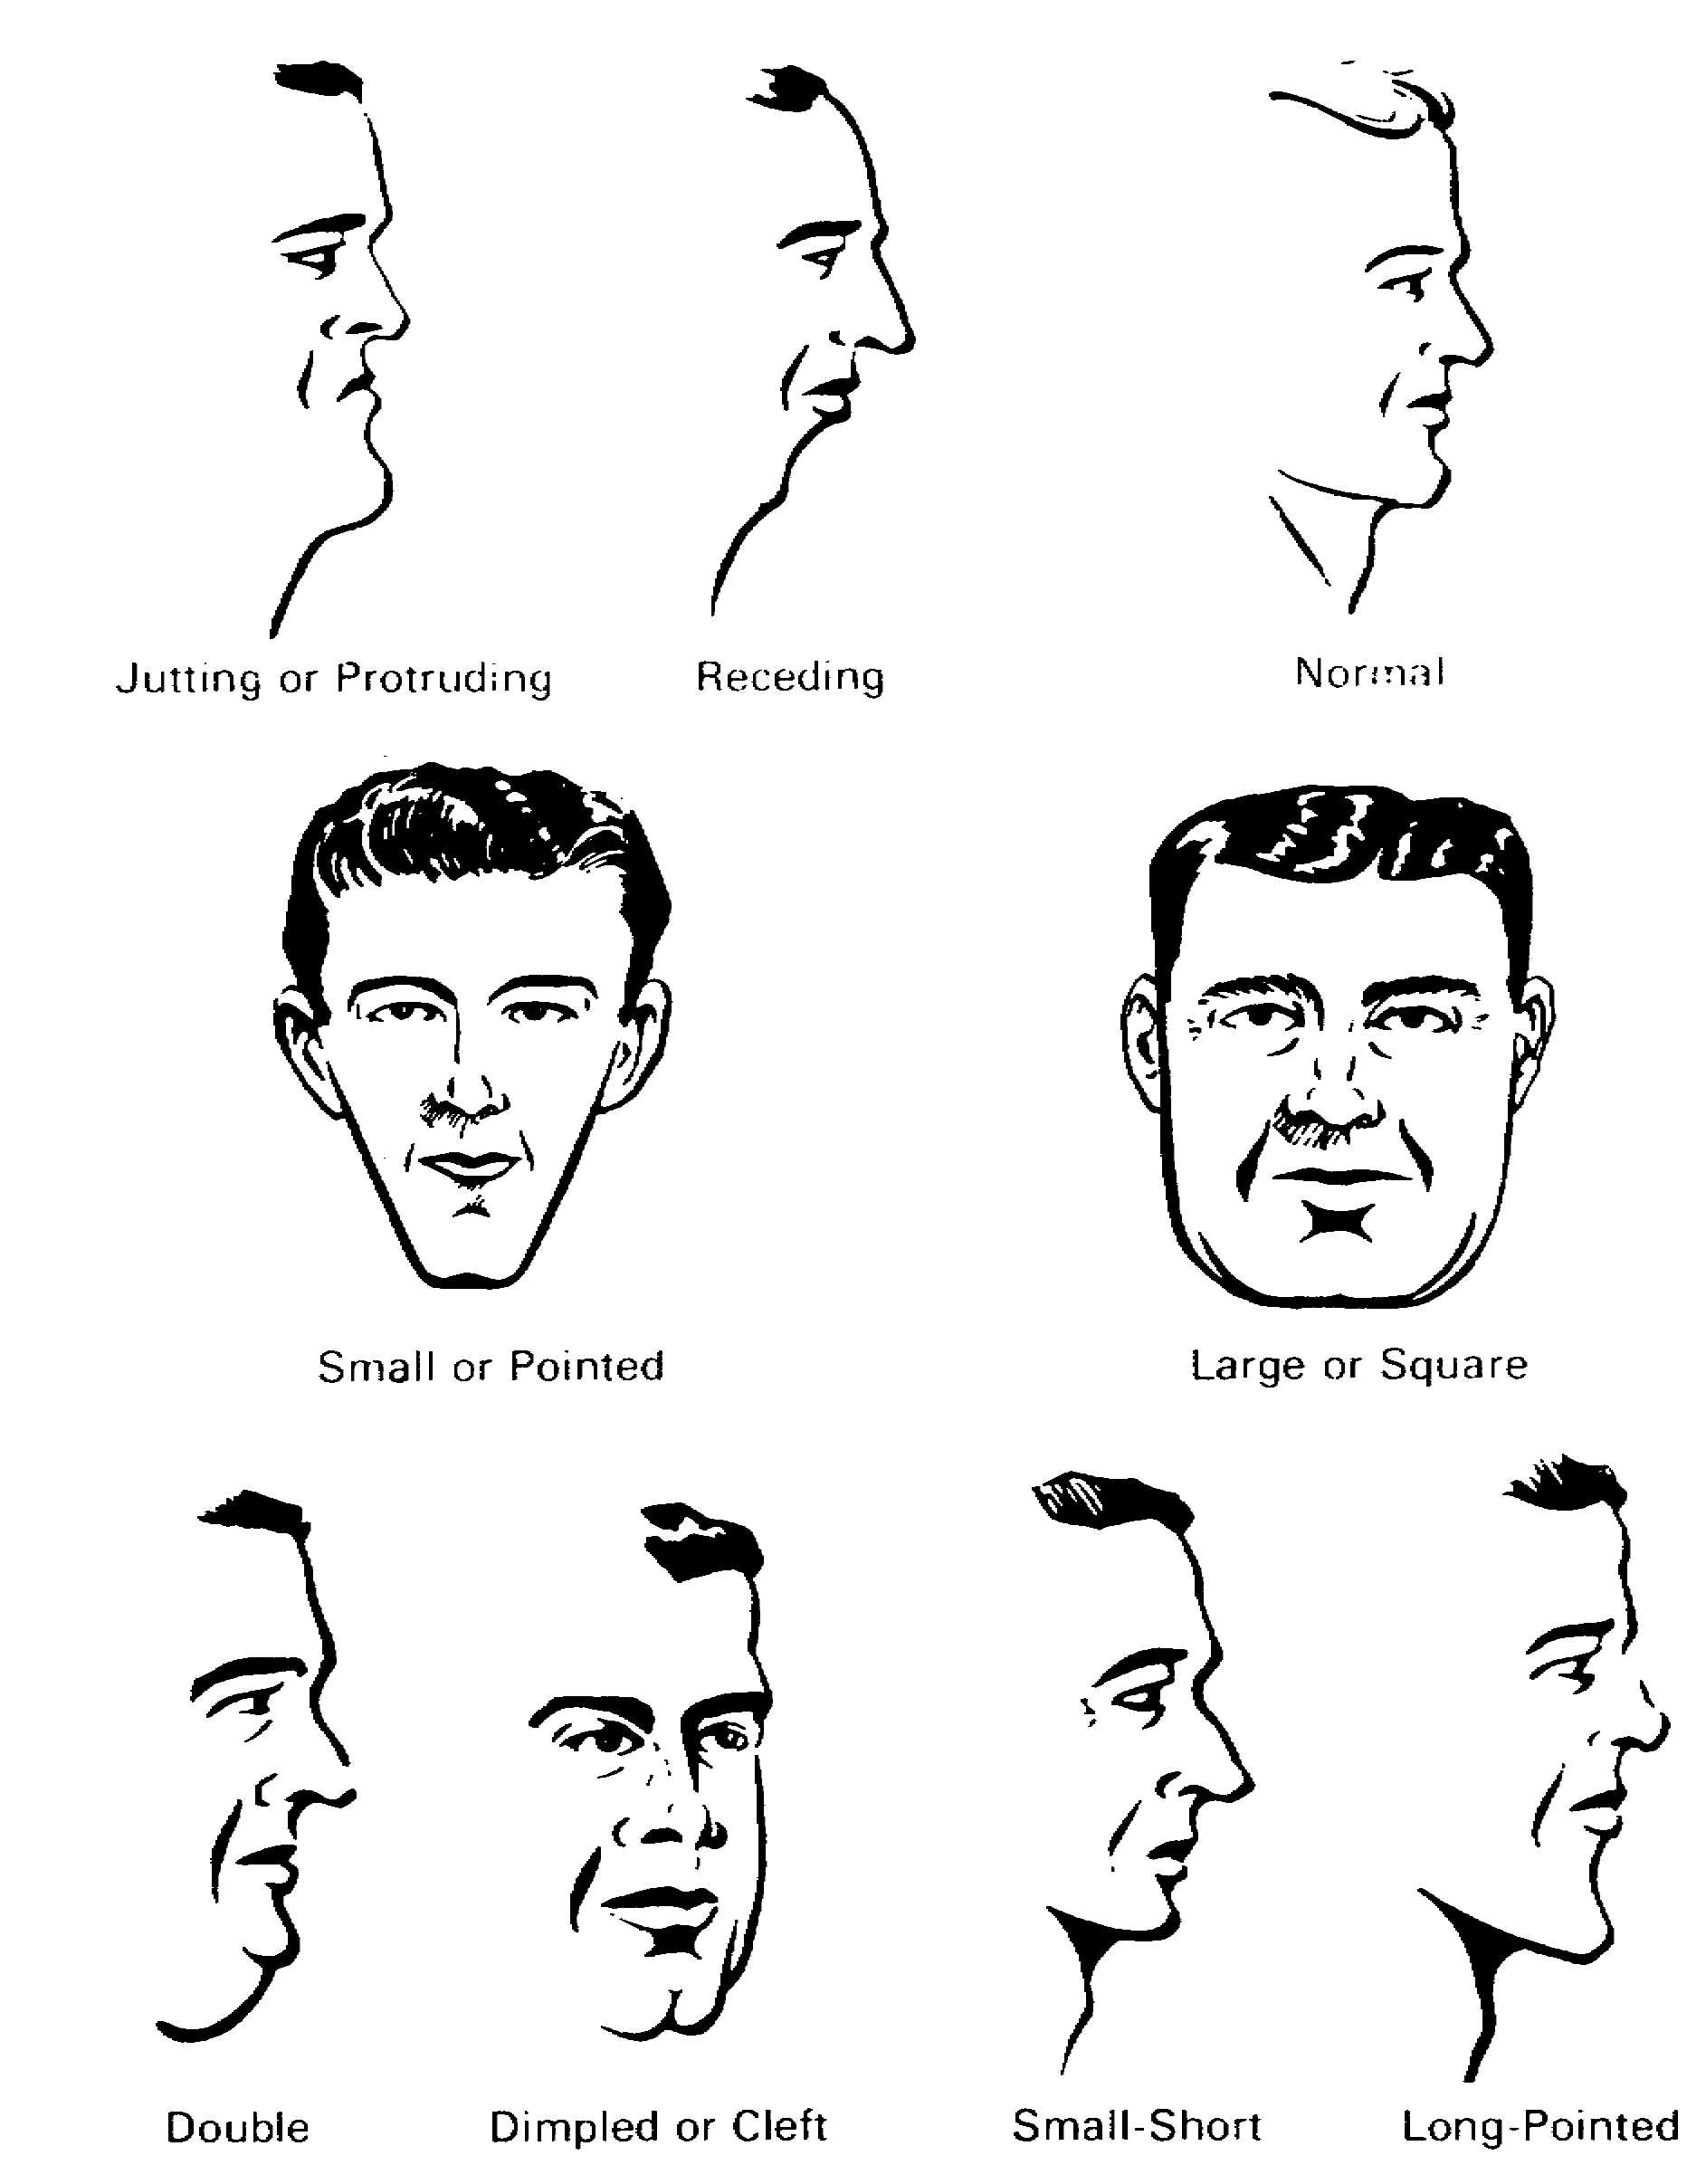
Figure 5-15. The Chin.

5-19 MP1016

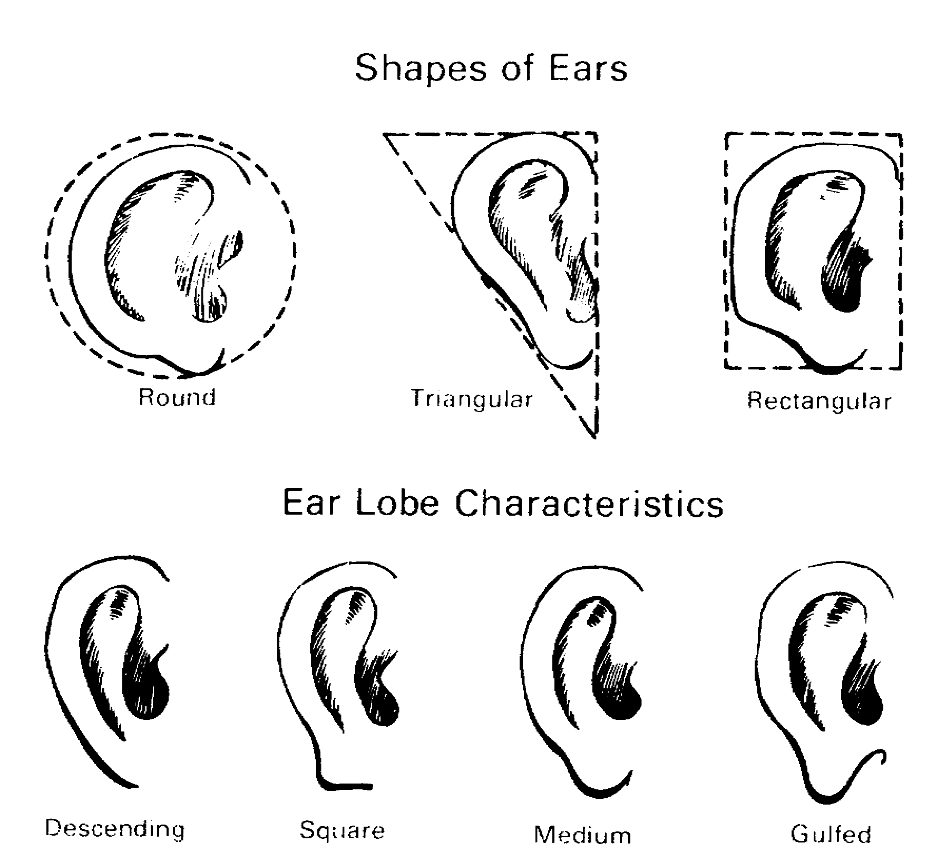
Figure 5-16. The Ears: Shape and Lobe.

MP1016 5-20

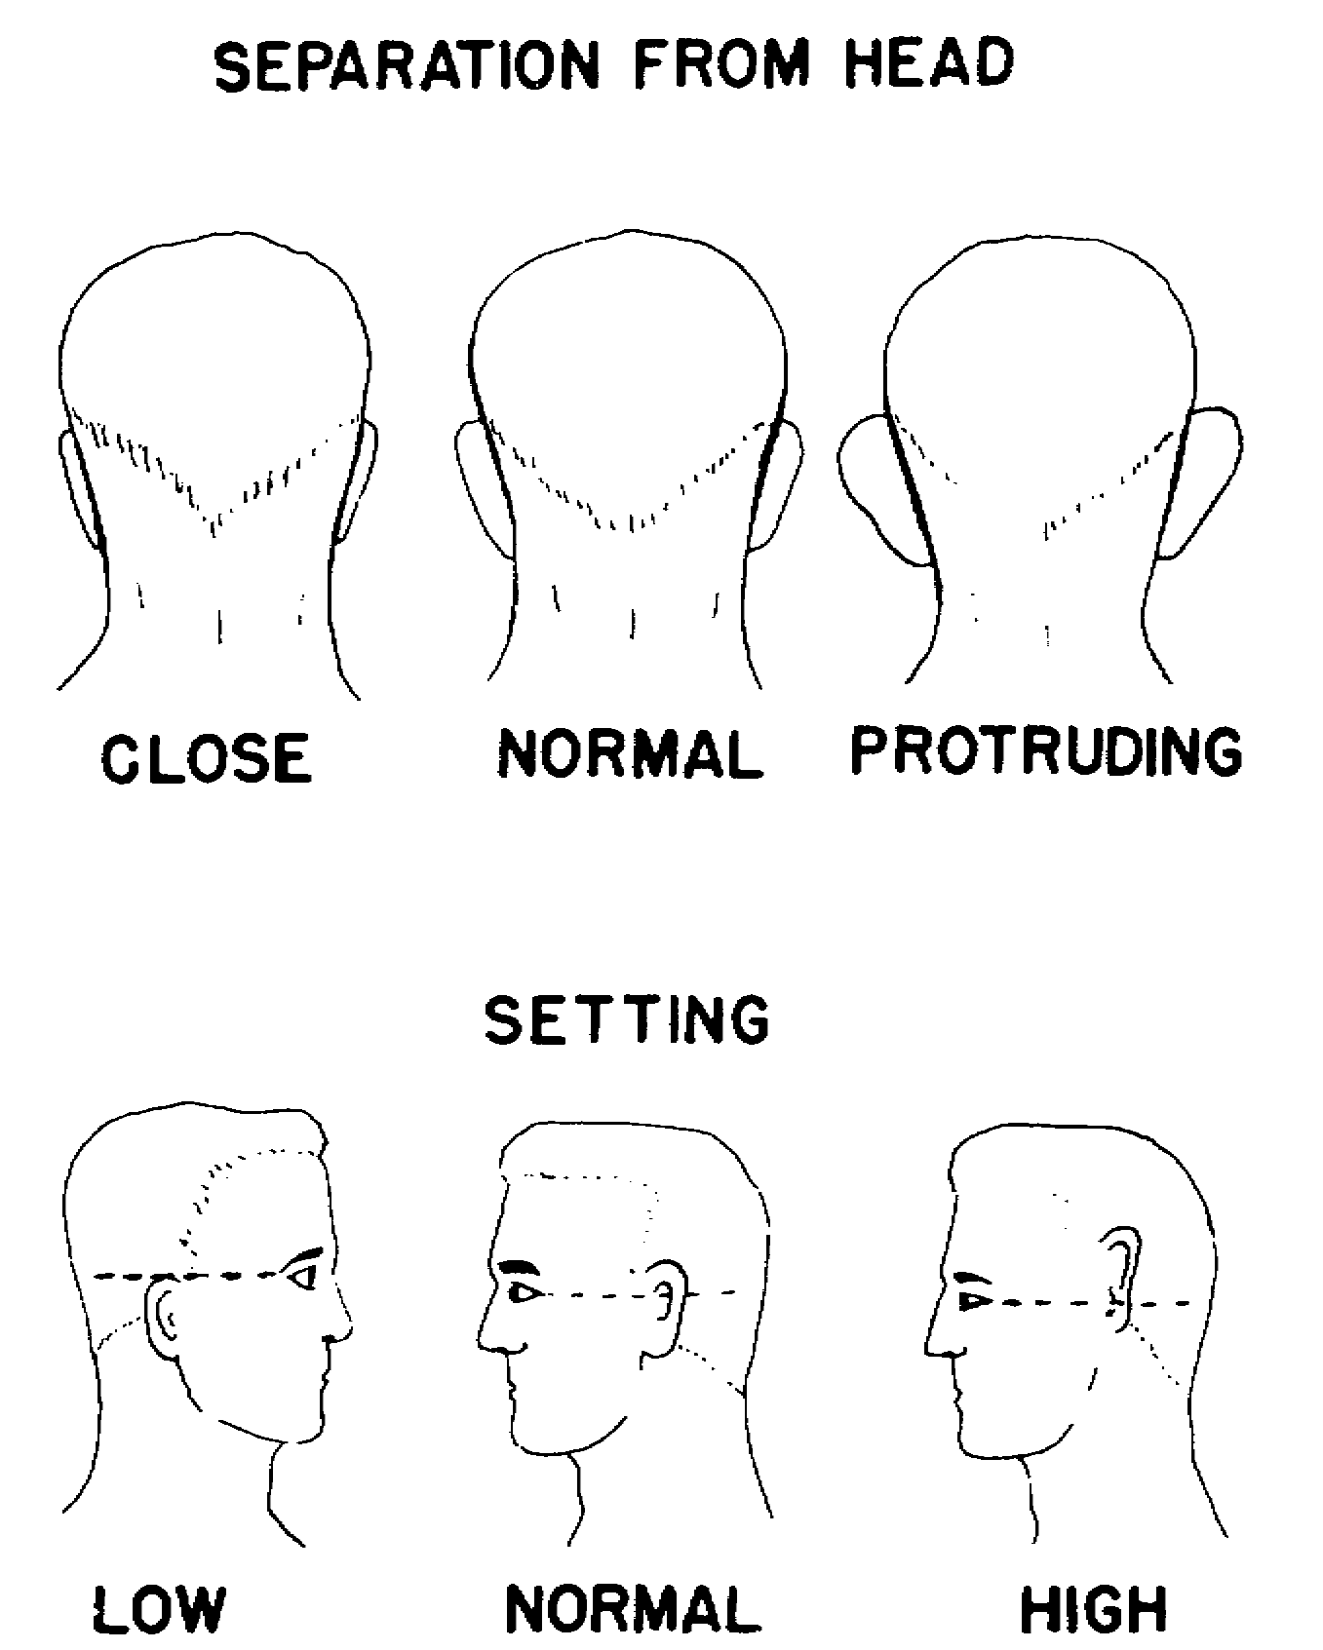
Figure 5-17. The Ears: Separation and Setting.

(d) Arms. Long, medium, or short in comparison to rest of the body (average or medium arms terminate with the heel of the hand about halfway between the hips and the knee when the arms are hanging naturally); musculature as slight, medium, or heavy.

(e) Hands and fingers.

1. Hands. Small, medium, or large in relation to the size of the person; peculiarities should be noted in detail.

5-21 MP1016

2. Fingers. Long, medium, or short; thin, medium, or thick (stubby); deformities, such as missing fingers, disfigured nail, or crooked fingers, should be indicated.

(f) Trunk.

1. Overall. Long, medium, or short (in relation to rest of body).

2. Chest. Deep, medium, or flat, as seen in profile; broad, medium, or narrow, as seen from the front (Figure 5-19).

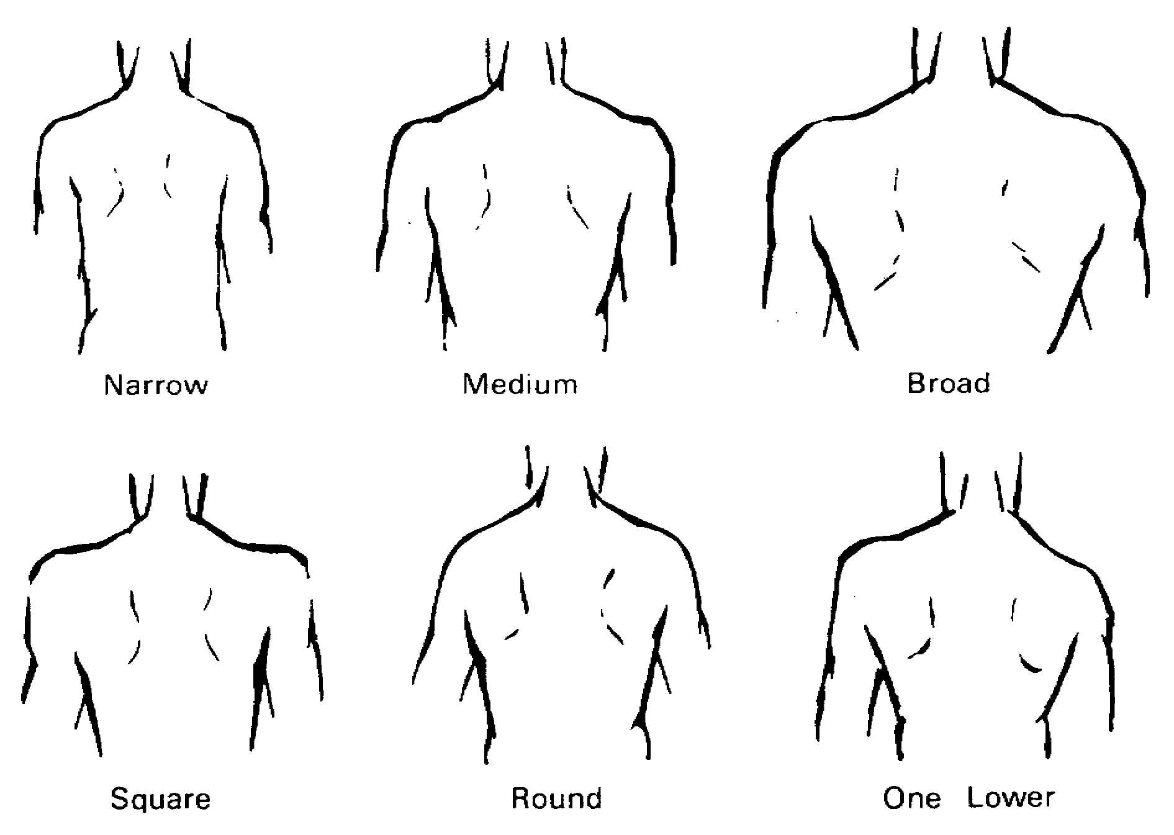
Figure 5-18. The Shoulders.

MP1016 5-22

3. Back. Straight, curved, humped, or bowed, as viewed in profile; straight or curved, as viewed from the rear.

4. Waist. Small, medium, or large (Figure 5-20).

5. Abdomen. Flat, medium, or protruding (Figure 5-20).

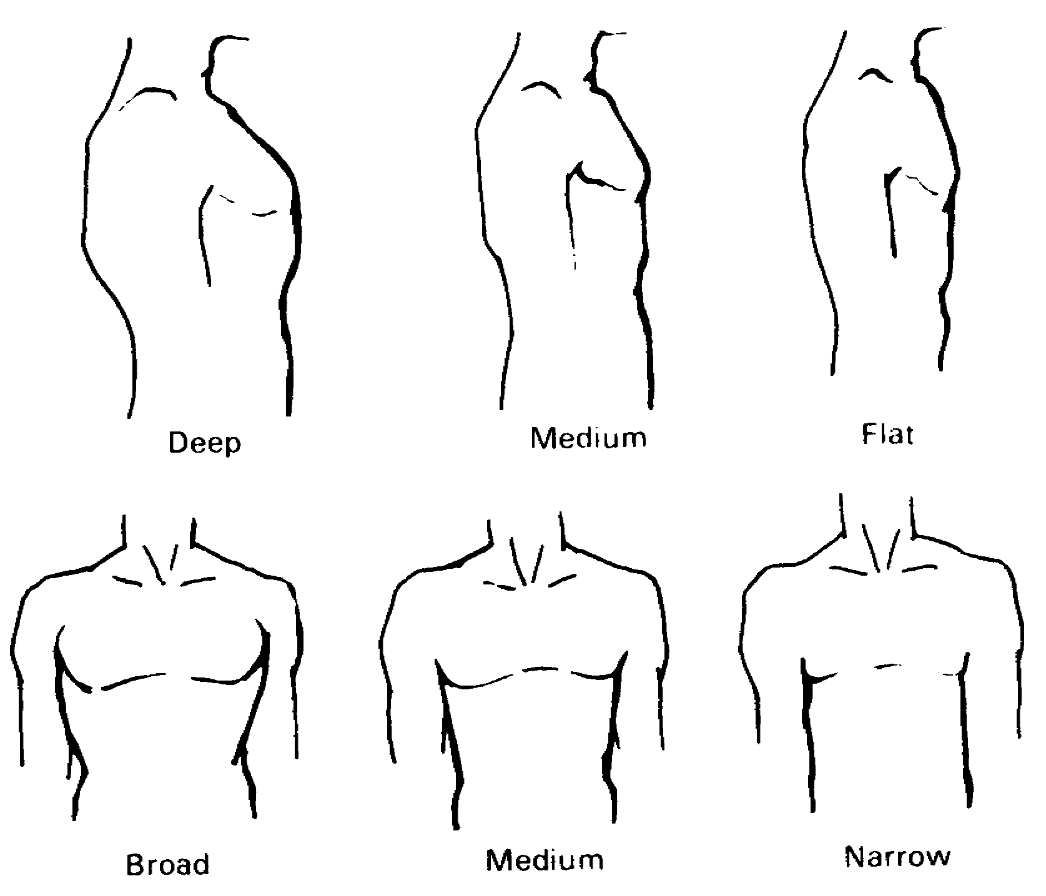
Figure 5-19. The Chest.

5-23 MP1016

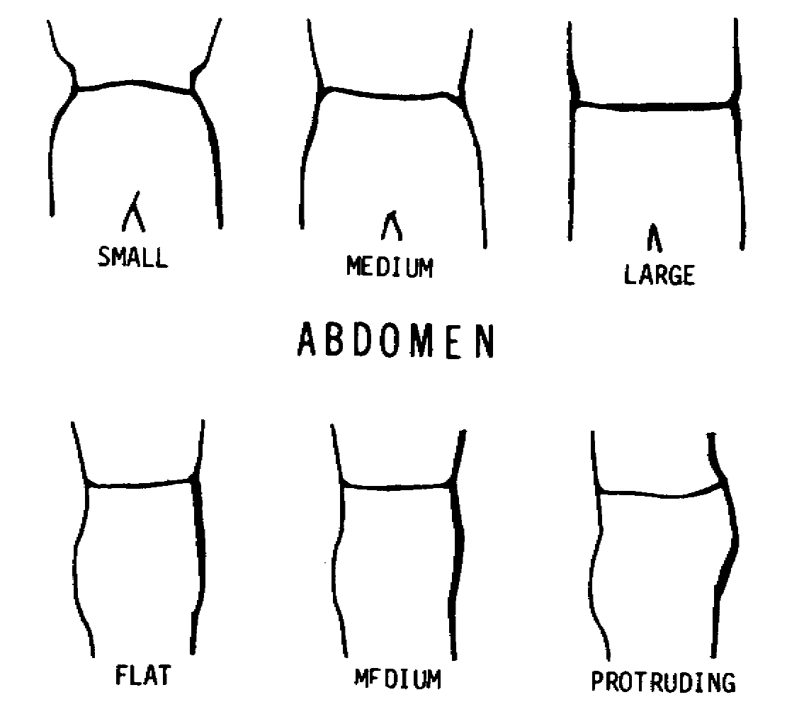
Figure 5-20. The Waist and the Abdomen.

(g) Hips. Broad, medium, or narrow, as seen from the front; small, medium, or large, as seen in profile. In this connection, the observer should keep in mind the basic differences between male and female.

(h) Legs. Long, medium, or short in comparison to rest of the body (average or medium legs combined with the hips constitute about half the body length); straight, bowed (bandy), or knock-kneed; musculature as slight, medium, or heavy.

(i) Feet. Small, medium, or large in relation to body size; deformities and peculiarities, such as pigeon-toed, flatfooted, or clubfooted, should be carefully recorded.

(j) Marks and scars. Such identifying marks as birthmarks, moles, warts, tattoos, and scars should be clearly described as to size, color, location on the body, and shape.

(k) Speech. The tone and manner of a person's speech may often be important aspects of his description. His habitual tone should be indicated as low, medium, or loud; short or gruff, or by other qualities. His manner of speaking should be indicated as cultured, vulgar, clipped, fluent, broken English, with accent (identified if possible); or non-English speaking (language specified when possible); such peculiarities as stuttering, nasal twang, pronounced drawl, or a mute condition should be stated and explained.

MP1016 5-24

(1) Dress. Since a person may change the clothing he was wearing, its value for descriptive purposes is limited. Noticeable habits in manner of dress, such as neatness, carelessness, and style, should be indicated. Clothing worn by a person at the time of an offense or when last seen should be described in detail, such as military (service or fatigue), civilian, mixed military and civilian, color(s), and condition such as clean, soiled, torn, ragged, greasy, or bloodstained.

(m) Personal appearance. Neat or untidy; well-groomed or unkept; refined or tough.

(n) Mannerisms and habits. Often the mannerisms or traits of a person will be the major key parts of his description. Be alert to record such characteristics as:

1. Feminine traits in men and masculine traits in women.

2. Mannerisms in walking, moving, or talking.

3. Outward emotional instability, nervousness, or indecision.

4. Type of companions preferred.

5. Subconscious mannerisms, such as scratching the nose, running the hand through the hair, pulling on an ear, hitching up the pants, jingling keys, or flipping coins.

6. Facial tics, muscular twitches, and excessive "talking" with the hands.

7. Kind(s) of recreation preferred or hobbies pursued.

8. Jewelry worn and type(s) of jewelry preferred.

4. Describing Objects. This is generally limited to those that are located at the crime scene, or to those that have been said by a witness or victim to relate to the case. Due to the great variation of objects which may be described, it is not possible to prescribe a detailed pattern for their observation description. However, as in the case of persons, begin with the general characteristics and proceed to the more specific ones.

a. The description should be such as to define the general category of the object and preclude its being confused with similar objects. This should include those aspects of an object which may serve for a quick and conclusive recognition. Thus, in the case of a motor vehicle, a general description should include whether passenger or cargo type, make, model, color, and year of manufacture.

b. It is the specific feature that will distinguish an object from all
others of a similar kind. The description will vary according to the type
of object; however, it should follow a general pattern, such as top to bottom,

5-25 MP1016

right to left, or front to rear. Such things as marks, scratches, alterations, damaged parts, worn areas, signs of repair, faded paint, serial number, identifying marks, and missing parts should be noted in detail.

5. Describing Places. In order to present a concise and readily understandable work picture of the scene, it should contain all the elements and should proceed by the methods of observation discussed in paragraph 2c. To help describe it, sketches and photographs can be made.

6. Describing Events. This should present as accurately as possible what happened. The description must be as complete as practical. It should always contain the time, location, sequence of action, objects and persons involved, and the results. To accomplish a thorough and logical description of an event, consider all information from your own observations, statements made by witnesses and suspects, and the evaluation of evidence from the scene. The description should also have sketches and photographs.

7. Techniques and Identification. Identification of persons, objects, places, and events is dependent upon the observations and descriptions made either by you or by others. This is the relationship of a person, object, place, or event to a specific incident, offense, or another event. Your ability to do so must be developed through practice and experience.

a. The identification of persons will depend, to a large measure, on the quality of the description. In observing for identification, the characteristics of a person will normally be the primary and critical points. The general characteristics may become secondary other than for such basic distinctions as sex, race, or size.

b. As in the case of persons, the identification of objects known or suspected to be connected with a crime or an incident will often proceed from an observation of specific identifying characteristics. Both objects and persons are subject to change. You must be adept in recognizing such alteration.

c. The places and scenes which you will most frequently identify are those which were observed and described by witnesses or victims of a crime or incident. Ease of identification will be largely determined by the quality of the description. However, you must identify quickly with reasonable certainty the landmarks, terrain, and objects described to you.

d. You will not often personally observe the crime or incident. You must acquire skill in interpreting the description of such events from others. Be alert to associated facts or actions as described in paragraph 2d.

8. The Observations, Descriptions, and Identifications by Witnesses or Victims. This is a major source of information. You must acquire a high level of skill in obtaining, evaluating, and using this information during your investigation.

MP1016 5-26

9. The Observations. Although you cannot control the technique of observation by other persons, you may, through skillful and patient questioning, often aid them in recalling details observed. Thus, while the witness may not be trained or experienced in observing, it may be possible for you to develop a reasonably clear word picture of what they observed by encouraging the use of a pattern of recall. When thus encouraged to recall in a methodical fashion that which he observed, a witness may realize that he saw much more than he recorded at the time of observation. Before you can obtain and develop the descriptions of other persons, you must acquire an awareness of, and be able to make allowances for, the facts which influence perception, interpretation, and retention.

a. External Influences.

(1) Location of the Witness at Time of Observation. Two or more persons will seldom have witnessed an incident from exactly the same location. Location may account for differences in observations.

(2) Weather and Light Conditions. The effects of weather and light upon observations are self-evident. You must make proper allowance for them.

(3) Presence of Distracting Events. Unrelated events may influence a witness' observation of a particular incident. Thus, an exciting play on a football field may cause a spectator to fail to observe what the person sitting next to him is doing.

(4) Lapse of Time Since the Observation was Made. The passage of time between observation and recall can influence a description. The imaginative person may tend to fill in the gaps in his knowledge if he has learned that the incident is important in an investigation. On the other hand, many persons will tend to forget or confuse details with the passage of time. It is important that witnesses and victims be interviewed as soon as possible after they made their observation and before they had time to adjust their observations to fit the pattern of other information they may have seen or heard.

b. Human Factors. Perception is largely determined and influenced by past experiences, physiological and psychological influences, and training. Within this framework, a person evaluates and interprets through the five senses. The special agent must recognize the implication of individual differences and must be able to evaluate their effects upon the observations of a witness or victim.

(1) Past Experiences. The person's evaluation and interpretation of that which he observes tends to be predetermined by his past experience of similar or related occurrences. The size of an object could be compared with the size of another object with which he is familiar. Familiar sounds, odors, tastes, and comparable perceptions will be properly interpreted. Incoming stimuli with which there are not past comparable perceptions will often be misinterpreted in terms of familiar things. In general, you should bear in mind that:

5-27 MP1016

(a) Young persons have limited past experiences on which to base their interpretations, yet, depending upon their interest, they may make accurate observations. For example, how many American boys can quickly recognize and identify the make and model of an automobile, but would not likely perceive details of the driver, the license number, or make and condition of the tires.

(b) Normally, the mature person has had many and varied experiences on which to base his interpretations. However, this will be limited to occurrences in his area of residence and employment. Thus, a lifelong resident of a city might be incapable of describing a farm scene; and a native of a tropical island could hardly be expected to describe in minute detail a high-speed motor vehicle accident.

(c) In the case of elderly persons, weakness may prevent proper patterned interpretation, or experiences may be so varied and interrelated as to result in confusion.

(d) Specialists may have developed acute perception within their fields but be unobservant in other fields. For example, an artist will be acutely aware and take note of color, form, and proportion but may fail to note or interpret properly sounds, or odors. A mechanic may be quick to observe the sound of a motor or other indications of the state of repair of an automobile but may be inexact in describing the appearance and actions of the driver.

(2) Physiological Influences. Defects in the physical condition may greatly affect ability to observe accurately and to interpret properly. Such factors as age, disease, injury, underdevelopment, and undernourishment must be considered. Pain, hunger, fatigue, and unnatural positions of the body may cause a witness to interpret, inaccurately that which he would normally place into proper perspective. The following factors should be considered:

(a) A person of short or tall stature may misinterpret the size of another person. For example, a person six feet tall may appear very tall to an observer who is himself only 4 feet 10 inches tall, while the same six-footer would likely appear to be of normal height to an observer who is 5 feet 10 inches tall.

(b) The senses of hearing and touch of a blind person are usually developed far beyond those of a person with normal vision. Thus, he may perceive sounds or note details of objects touched which the normal person may fail to observe.

(c) The senses of taste and smell are subject to distortion by physical disorders and by external stimuli. The presence of a strong taste or odor may conceal other tastes or odors; therefore, these two senses are considered the least reliable of the senses.

MP1016 5-28

(3) Psychological Influences. Emotional disturbances, such as fear, anger, worry, prejudice, or mental instability, may impair the functioning of a person's senses and result in poor observation. The special agent must recognize this and make allowance for them.

(a) The victim of a robbery may be in such fear of the weapon used, that his recollection of the incident will be only that of the size of the bore of the weapon and he will be unable to describe the perpetrator. Furthermore, he might be expected to exaggerate the size of the bore.

(b) A witness may so dislike a person involved as to see only the actions of that person and no others.

(c) A witness may be so prejudiced against a class or race of persons that he will be inaccurate even though his senses recorded a true report of what occurred.

(4) Training. Specialized training may intensify power of observation. However, often such training may tend to focus attention onto particular characteristics only. For example, a dye chemist may quickly recognize the dye used in a garment but fail to observe the form or state of repair of the garment. A tailor, on the other hand, might observe the cut of the same garment but fail to note the dye. A person with neither training may make a more accurate observation of the same garment than either the chemist or the tailor.

10. Description.

a. Some witnesses may be able to give a concise and factual account without your aid. However, in almost every case, you will need to ask questions to develop details considered unimportant to the witness, to assist in evaluating and interpreting his observations, or to settle discrepancies in his statements. While you can do little to influence or mold witness observations, you can greatly aid your investigation, through the use of skillful questioning techniques.

b. When obtaining a description, learn as much about the witness as is possible within the limitations of time and urgency. Consider the maze of differences that may affect his interpretation of his observation. Determine what might tend to cause him to withhold or distort details. Without background investigation, which the urgency of most cases will usually preclude, it may be difficult to determine differences and influences. However, certain techniques may be used to aid in determining the extent of these influences. Some of these are:

(1) Talking briefly with the witness prior to questioning may reduce his apprehensions regarding your CID special agent methods, self-involvement, and inconvenience. During the talk, you may discover traits which may influence his interpretation.

5-29 MP1016

(2) Having the witness repeat his description one or more times may reveal discrepancies. Pointing out and discussing these lead to a better description or to his admission of intentional distortion.

(3) Weighing the description made by a witness in the light of information in the case will help you to evaluate his credibility. A witness suspected of concealing information or of lying will make unconscious slips.

11. Identification. This is the act relating a person, place, object, or event to an incident or offense under investigation. You must conduct identification activities in such a manner as to preclude error or injustice. Before an identification is undertaken, you must be sure that the witness has made as complete and as detailed a description as possible. To avoid false identification and to eliminate the possibility of error, he should be given the chance to make comparisons of similar persons, objects, places, and events. For example, showing a witness a single weapon or confronting him with one person for identification purposes may confuse the witness and lead him to make a false identification simply because the weapon or person has been shown to him by you. He should be asked to identify a person or object from among a group of similar persons or objects. A witness attempting to identify a place should be asked to describe it in detail after having described it in relation to known landmarks; he should be asked to lead you to the scene. Certain techniques may prove useful. These include:

a. The Lineup. In order to minimize error and eliminate false identifications of persons or objects, a procedure known as the lineup may be employed. This offers a confrontation without leading or misleading the witness. While it is most commonly employed in the identification of suspected persons, it is equally useful with objects.

(1) Persons. A lineup for the purpose of identification of a suspected person involves assembling a group of six to twelve persons including the suspect. This gives a witness the chance to view the group in an attempt to identify the suspect. In planning for a lineup of this nature, consideration should be given to:

(a) Ensuring that the suspect is not made conspicuous in some manner which would influence that witness in making the identification. For example, all in the lineup should be of the same general appearance as the suspect.

(b) Location so as to facilitate the conduct of the lineup without attracting undue attention or creating a disturbance. The lineup should be held in a room, office, barracks, or other area screened from public view.

(c) Lighting should illuminate brightly the group of persons to
be viewed. Leave the remainder of the room or area in the dim light.
Lighting should be so planned as to prevent the persons in the lineup from
seeing the person making the identification. When such lighting is provided, the

MP1016 5-30

witness will tend to be more relaxed and not embarrassed by a face-to-face confrontation with the suspect.

(2) Objects. A lineup of objects for identification may be important in an investigation. When this procedure is used, a group of six or more objects, similar to and including the particular object of interest, should be assembled for inspection by the witness, who should then be requested to identify the object of interest from among the group. The identification should be held in a well-lighted room or other area away from public view. Conducting the lineup will vary according to the type of objects to be identified. For example:

(a) A vehicle to be identified may be placed in a parking lot with other vehicles.

(b) A coat may be hung on an office coat rack among the coats of office personnel.

(c) A firearm may be placed in a rack or cabinet with other firearms. It is usually difficult for a witness to identify a firearm involved in an incident. If investigation has revealed that the witness can identify firearms only as to type, the group of weapons should include one or two weapons of the type described by him.

b. Composite Photographs and Sketches. In the identification of persons, employing composite photographs or sketches may be valuable. This involves showing the witness a number of photographs or sketches of facial features, such as foreheads, eyes, noses, mouths, and chins. Request that he select in each instance the one which most nearly resembles that facial feature of the person to be identified.

c. Use of an Artist. To provide a picture of the likeness of persons or objects, the service of an artist may be employed. From the description given by a witness, or from a composite of the description given by several witnesses, a skillful artist can often prepare a sketch or portrait that will be of value in locating the subject of interest. This technique may also be combined with the use of composite photographs or sketches; or, if they are not available, the witness may be shown photographs of different persons or objects and requested to indicate to the artist those features which most closely resemble those of the person or object to be drawn. In the case of an object, the witness may be able to describe accurately an item of well-known appearance or one from his own property without the aid of photographs of similar objects. The goal is the drawing or portrait which will be useful in the conduct of the investigation.

5-31 MP1016

LESSON 5

PRACTICE EXERCISE

REQUIREMENT. The following questions are multiple choice. There are four choices to each. You are to select the one that is correct. Indicate your choice by CIRCLING the letter beside the correct choice directly on the page. This is a self-graded lesson exercise. Do not look up the correct answer from the lesson solution sheet until you have finished. To do so will endanger your ability to learn this material. Also, your final examination score will tend to be lower than if you had not followed this recommendation.

GENERAL SITUATION. You are a CID special agent assigned to the Fort Blank Field Office, Third Region, USACIDC, Fort Blank.

1. What is your basic approach in observing persons, places, and things?

A. Along systematic lines, beginning with the distinguishing features.

B. Use a different approach or pattern of observation for each.

C. Methodical, beginning with a non-specific rather than the characteristic traits.

D. Use a pattern of observation that begins with the specific characteristics.

2. What should you do to assure yourself that the most accurate description is obtained from a witness?

A. Not talk to him until he has calmed down or relaxed, probably the day following the accident.

B. Rely mostly on the statements of a young witness for a detailed description of circumstances surrounding the incident.

C. Aid the observation of the witness by asking pertinent questions to uncover important details.

D. Use the technique of having the witness repeat the statement several times.

MP1016 5-32

3. When would you want to modify or reverse the pattern of description that a witness gives you on a subject?

A. If subject is dressed in conspicuous clothing.

B. If subject has a marked individual trait.

C. If witness cannot give a full description of the subject.

D. If subject is a woman.

4. A woman is describing a hit-and-run vehicle to you. To obtain the best description, what should you have her start with?

A. Damage done to the vehicle.

B. Make and model.

C. Distinguishing features.

D. Specific characteristics.

5. When attempting to locate the vehicle described by the woman in question 4, what should your pattern of observation begin with?

A. Type and color of the vehicle.

B. Vehicle's license number or other identifying mark.

C. Vehicle's distinguishing characteristics.

D. Damage done to the vehicle.

6. Which of the following would your success in locating and recognizing a subject depend upon?

I. Your experience and training.

II. Your own observation.

III. The observations and descriptions of others.

IV. Your intuition.

A. I.

B. I, II, III.

C. II, III.

D. I, III.

5-33 MP1016

7. In observing and describing persons, what part of a person would normally represent one half of his height?

A. Arms and trunk.

B. Legs.

C. Legs and hips.

D. Arms.

8. Which of the following represent a special agent's ability to observe completely and accurately?

I. The ability to observe accurately can be developed through individual practice.

II. The development of habitual pattern of observation, utilizing all five senses, will improve the thoroughness of perception.

III. Accurate observation is based on the conscious application of effort.

IV. A complete observation is a result of happen-stance.

A. I, II, III.

B. II, III, IV.

C. I, IV.

D. I, III, IV.

9. What is the most useful description of a woman?

A. Start with her changeable characteristics.

B. Her natural, as well as her artificial appearance.

C. Start with her specific characteristics and proceed to her general characteristics.

D. Her specific characteristics along systematic lines, beginning with her outstanding features.

MP1016 5-34

10. What should you keep in mind when conducting a lineup of persons?

A. Select from six to twelve men of various races to avoid a prejudicial selection.

B. Have the lineup conducted in a well-lighted room.

C. Select participants having the same general appearance as the suspect.

D. Conduct the lineup at the scene of the crime.

11. Which of the following should guide a witness' description of a traffic accident?

I. Be in a chronological sequence.

II. Conduct the facts relating to time, location, sequence of action, and persons and objects involved.

III. Follow a pattern beginning with the general characteristics of the accident and ending with the specific characteristics.

IV. Be evaluated in relation to other witnesses' statements, the special agent's observations, and physical evidence.

A. I, II, IV.

B. II, III, IV.

C. II.

D. I, IV.

5-35 MP1016

12. Which of the following should a special agent interviewing witnesses to a crime keep in mind?

I. A witness of small stature will probable misjudge the heights of a tall subject.

II. A witness' sense of smell is considered to be the most reliable of the senses.

III. A witness will generally compare unfamiliar objects with similar objects with which he is familiar.

IV. A witness' ability to observe will be dependent upon his location in relation to the crime, weather conditions, past experiences, and available light.

A. I, III, IV.

B. I, II, III.

C. III, IV.

D. I, II, IV.

MP1016 5-36

13. Which of the following can you use to assist a victim in recalling and describing a subject?

I. Use of a skillful questioning technique.

II. A technique whereby the victim recalls the subject's actions in a logical order.

III. Conduct the interview as soon after the commission of the crime as is possible.

IV. Ensure that the victim observed the subject in a set pattern.

A. I, II, III.

B. I, III.

C. II, III.

D. II, III, IV.

14. How should you observe objects within a room?

A. In a clockwise manner, starting from a specific point.

B. Proceeding from the specific or limiting characteristics to the more general ones.

C. As they relate to the sequence of the action of a crime or incident.

D. In a method or pattern that utilizes all of the scene.

SPECIAL SITUATION: Exercises 15, 16, and 17 are based on the attached sketch, Figure 5-21 (see page 5-39).

15. How would you describe the subject's nose as to the descriptive order of base, width, and projection?

A. Horizontal, medium, medium.

B. Turned up, narrow, medium.

C. Turned up, thin or narrow, short.

D. Horizontal, narrow, medium.

5-37 MP1016

16. Which of the following are characteristics of the subject?

I. Head high in crown.

II. Face long.

III. Bulging forehead.

IV. Head bulging in back.

V. Medium forehead.

A. I, II, IV.

B. II, IV, V.

C. I, II, III, IV.

D. I, II, III, IV, V.

MP1016 5-38

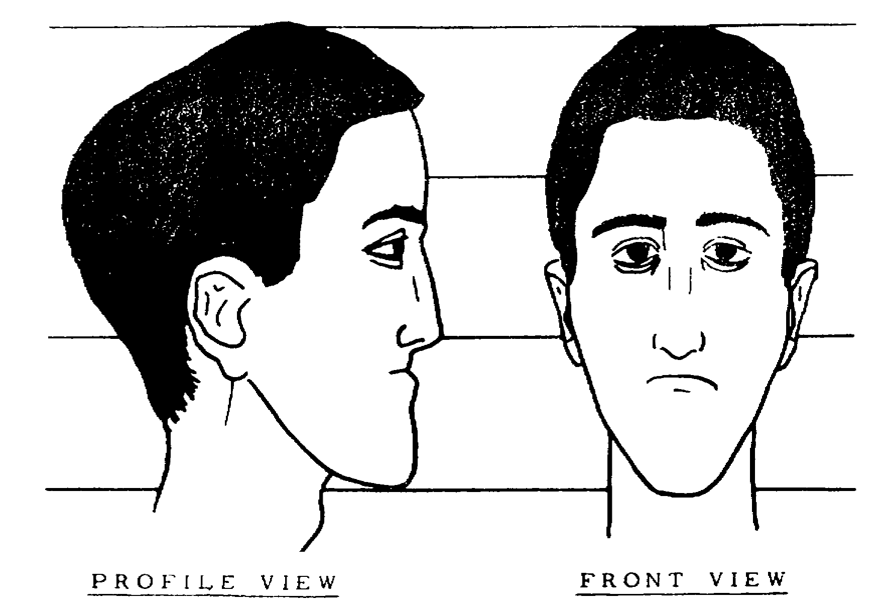
Figure 5-21

5-39 MP1016

17. How would the subject's ears be described?

A. Medium size, oval shape, medium lobe, low setting.

B. Medium size, rectangular shape, gulfed lobe, low setting.

C. Medium size, rectangular shape, medium lobe, high setting.

D. Medium size, rectangular shape, medium lobe, low setting.

SPECIAL SITUATION: Four individuals witnessed the same object, but at different locations, and at slightly different times.

PVT Alfa, from the second floor of his barracks, witnessed the subject leaning against a lamp post.

PVT Bravo saw the subject approximately 100 meters away walking towards him.

PVT Charlie saw the subject standing in a doorway.

PVT Delta saw the subject walking by the entry to a basement.

18. Who could probably give the most accurate estimate of the subject's height?

A. PVT Alfa.

B. PVT Bravo.

C. PVT Charlie.

D. PVT Delta.

19. Who could probably give the best overall description of the subject?

A. PVT Alfa.

B. PVT Bravo.

C. PVT Charlie.

D. PVT Delta.

MP1016 5-40

LESSON 5

PRACTICE EXERCISE

ANSWER KEY AND FEEDBACK

Item Correct Answer and Feedback

1. C. Methodical, beginning with a non-specific rather than the characteristic traits.
First, general traits... (pages 5-2; para 2a.(1), (2), (3)).

2. C. Aid the observation of the witness by asking pertinent questions to uncover important details.
However, in almost every case... (page 5-29, para 10a).

3. B. If subject has a marked individual trait.
When attempting to identify... (page 5-2, para 2).

4. B. Make and Model.
The description should be such... (page 5-25, para 4a).

5. A. Type and color of the vehicle.
Describing objects... (page 5-25, para 4).

6. B. I, II, III.
Techniques and identifications... (page 5-26, para 7).

7. C. Legs and hips.
Legs. Long, medium, or short... (page 5-24, para h).

8. A. I, II, III.
Observation in investigation... (page 5-1, para la, b).

9. B. Her natural, as well as her artificial appearance.
It is most useful to obtain... (page 5-6, para 4).

10. C. Select participants having the same general appearance as the suspect.
Ensuring that the suspect is not... (page 5-30, para lla.(l)(a)).

11. A. I, II, IV.
Describing events... (page 5-26, para 6).

12. A. I, III, IV.
The observations... (pages 5-27 and 5-28, para 9).

13. A. I, II, III.
The observations... (page 5-27, para 9).

5-41 MP1016

Item Correct Answer and Feedback

14. A. In a clockwise manner, starting from a specific point.
Objects located within... (page 5-4, para (2)(d)).

15. C. Turned up, thin or narrower, short.
Nose. Length as... (page 5-13, para 9).

16. A. I, II, IV.
Forehead... (page 5-11, para 5).

17. D. Medium size, rectangular shape, medium lob, low setting.
Ears... (page 5-17, para 15).

18. C. PVT Charlie.

19. A. PVT Alfa.

MP1016 5-42

